**SQL for Data Analysis (with dataset + 50 queries)**

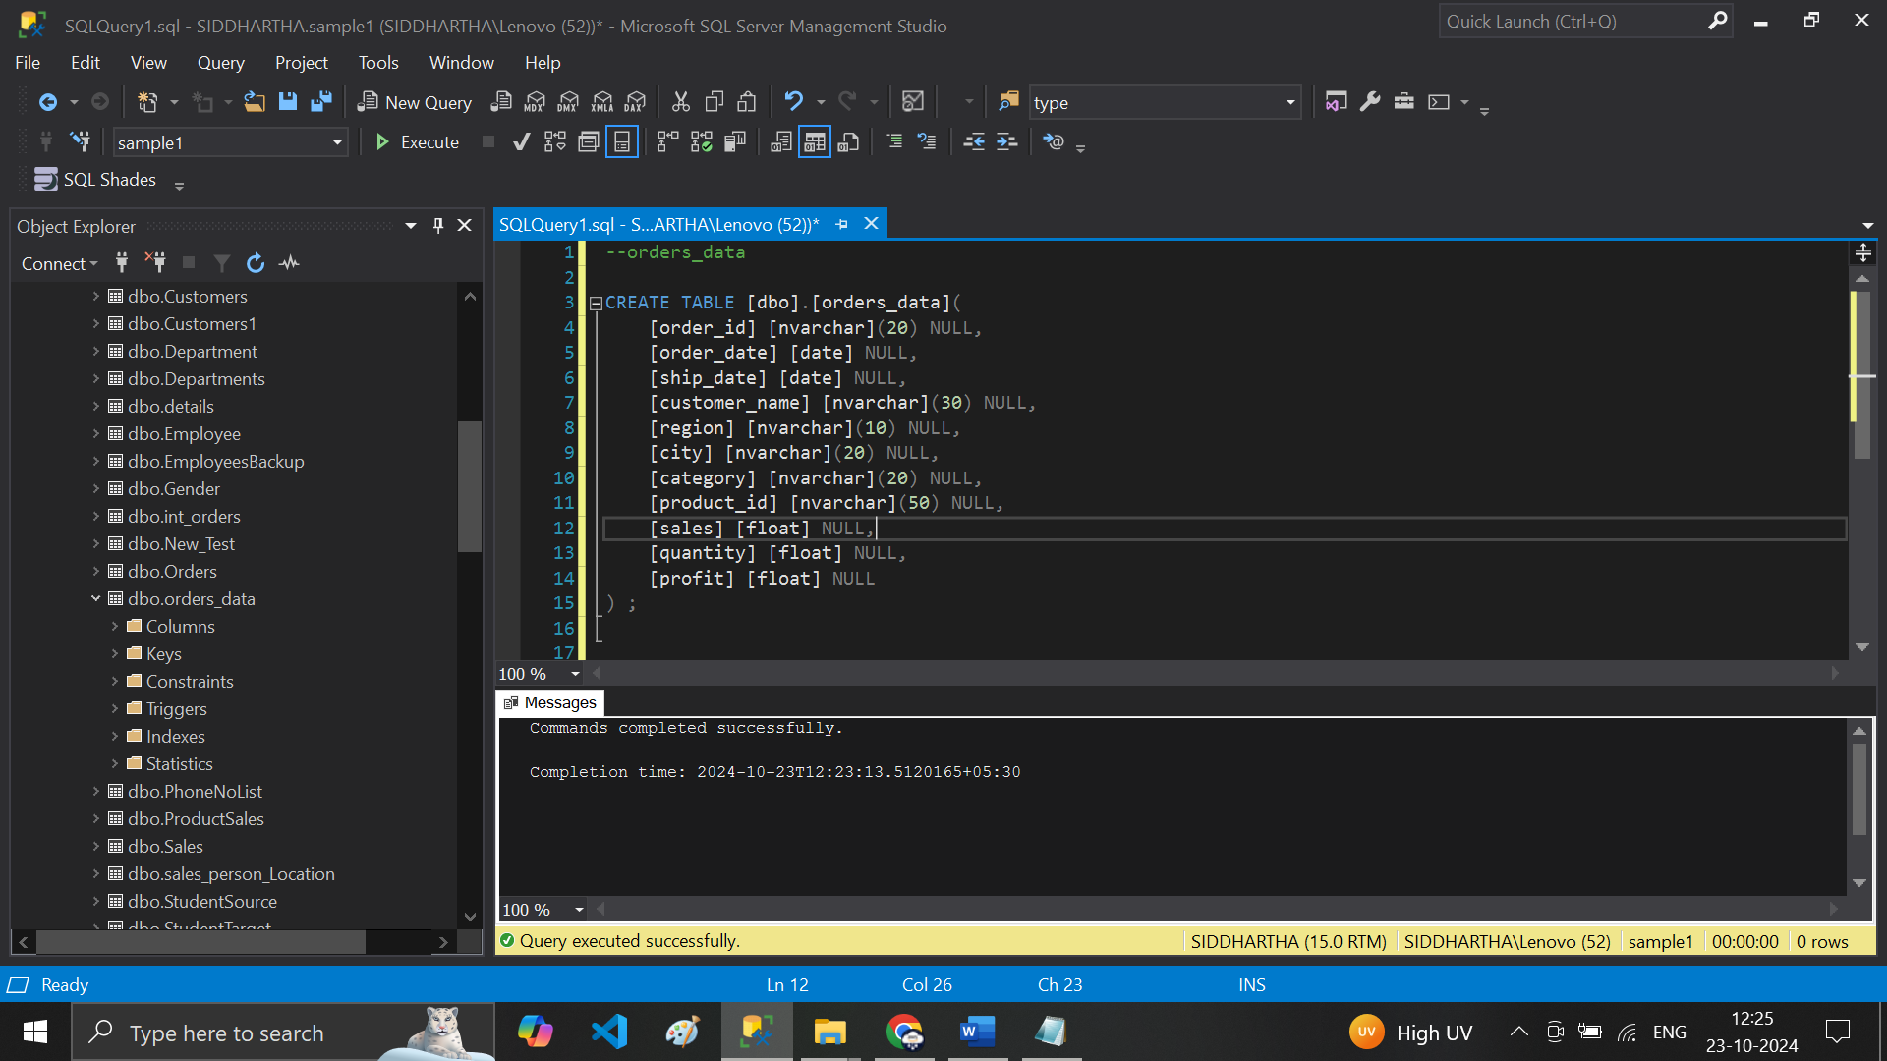

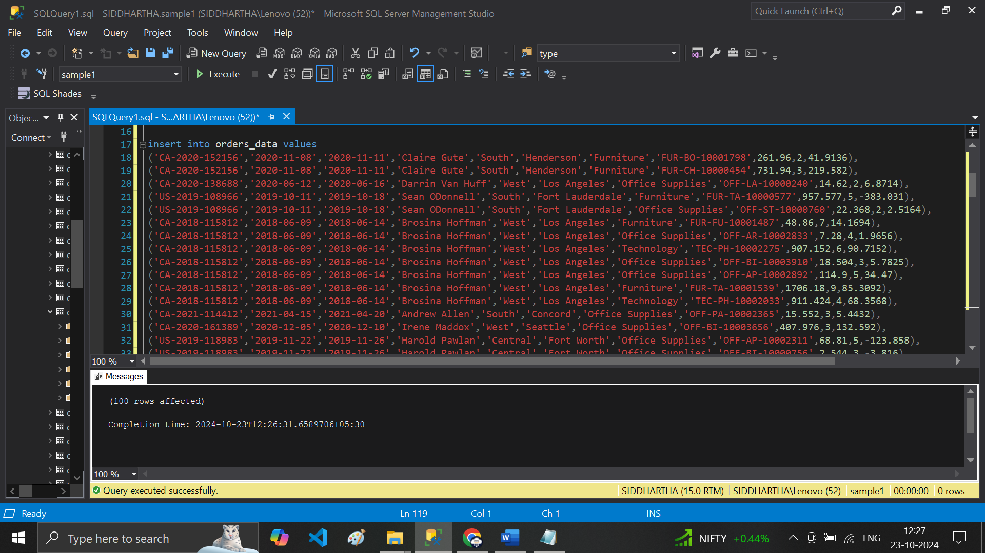

**# Data inserted & Ready to Executed**

**# 1 Select * from order_data..**

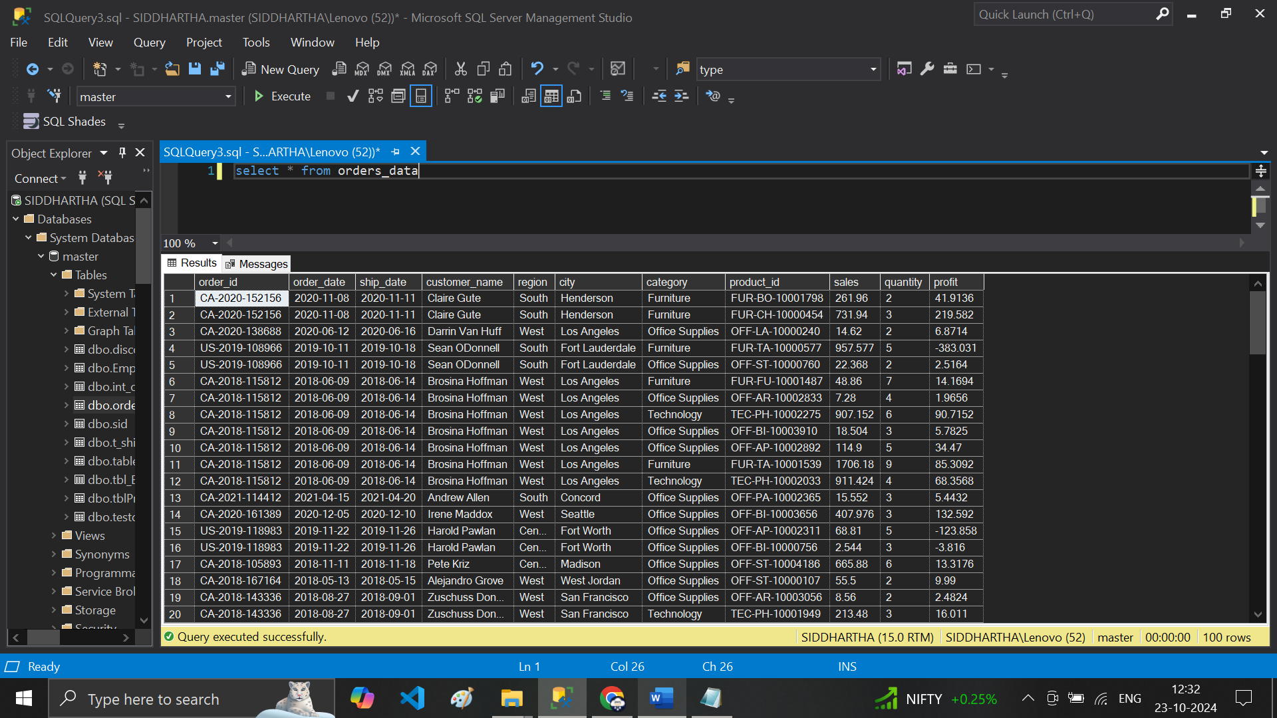

**# 2 select order_id,order_date,sales from orders_data**

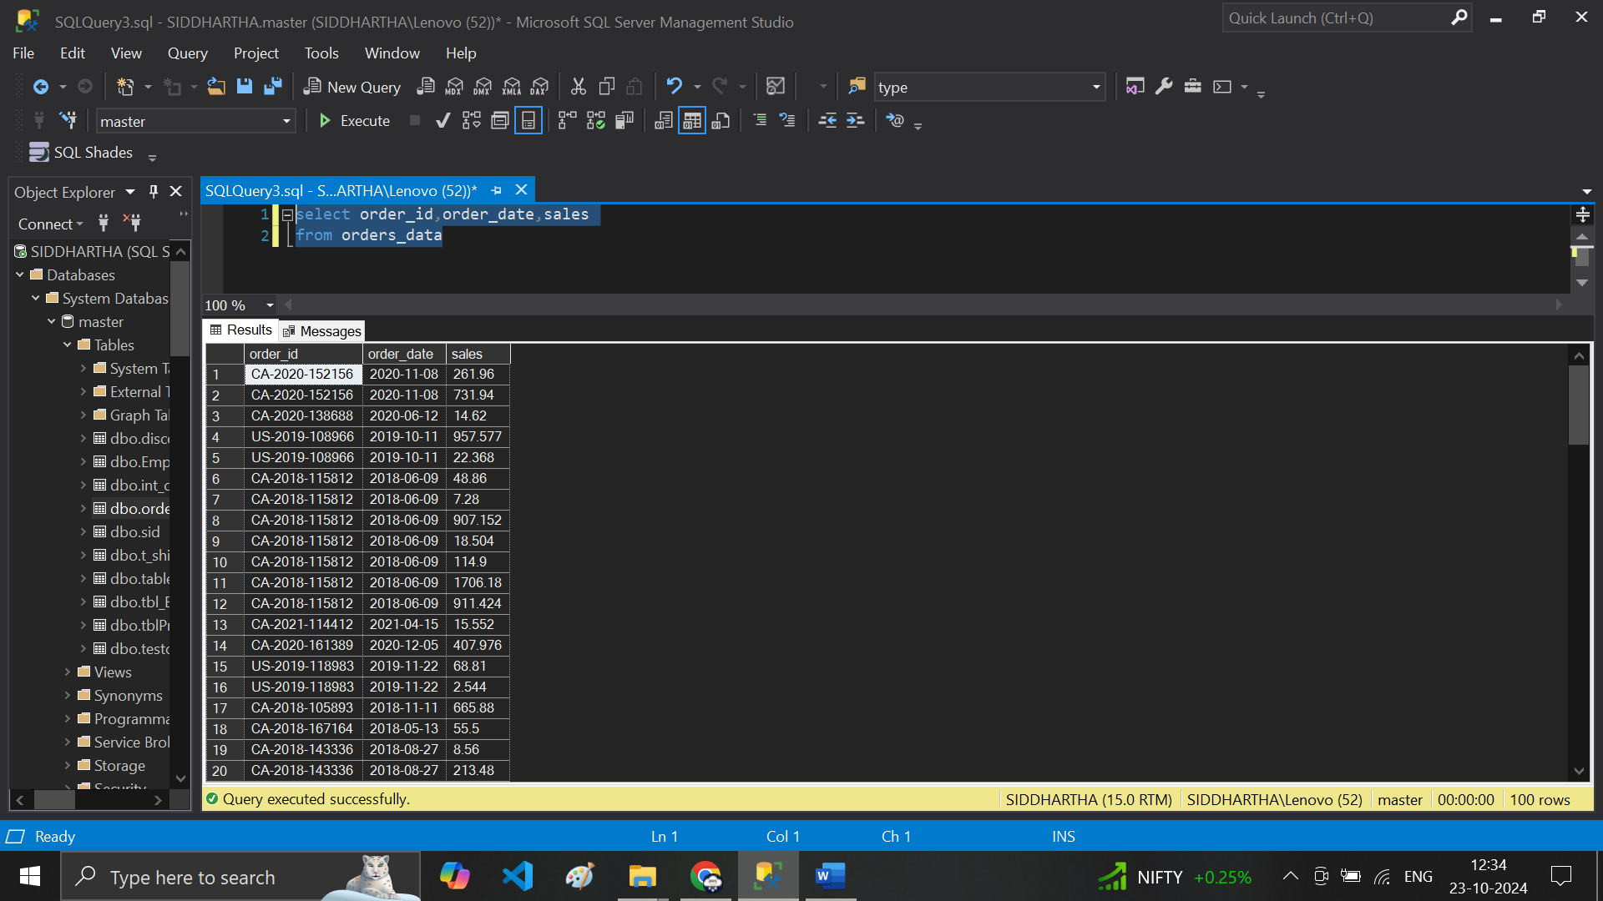

2. -- top 10 rows from the data table ---

# 3 select top 10 * from orders_data

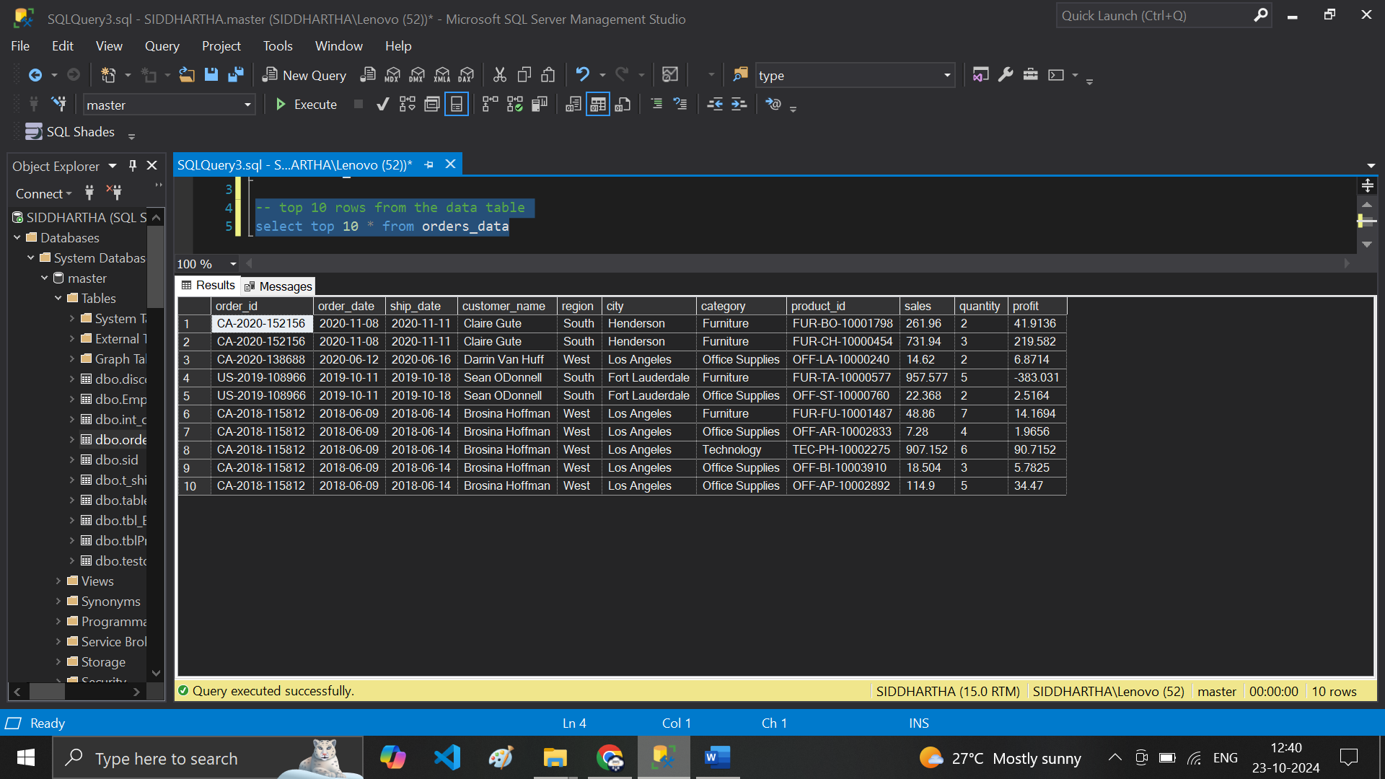

**# 4 select top 10 order_id,order_date,sales,profit from orders_data**

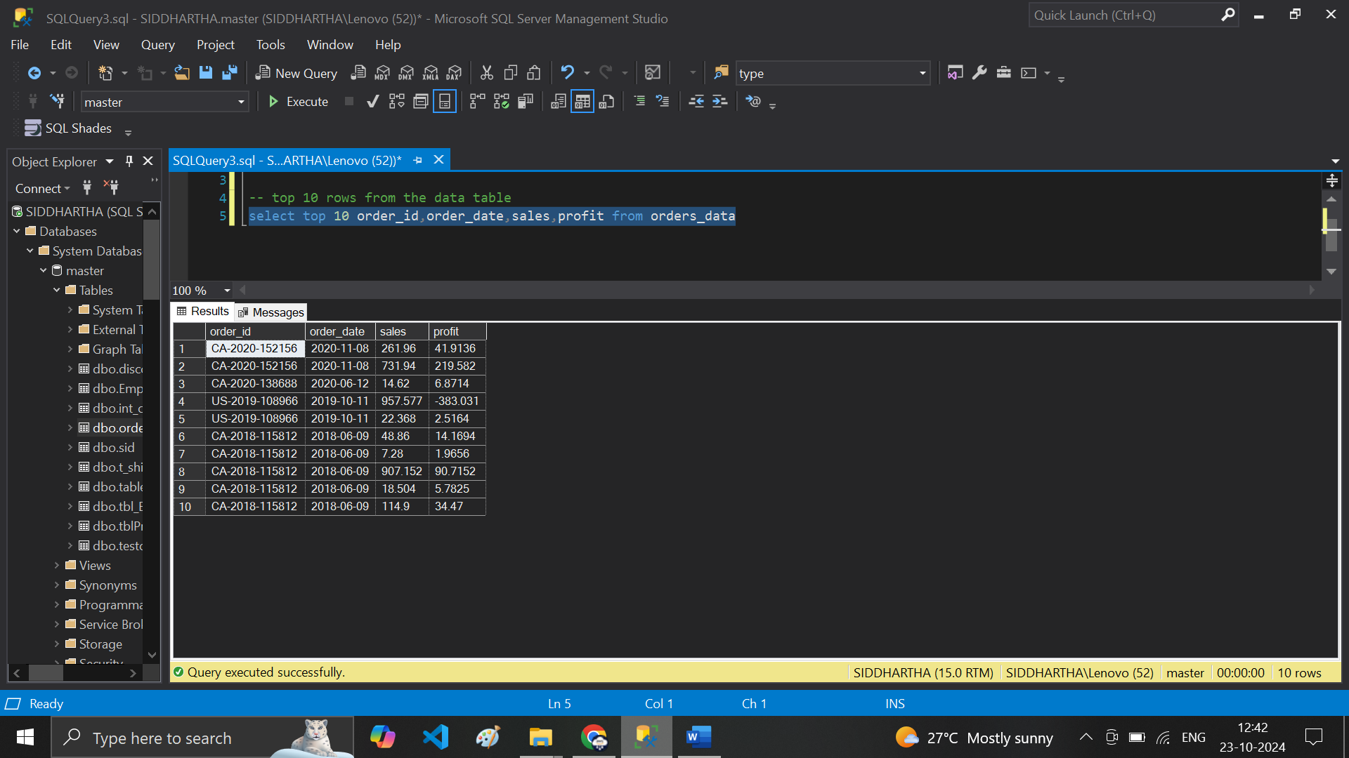

# note Order_Date is not in proper order ..

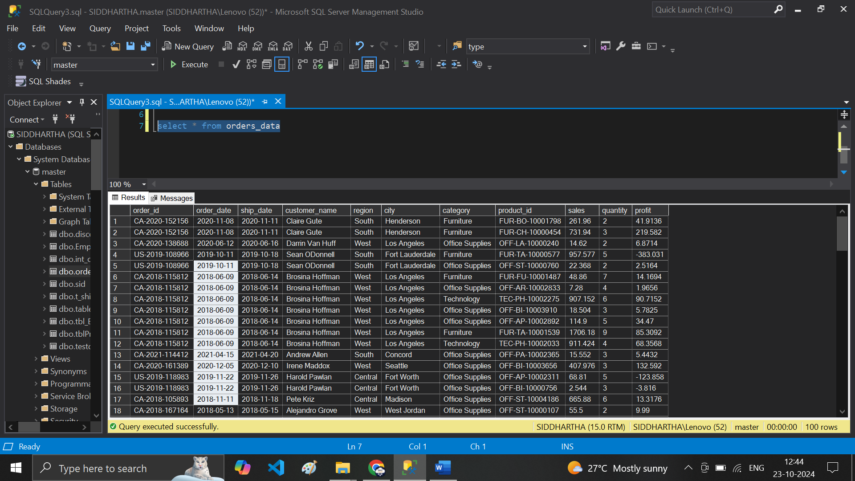

# 5 select * from orders_data order by order_date

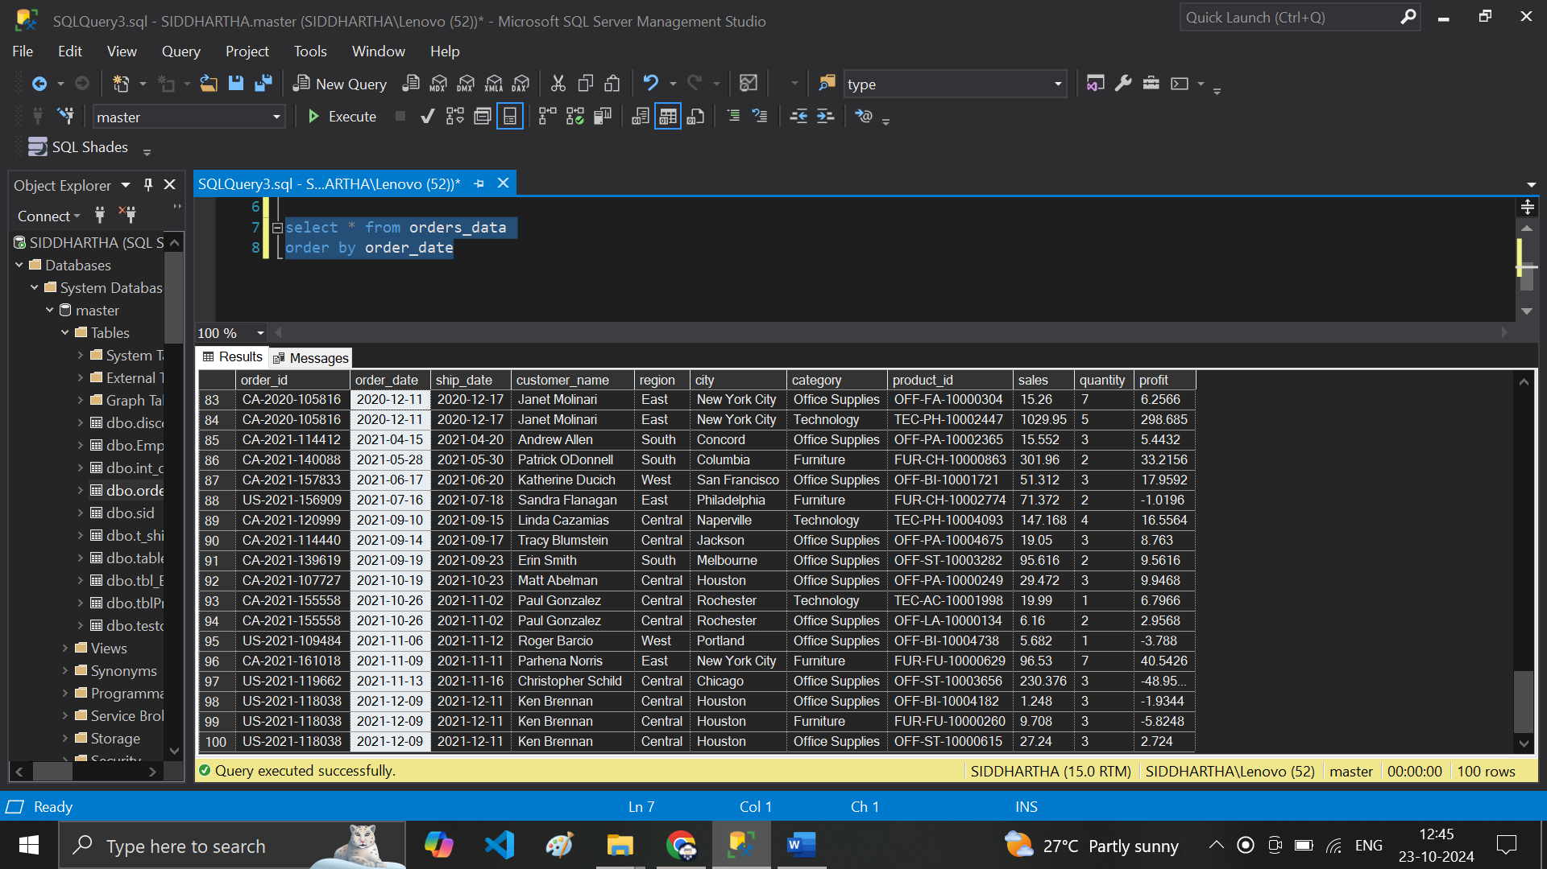

# in order_Date—multiple rows in same order date .. how to sort this ???

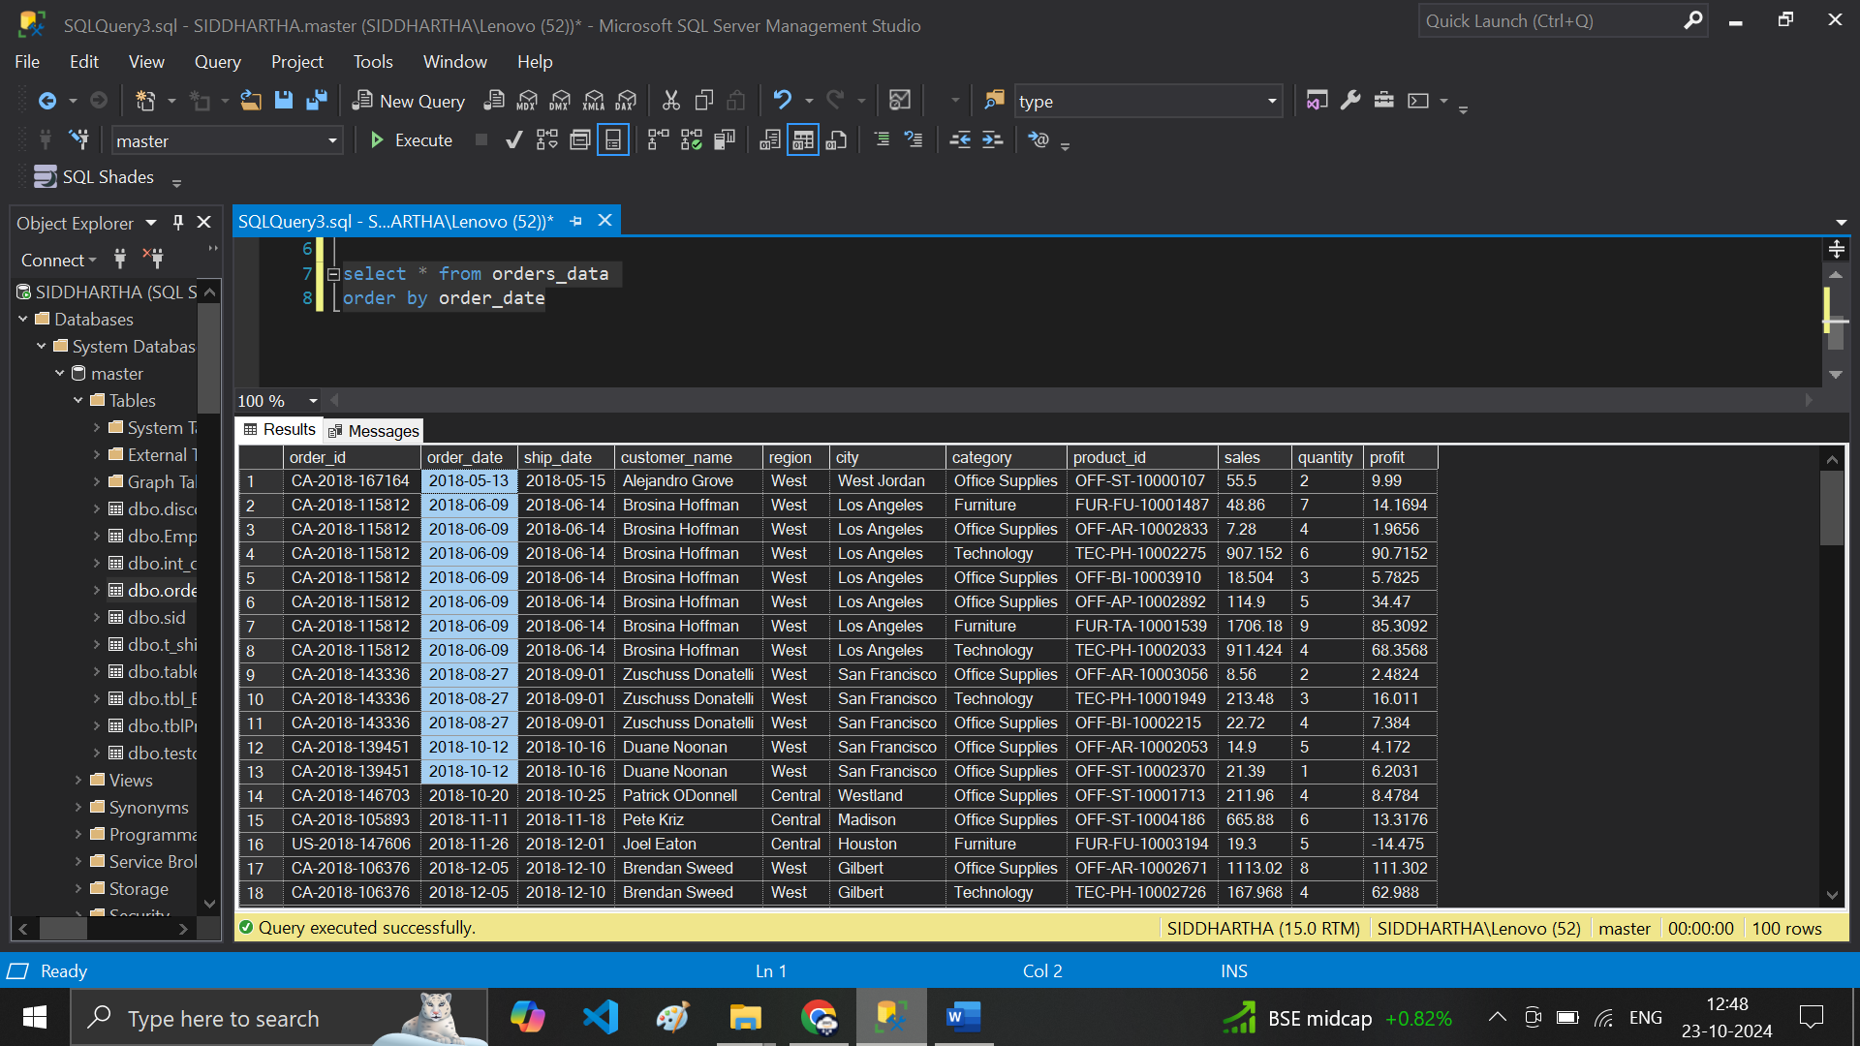

# Solutions – Sort it by the Order_id or profit check below

**# 6 select * from orders_data order by order_date,profit**

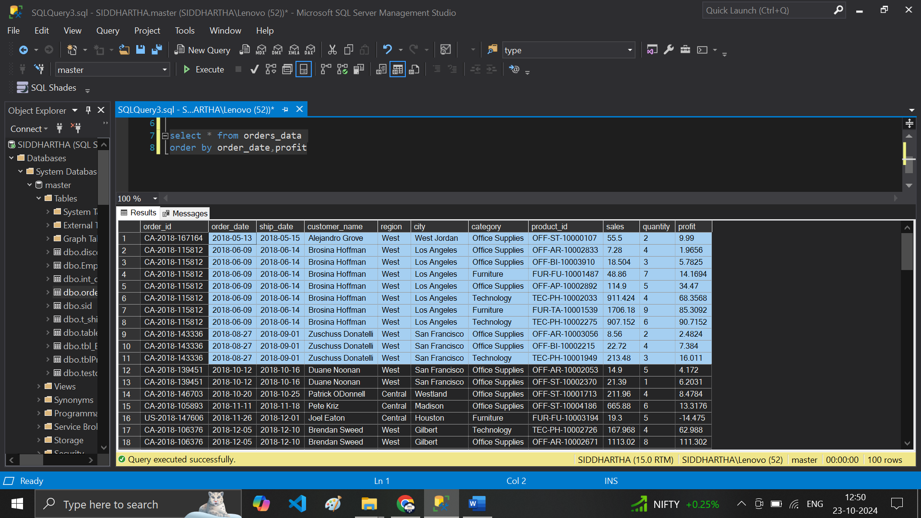

# Lets Check order_date in des order – latest in top .. oldest @ the Bottom

**# 7 select * from orders_data order by order_date desc - –profit**

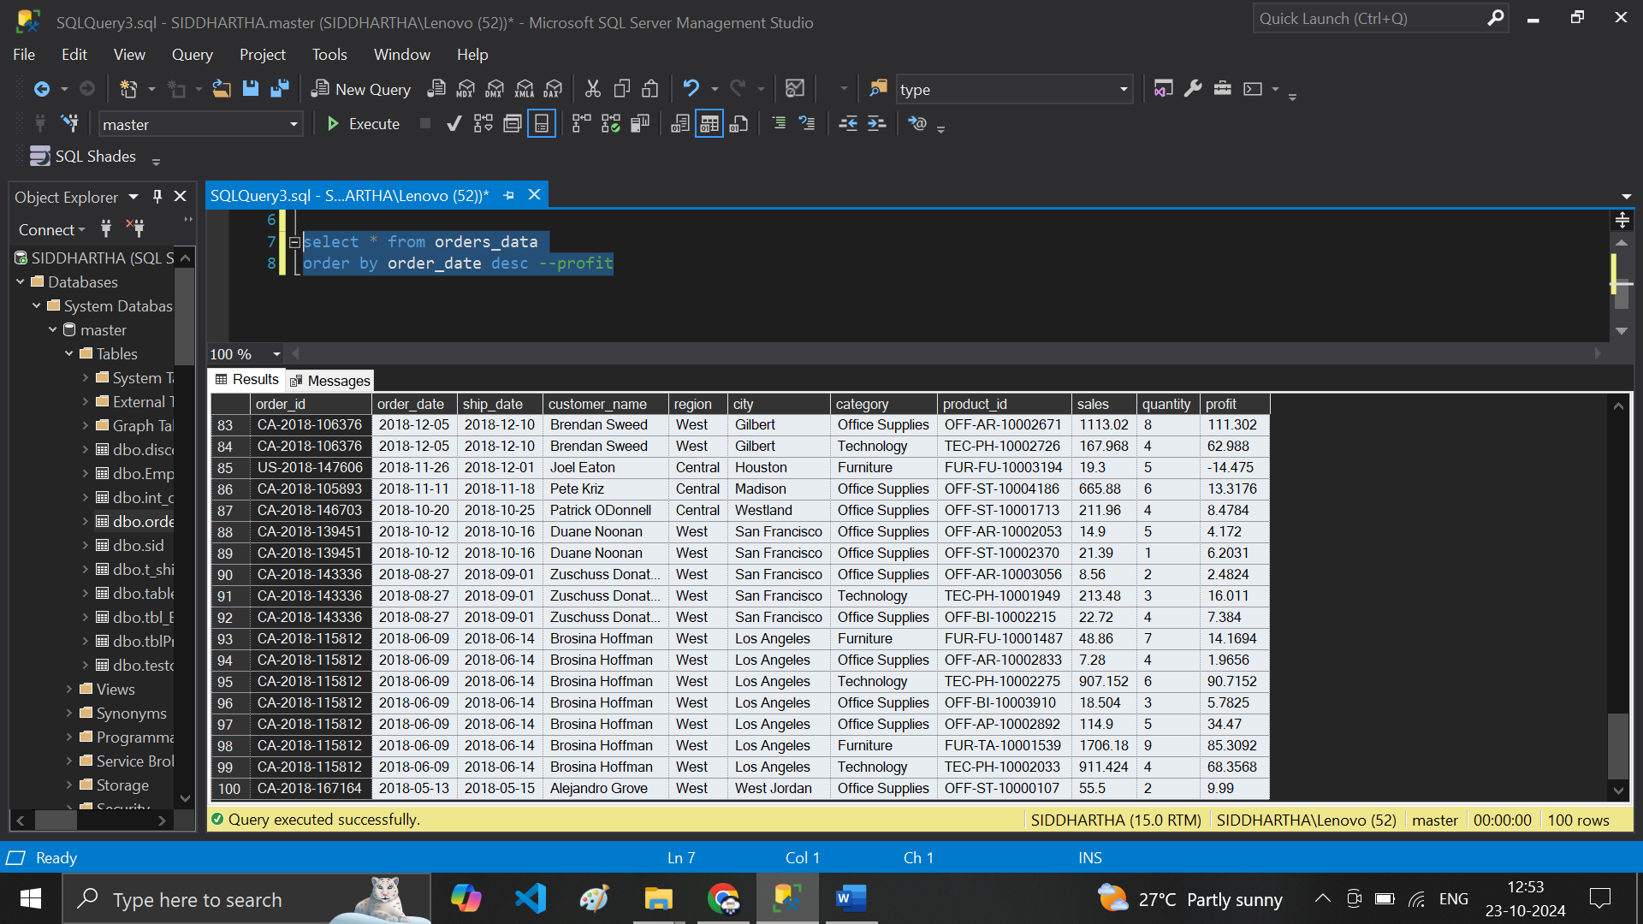

**# 8 select * from orders_data order by order_date desc ,profit**

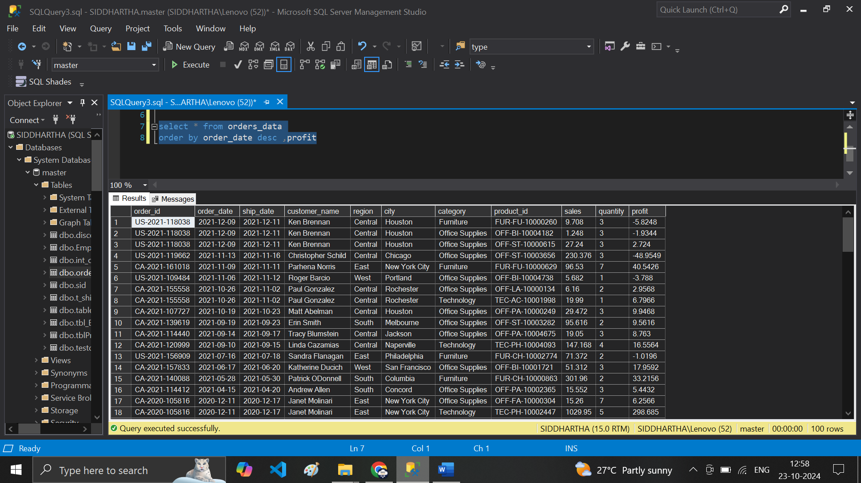

**# 9 select * from orders_data order by order_date desc ,profit desc**

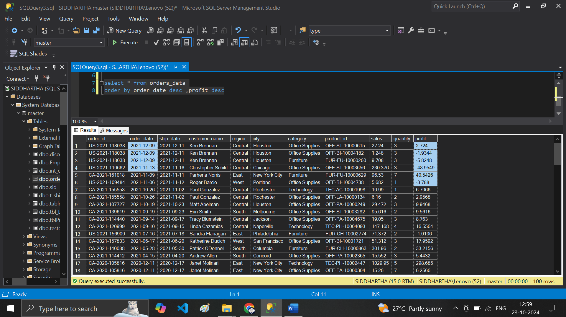

**# 10 select top 5 *from orders_data order by sales desc**

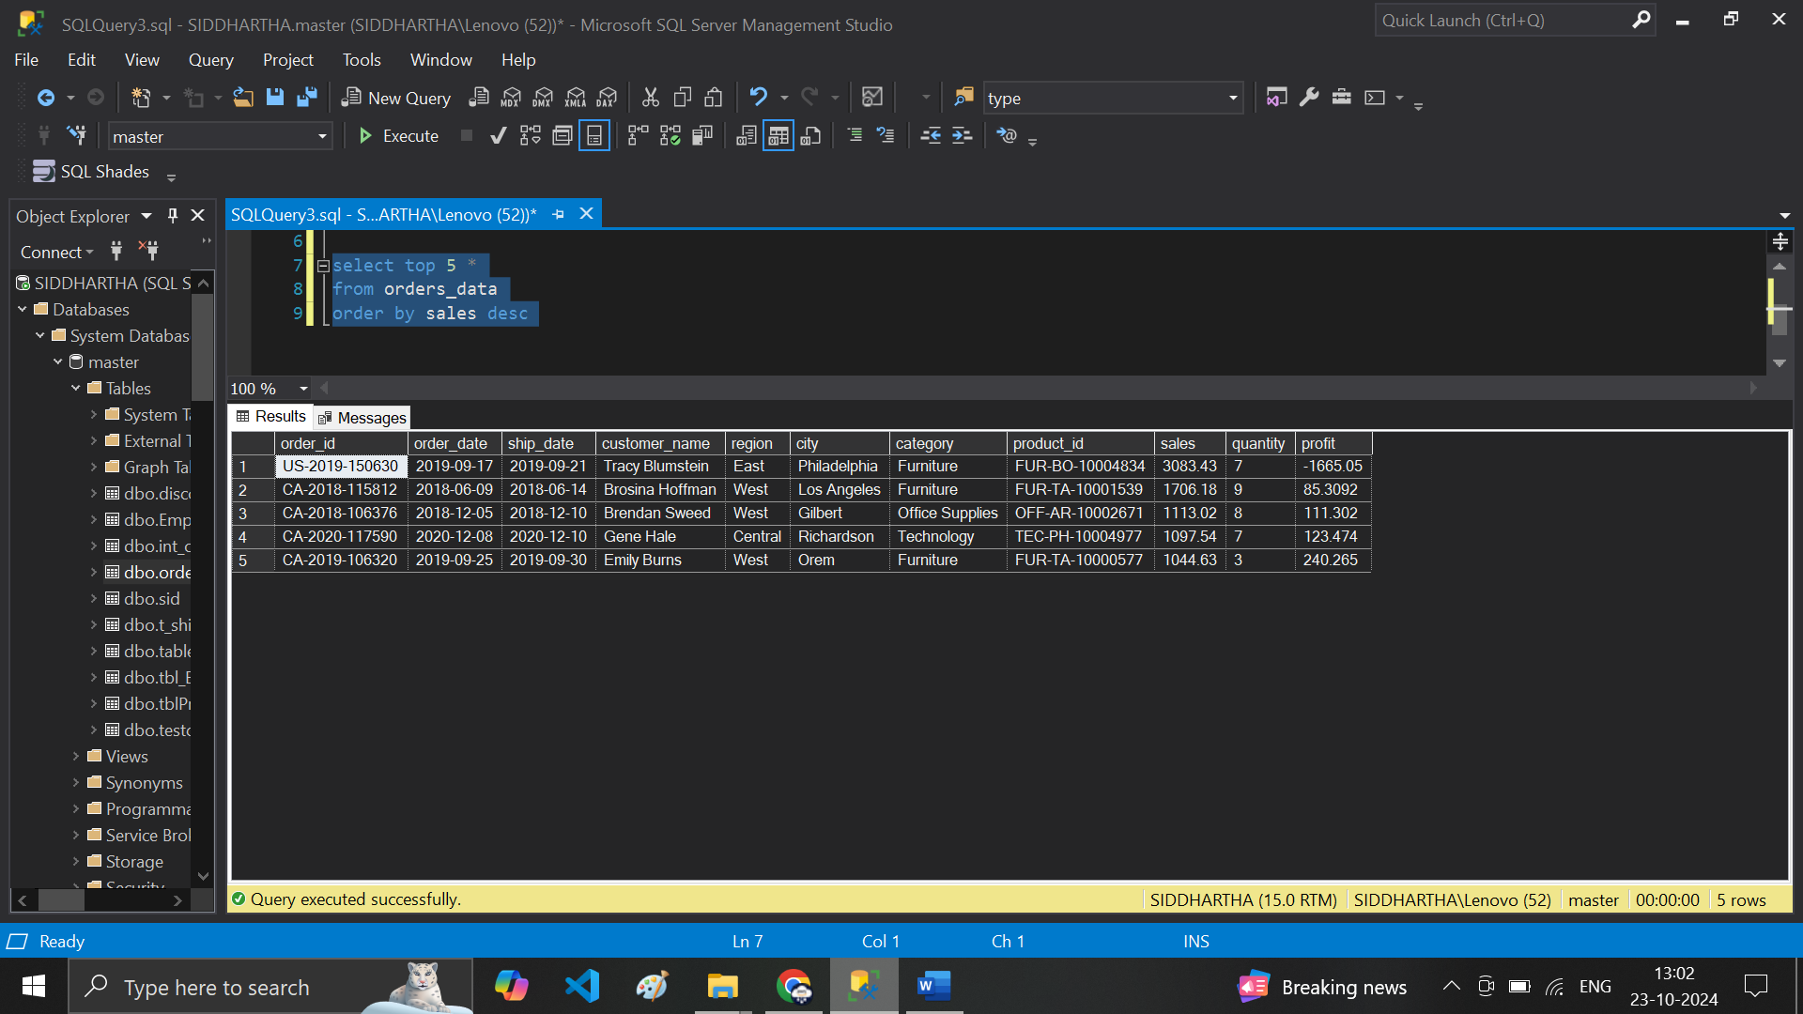

**# I want to create a new column from existing table**

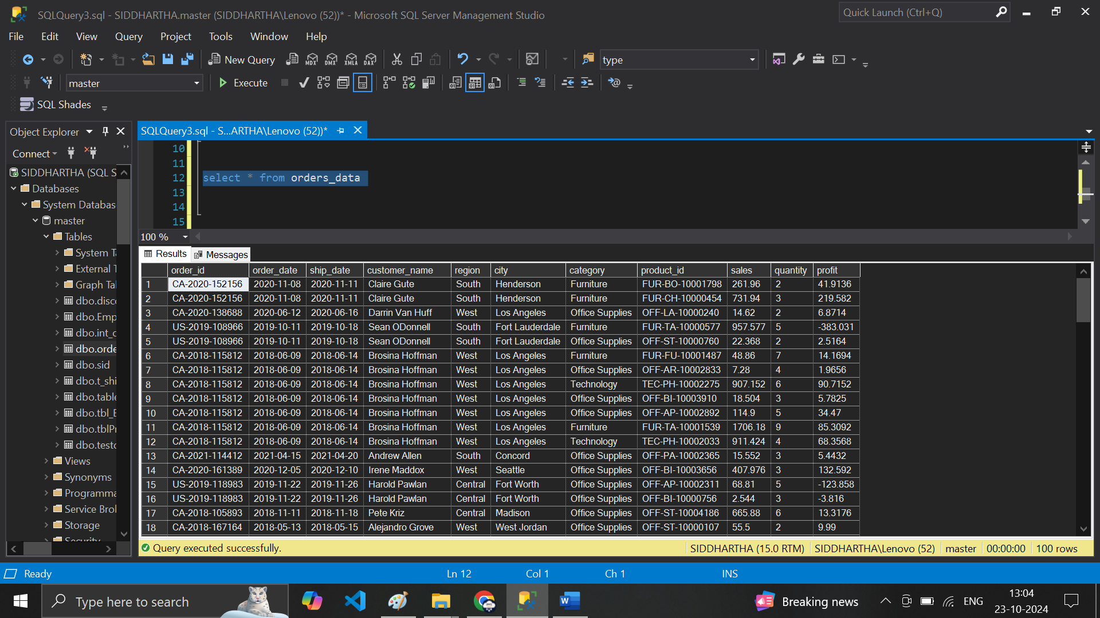

**Column – Ratio =profit/sales**

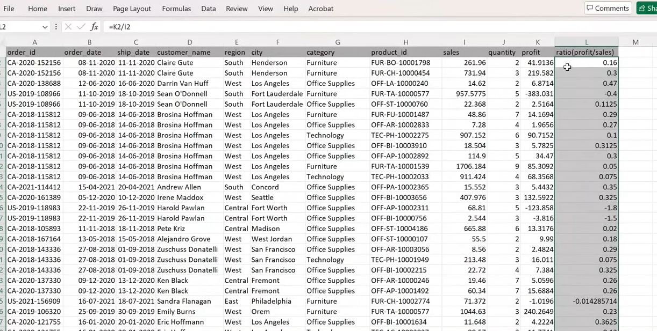

**# how to Do it in SQL ??? here is the Solution below**

**# 11 select * , profit/ sales as ratio from orders_data**

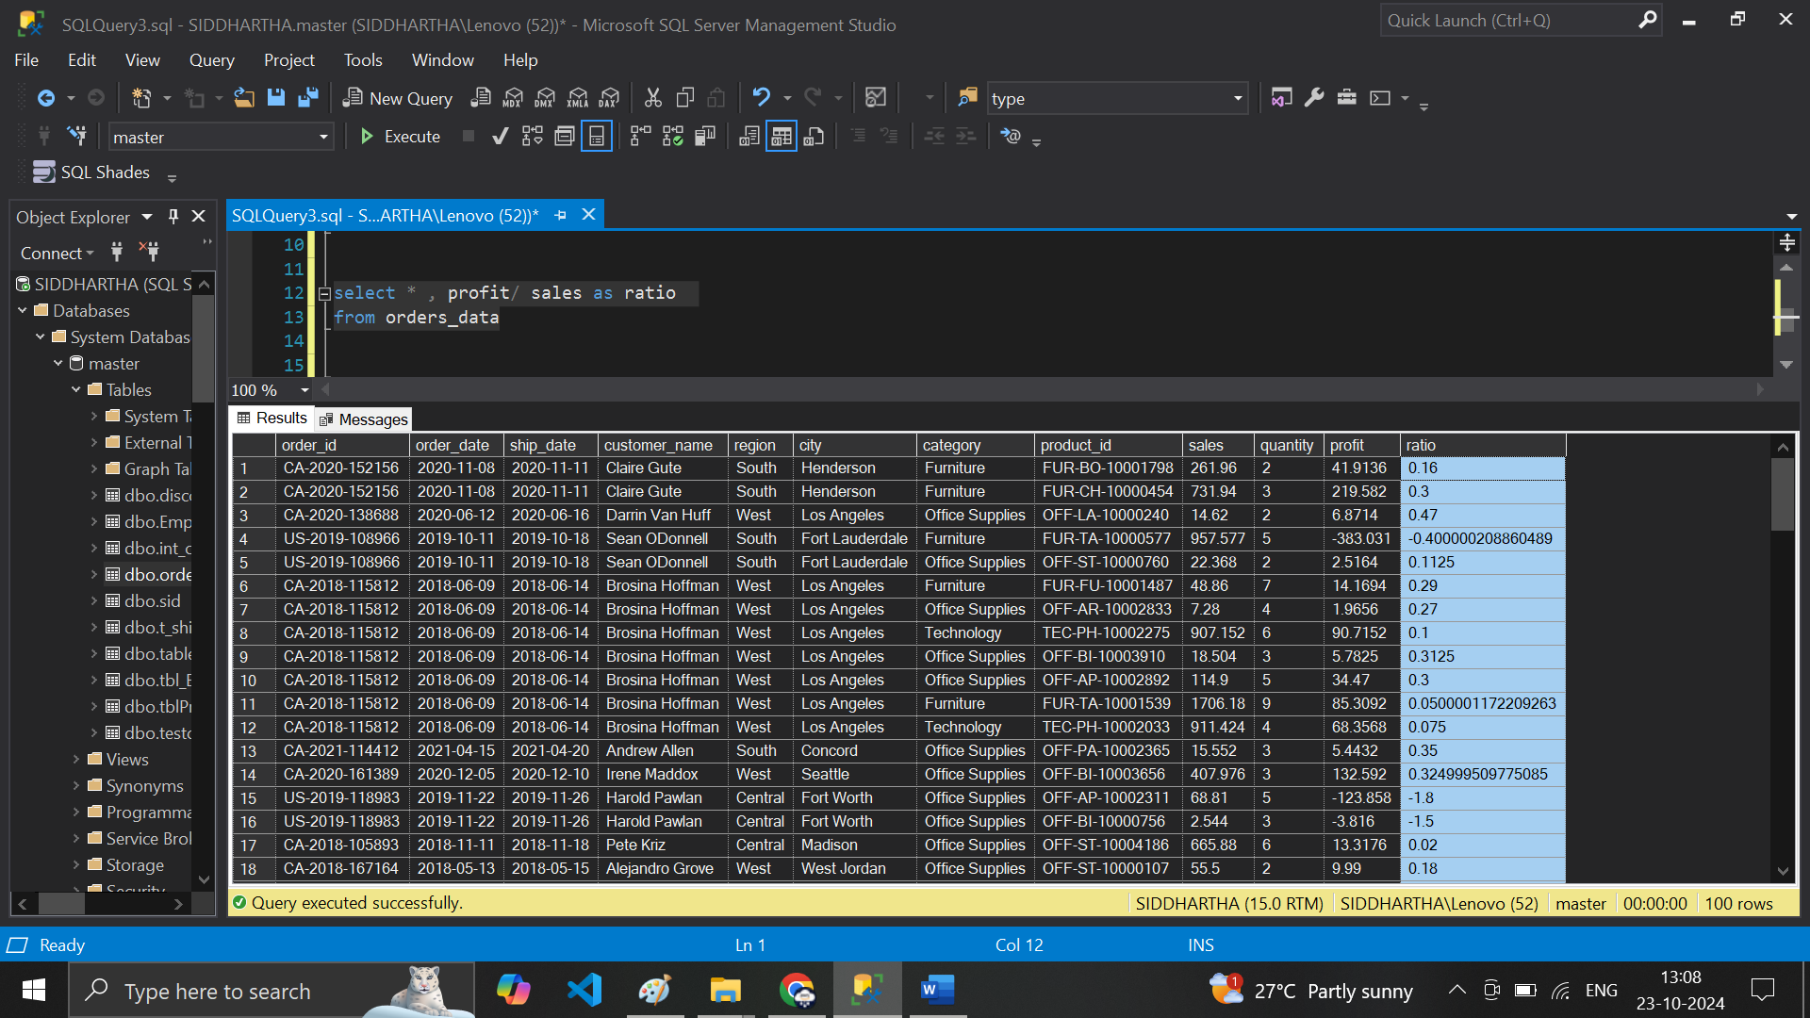

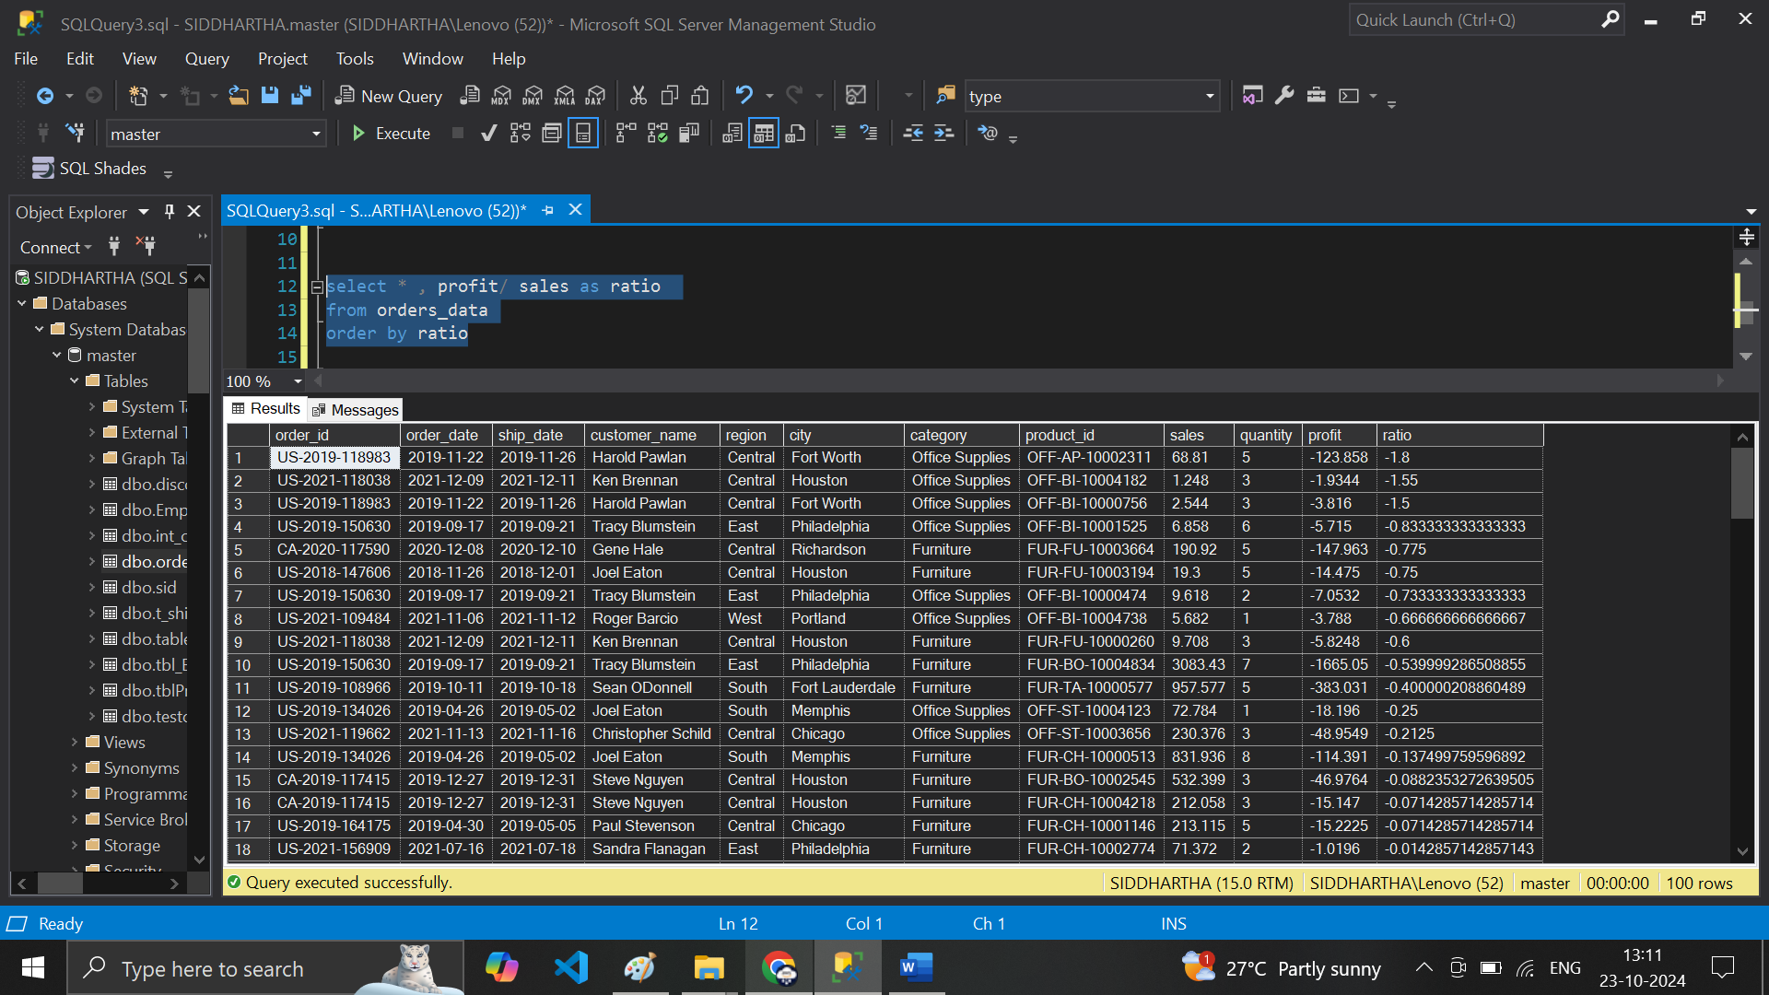

**# Going back to excel I can filter the data & get the specific region called “ Central”**

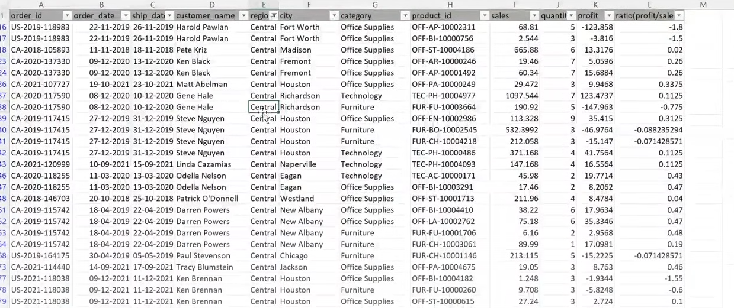

**# how to Do in the SQL ??**

**# 12 select *from orders_data where region='Central'**

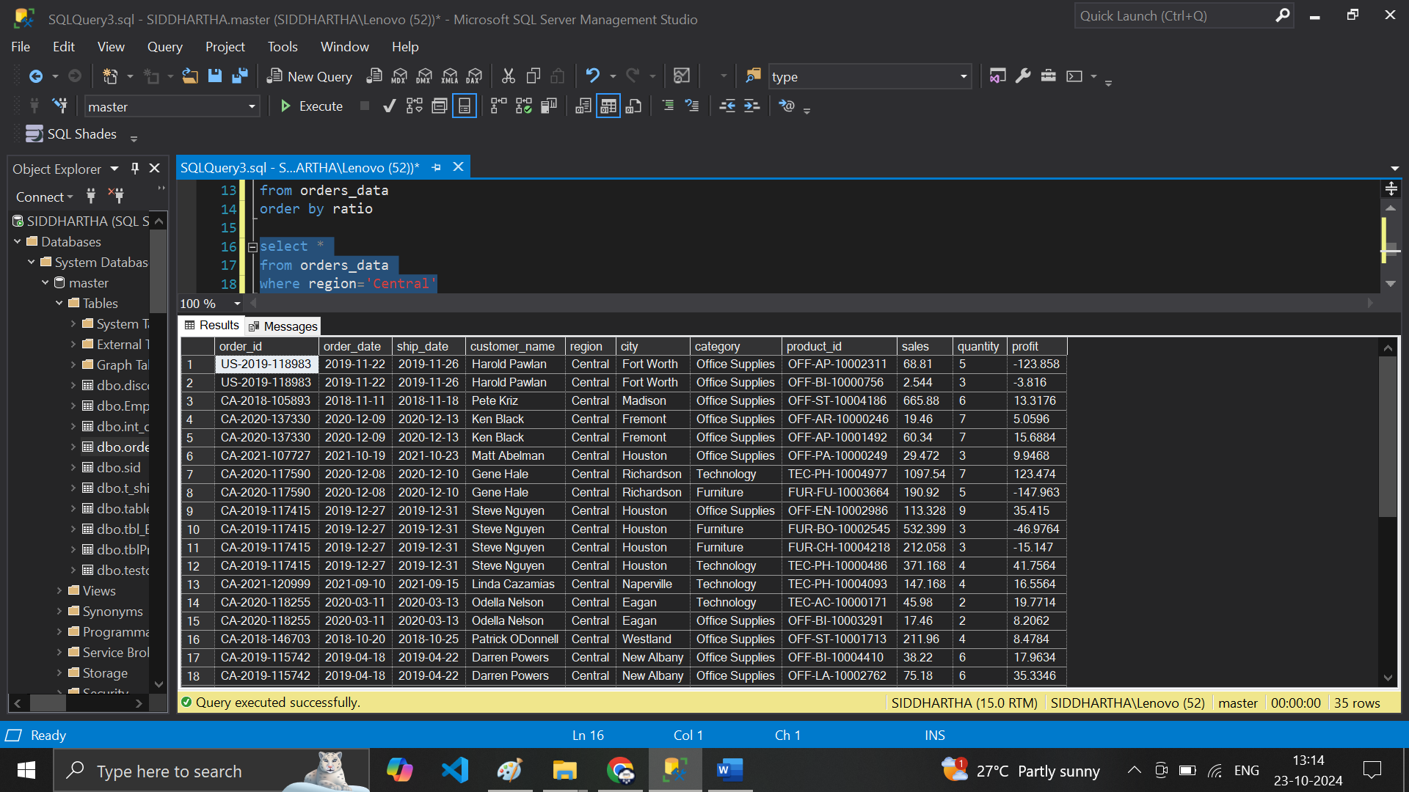

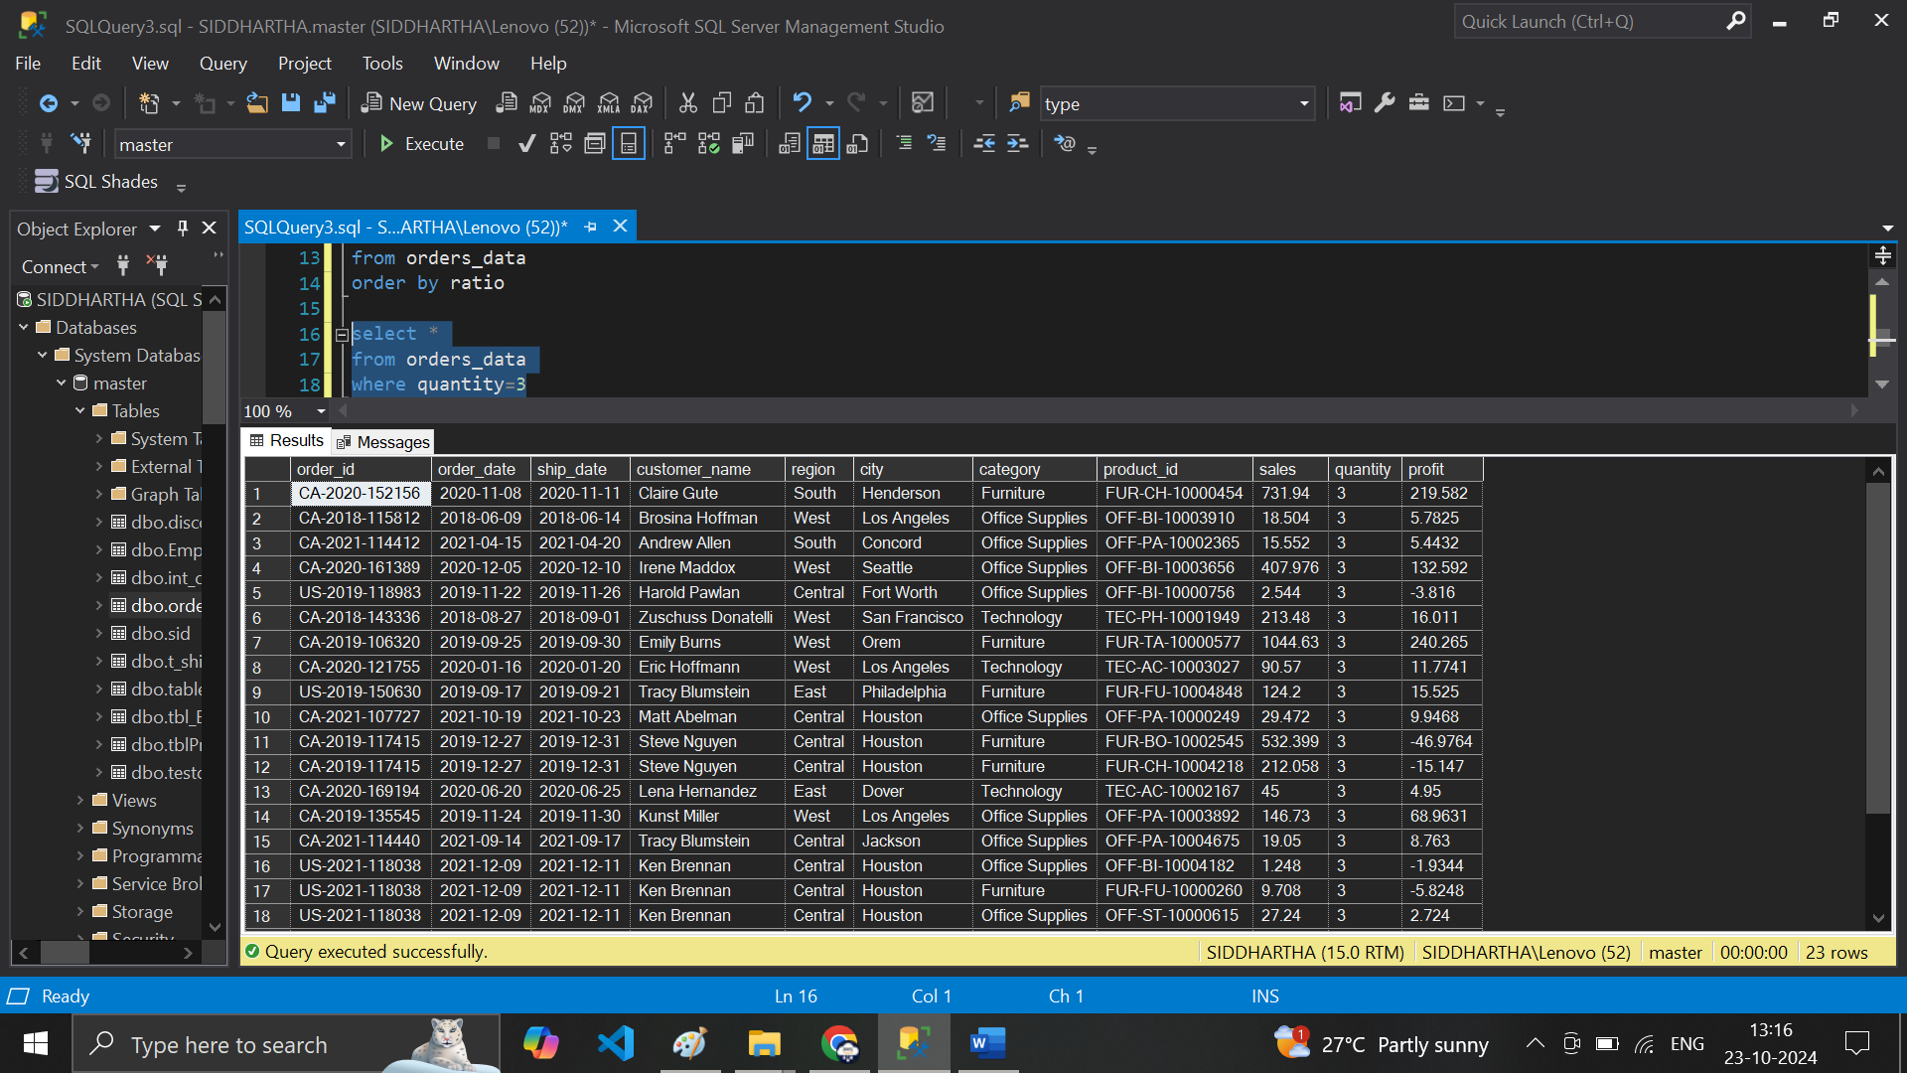

**# 13 date Filtering ---- select *from orders_datawhere order_date='2018-06-09'**

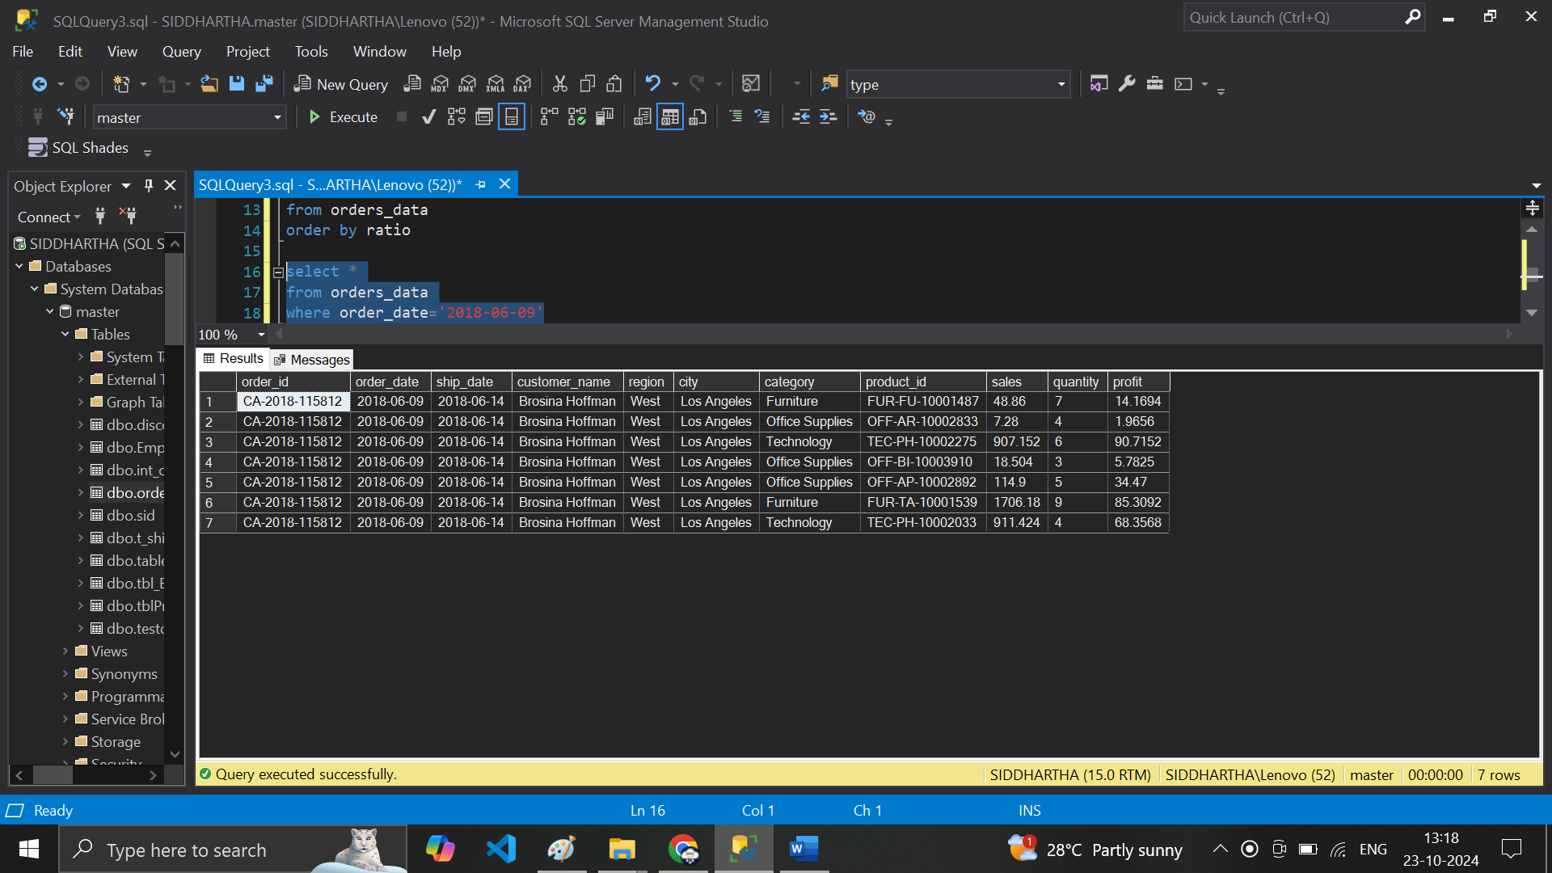

**# 14 select * from orders_data where order_date>'2018-06-09'**

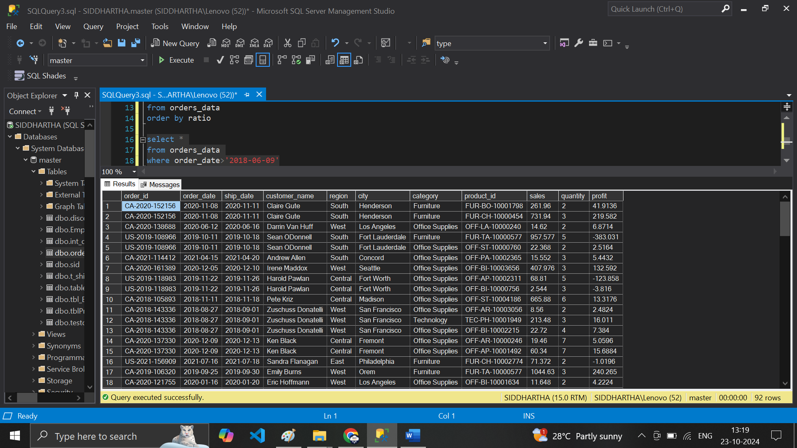

**# 14 select * from orders_data where region='Central' and category='Technology'**

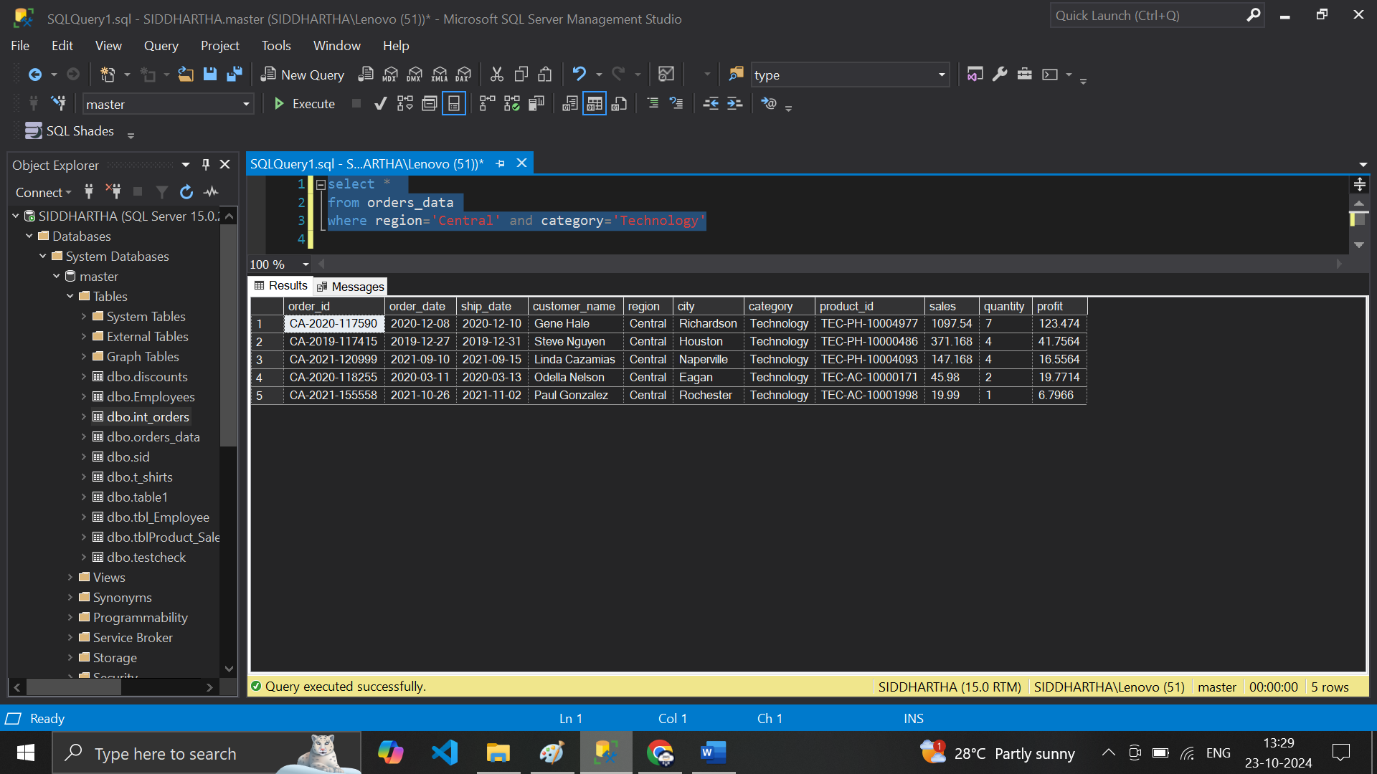

**# 15 - select * from orders_data where region='Central' and category='Technology' and quantity>3**

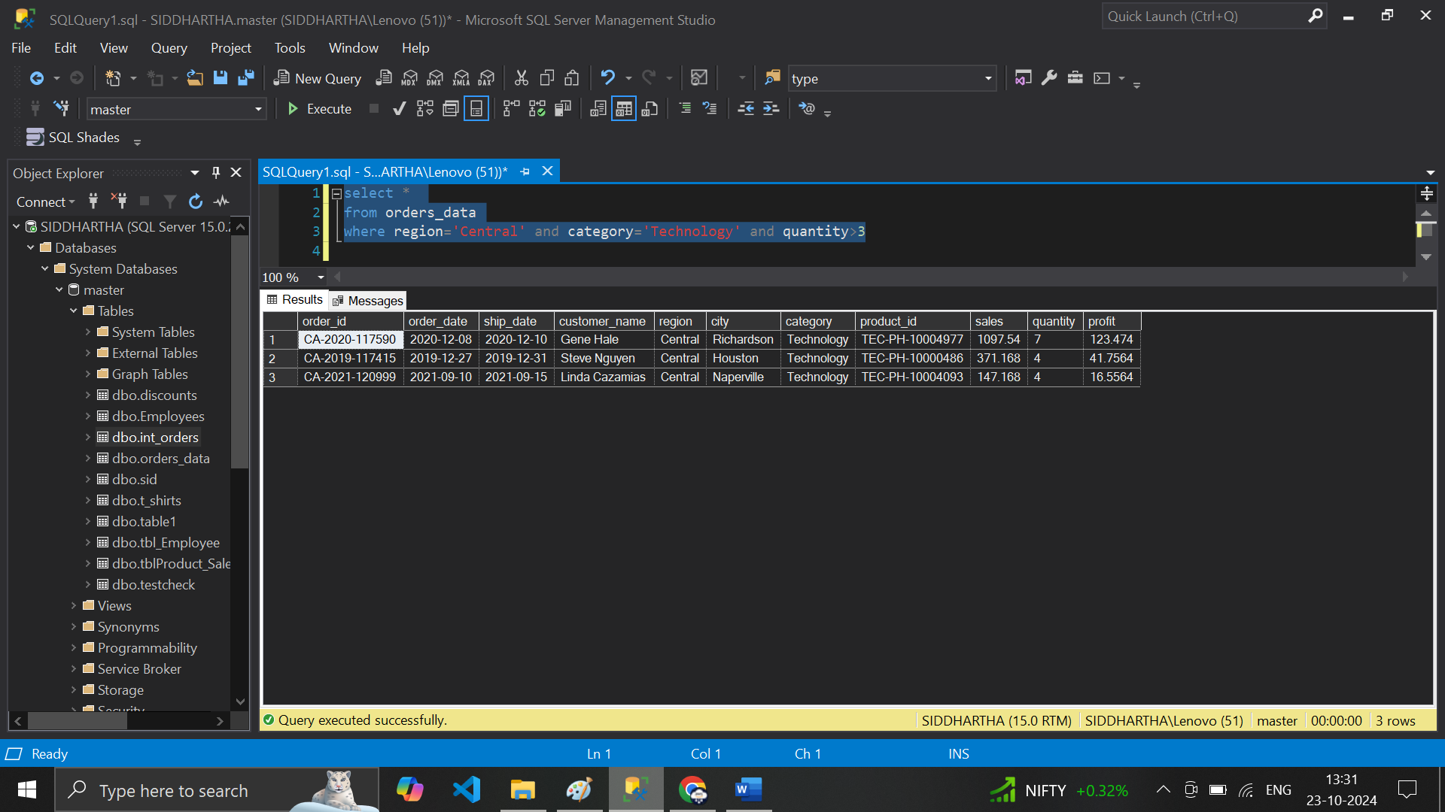

**# 16 or Clause ---select * from orders_data where region='Central' or category='Technology'**

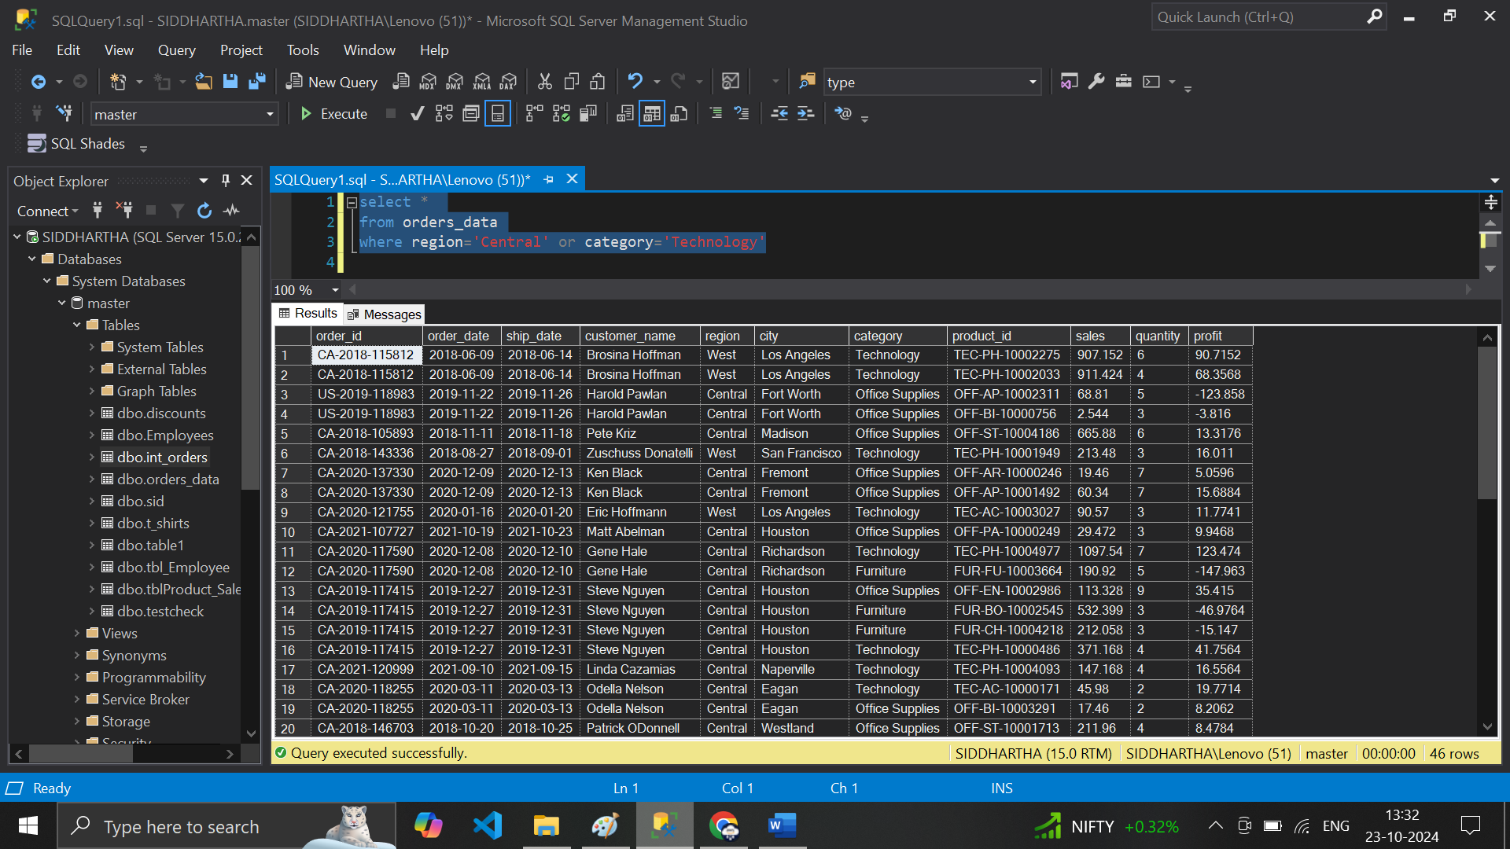

**# or and clause in Both format**

**# 17 select * from orders_data where (region='Central' or category='Technology') and quantity>3**

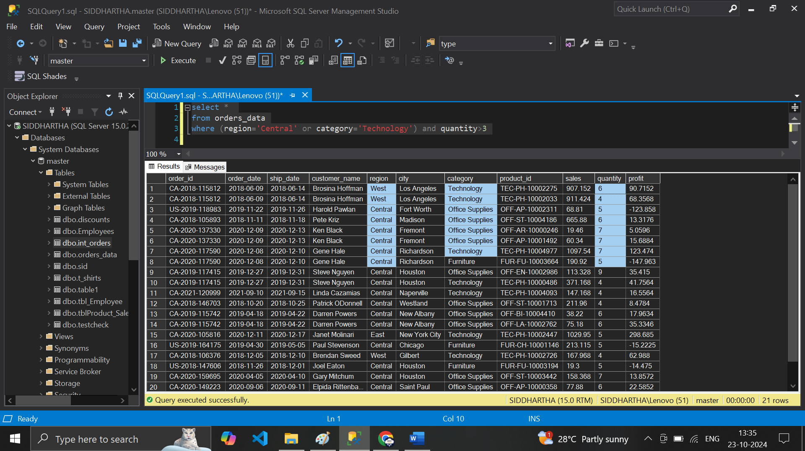

**# B/w Clause 18 --- select * from orders_data where quantity>=5 and quantity<=7**

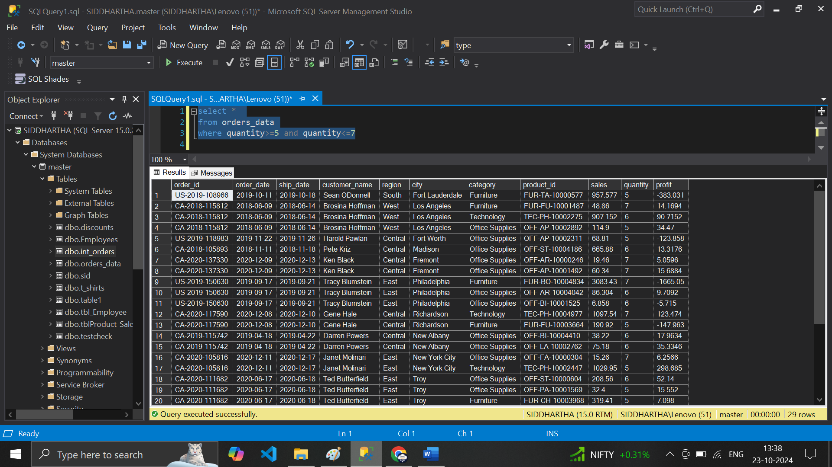

**# in Clause 19 -select * from orders_datawhere quantity in (5,6,7)**

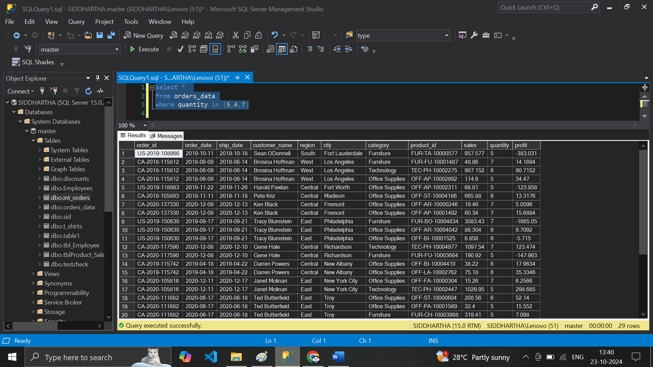

**# in City 20 --- select * from orders_datawhere city in ('Los Angele','Fort','Worth','Richardson','New York City')**

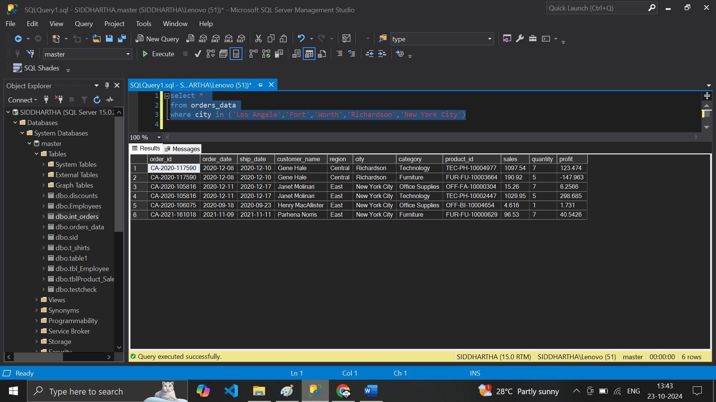

**# b/w ---- 21 select * from orders_data where order_date between ('2019-01-31') and ('2020-11-08')**

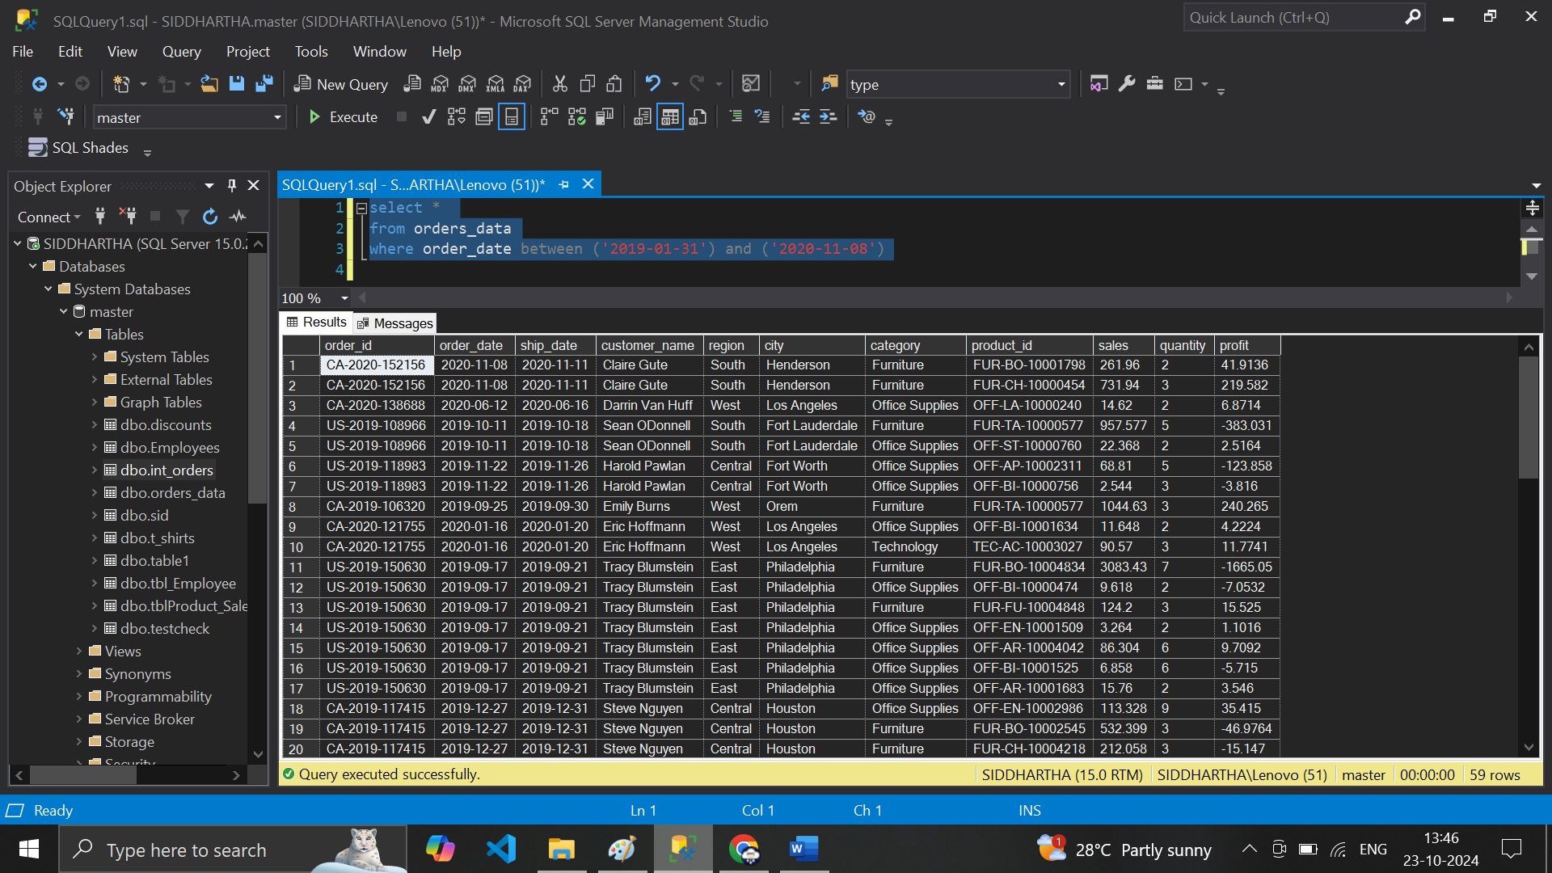

**# Customer name Starting with ‘A ‘ -- using LIKE**

**# 22 select * from orders_datawhere customer_name like 'A%'**

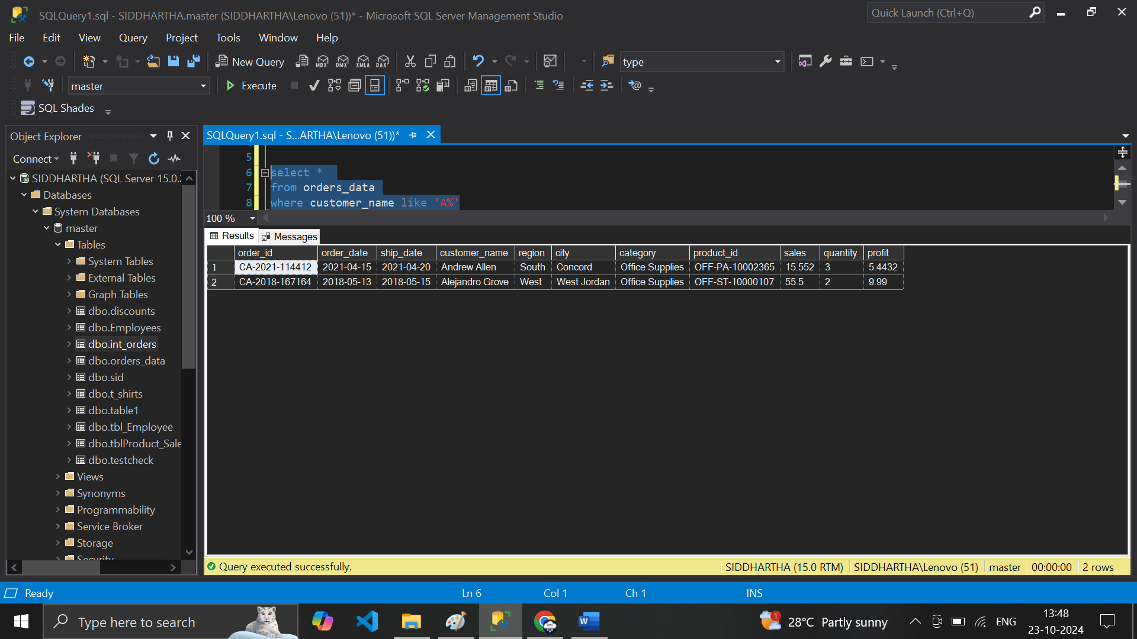

**# Customer name Ending with ‘e’**

**# 23 --select * from orders_data where customer_name like '%e'**

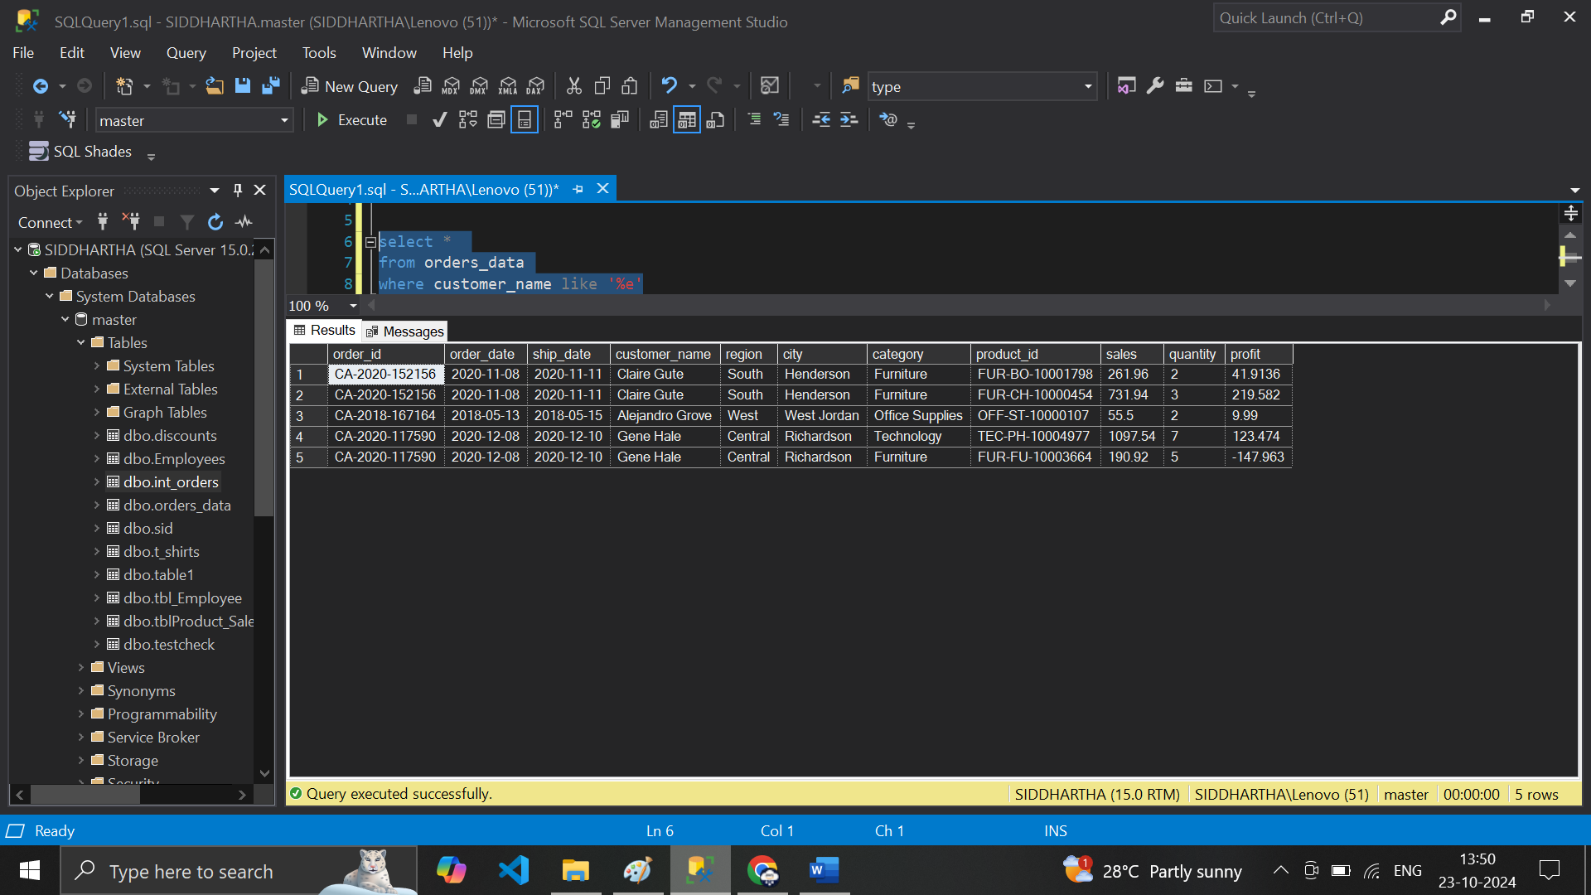

**# Customername – in b/w ‘%A%’**

**# 24 select * from orders_datawhere customer_name like '%A%'**

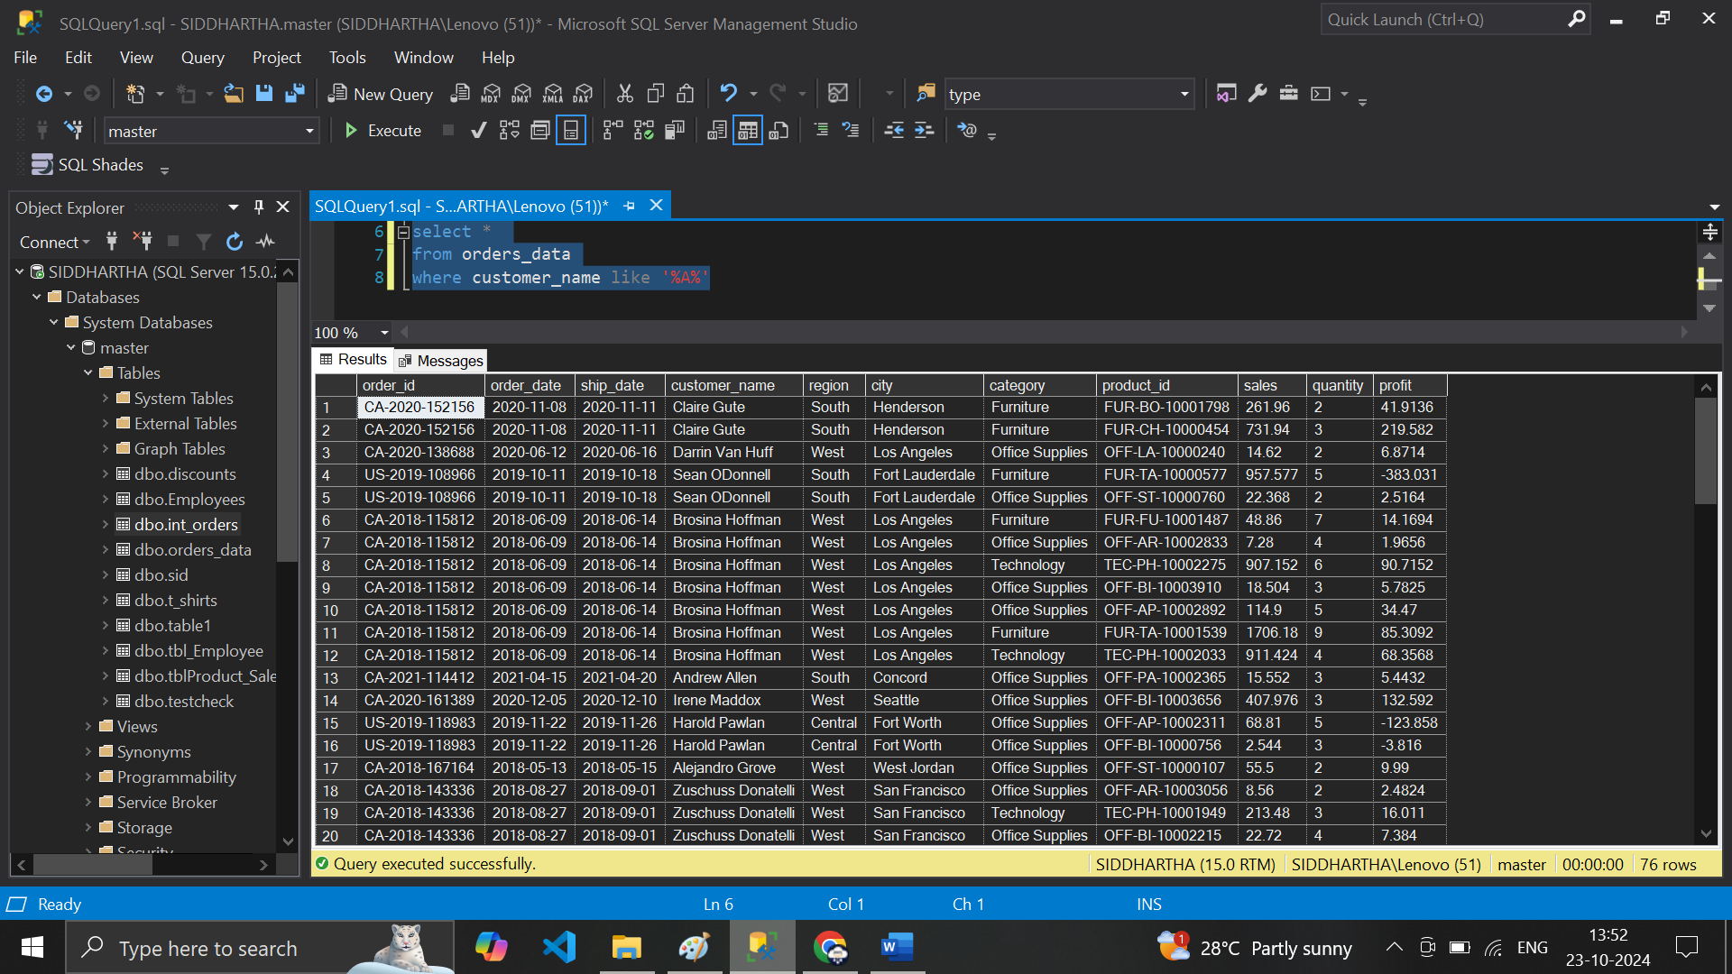

**# Customer name where second character Should be ‘e’**

**# 25 select * from orders_datawhere customer_name like '_e%'**

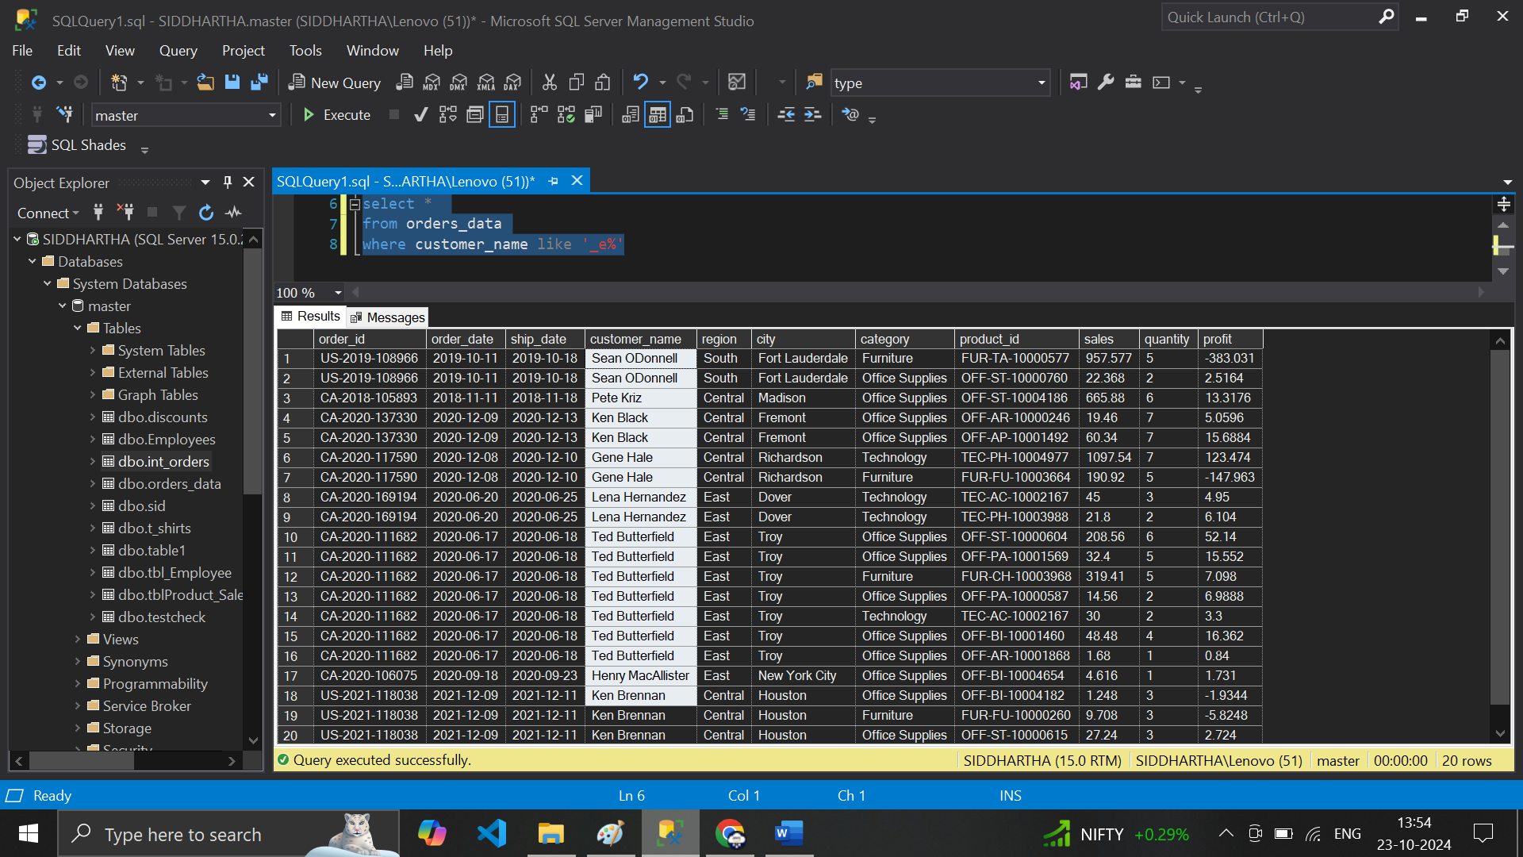

**# Customer name should have either one charater ‘a’ / ‘ ‘e’ in second place**

**# 26 select * from orders_data where customer_name like '_[ae]%'**

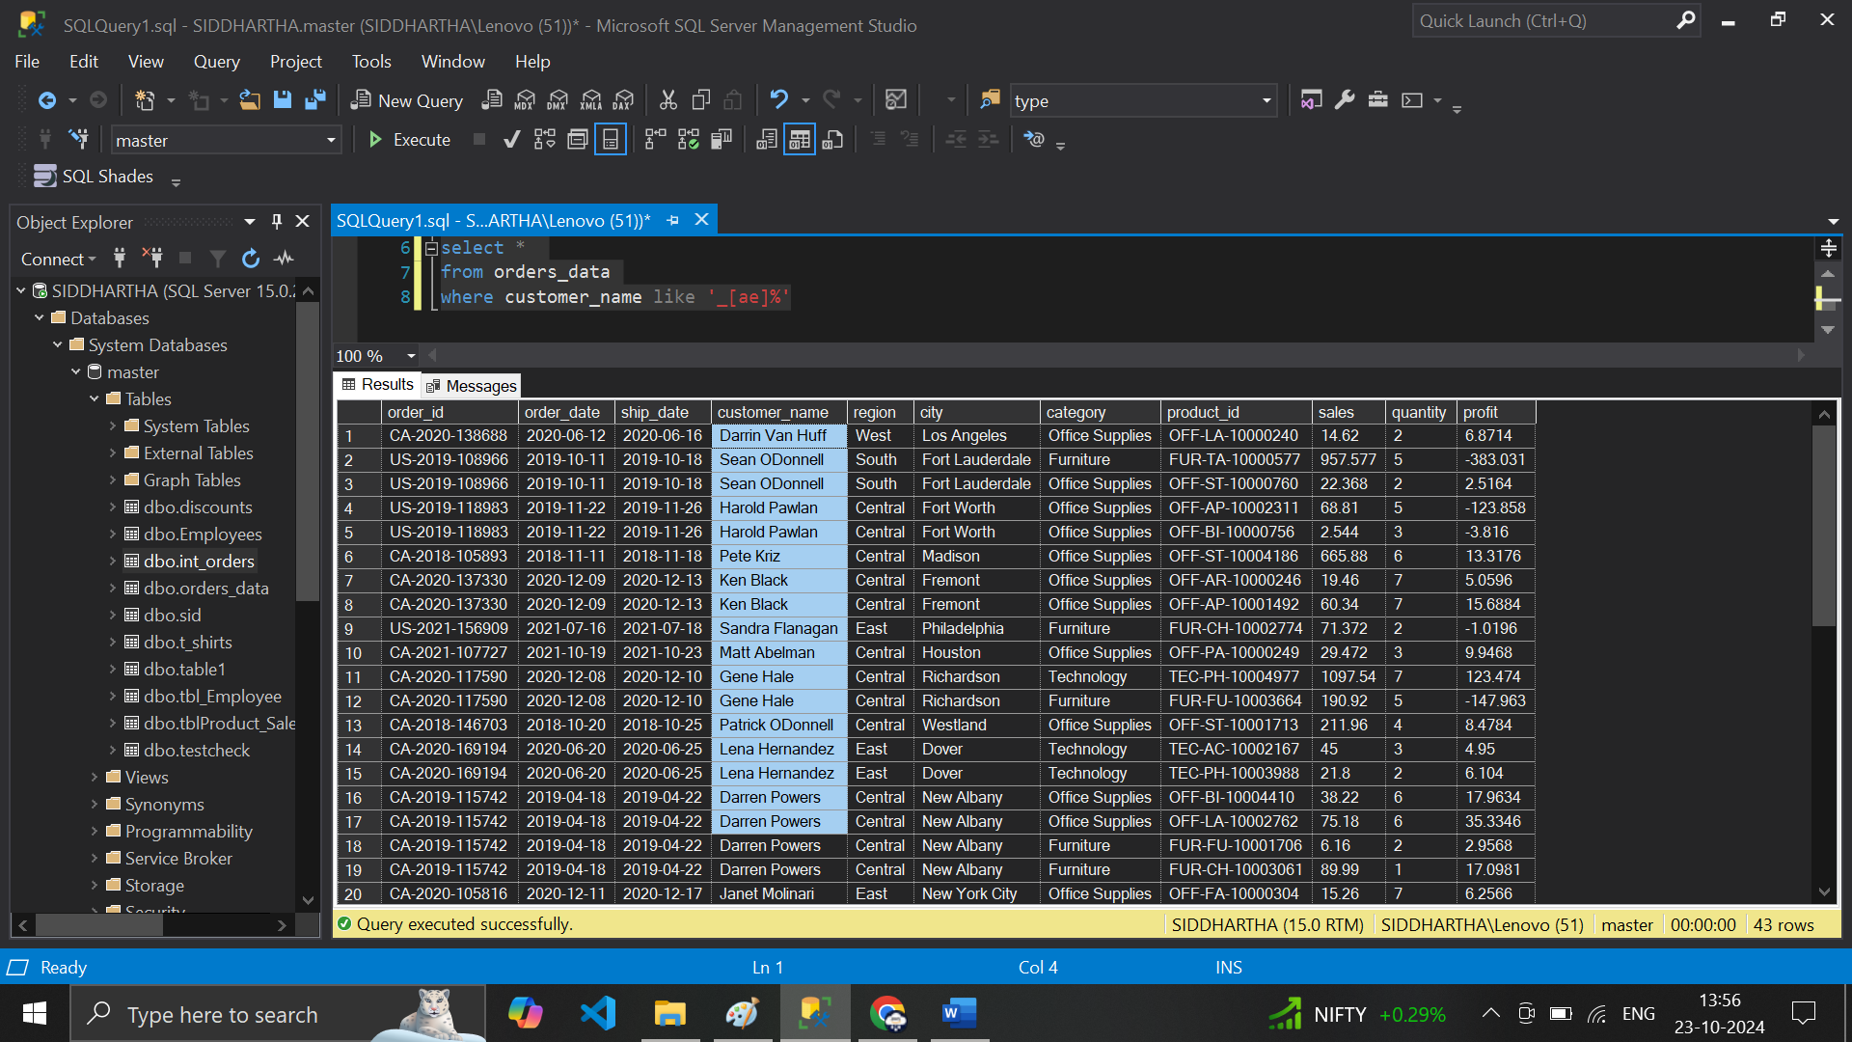

**# Customer name should have either one charater ‘a’ / ‘ ‘e’ in second place End with ‘n’**

**# 27 select * from orders_data where customer_name like '_[ae]%n**

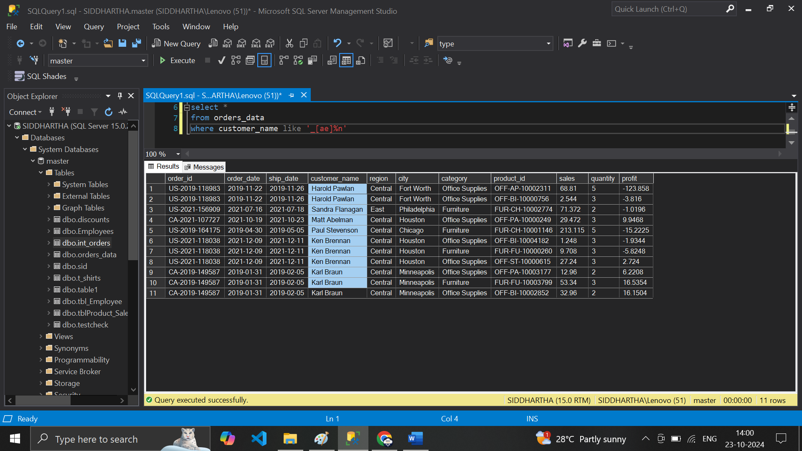**'**

**# Aggregate the sales data**

**# 28 select sum(sales) as Total_Sales from orders_data**

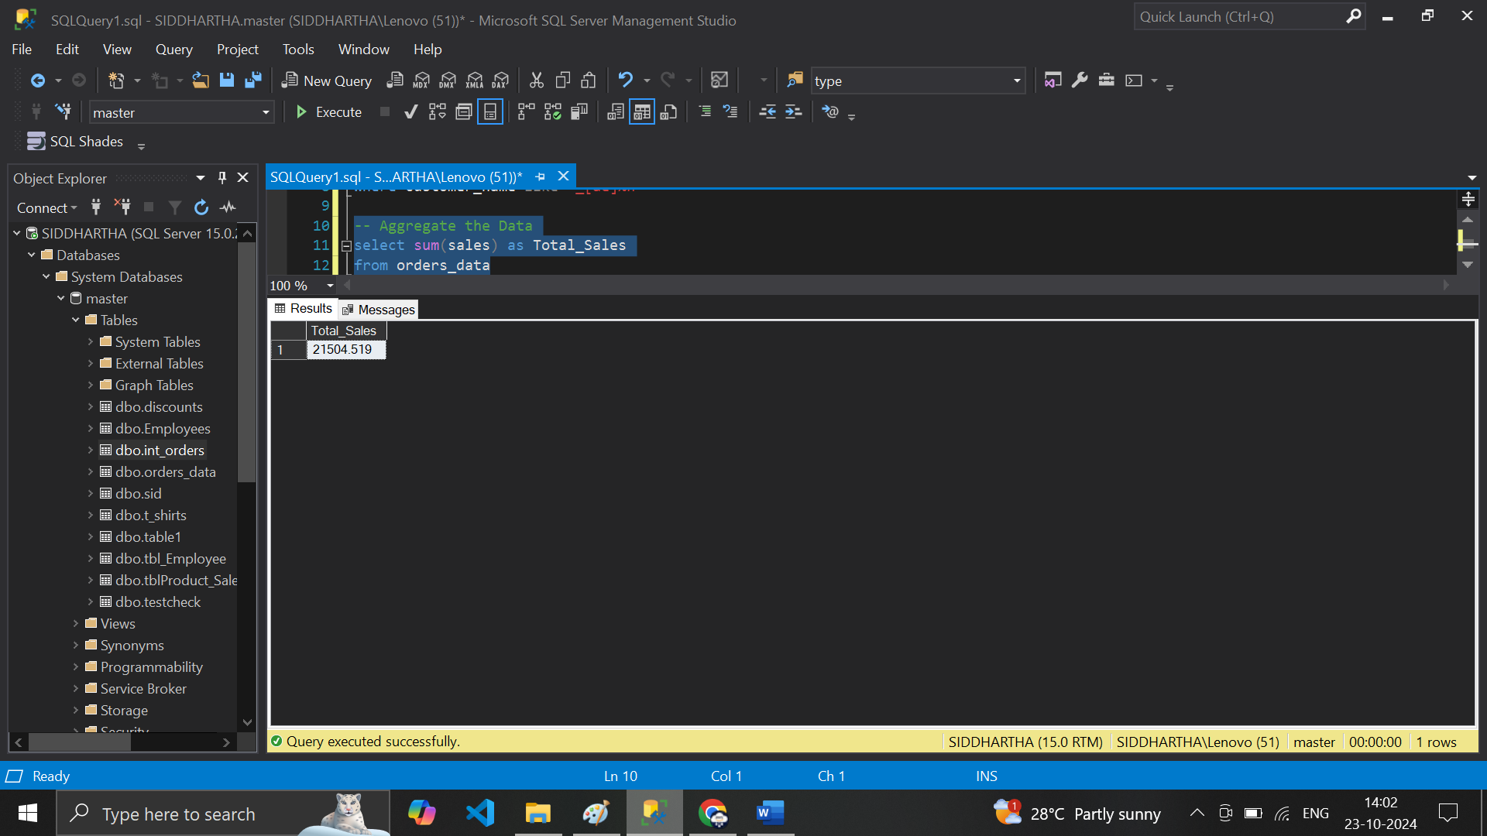

**# min Sale**

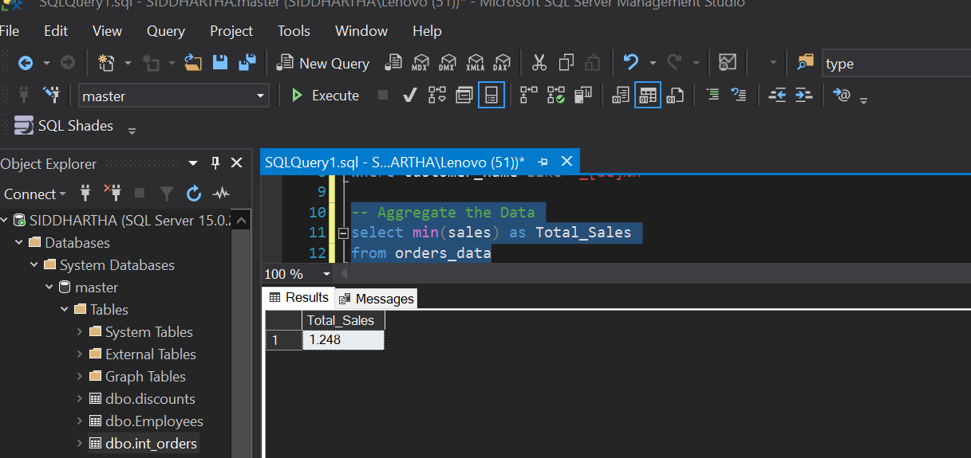

**# Max**

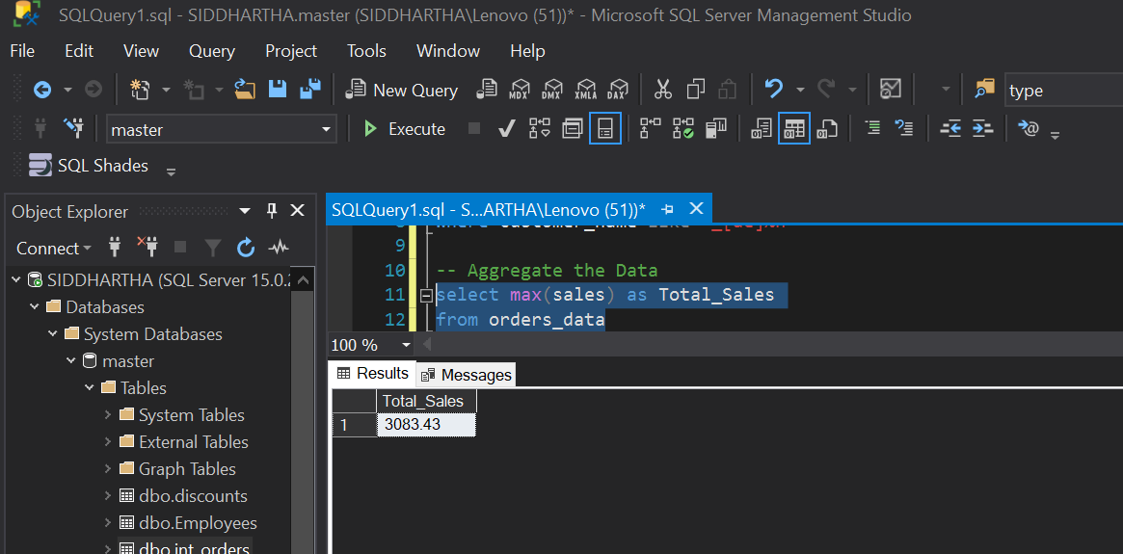

**# avg**

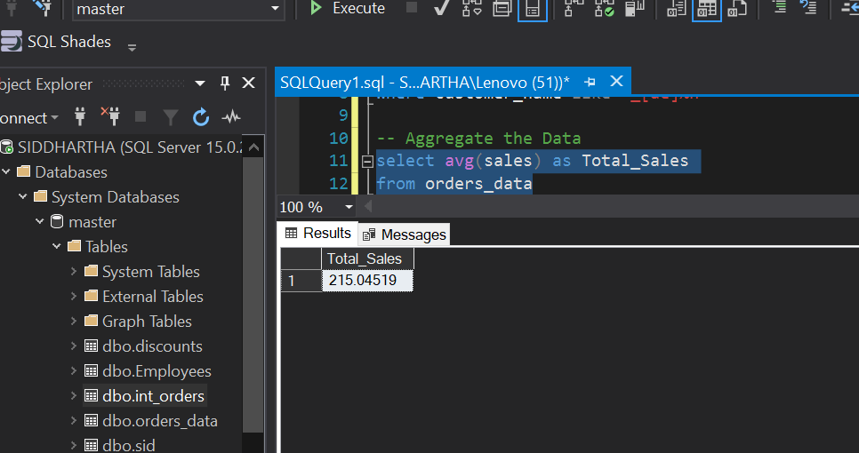

**# order by sales**

**# 30 select *from orders_data order by salesselect sum(sales) as Total_Salesfrom orders_data**

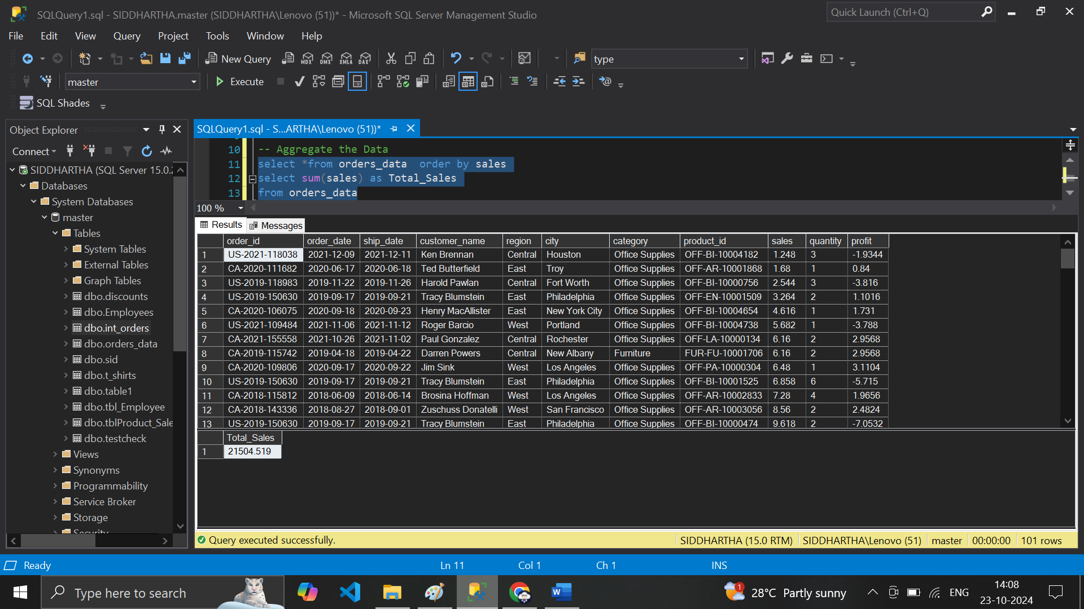

**# Count**

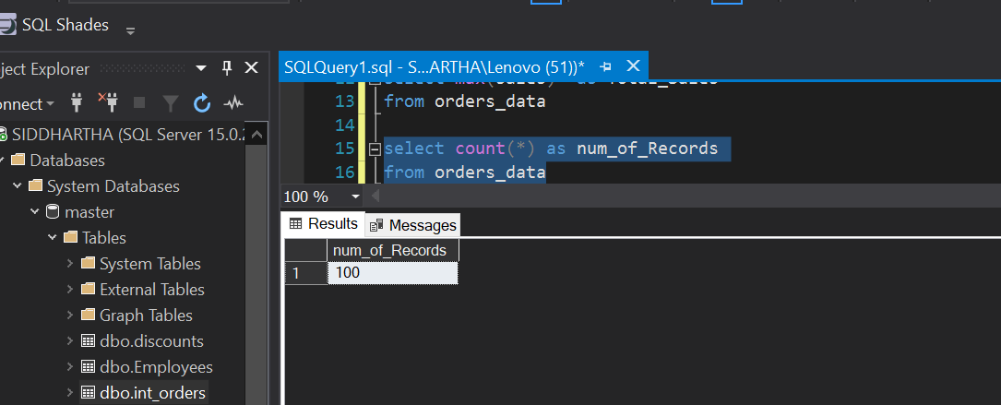

**# select avg(sales) as Avg_Sales from orders_data**

**# select sum(sales) /count(*) as Avg_salesfrom orders_data**

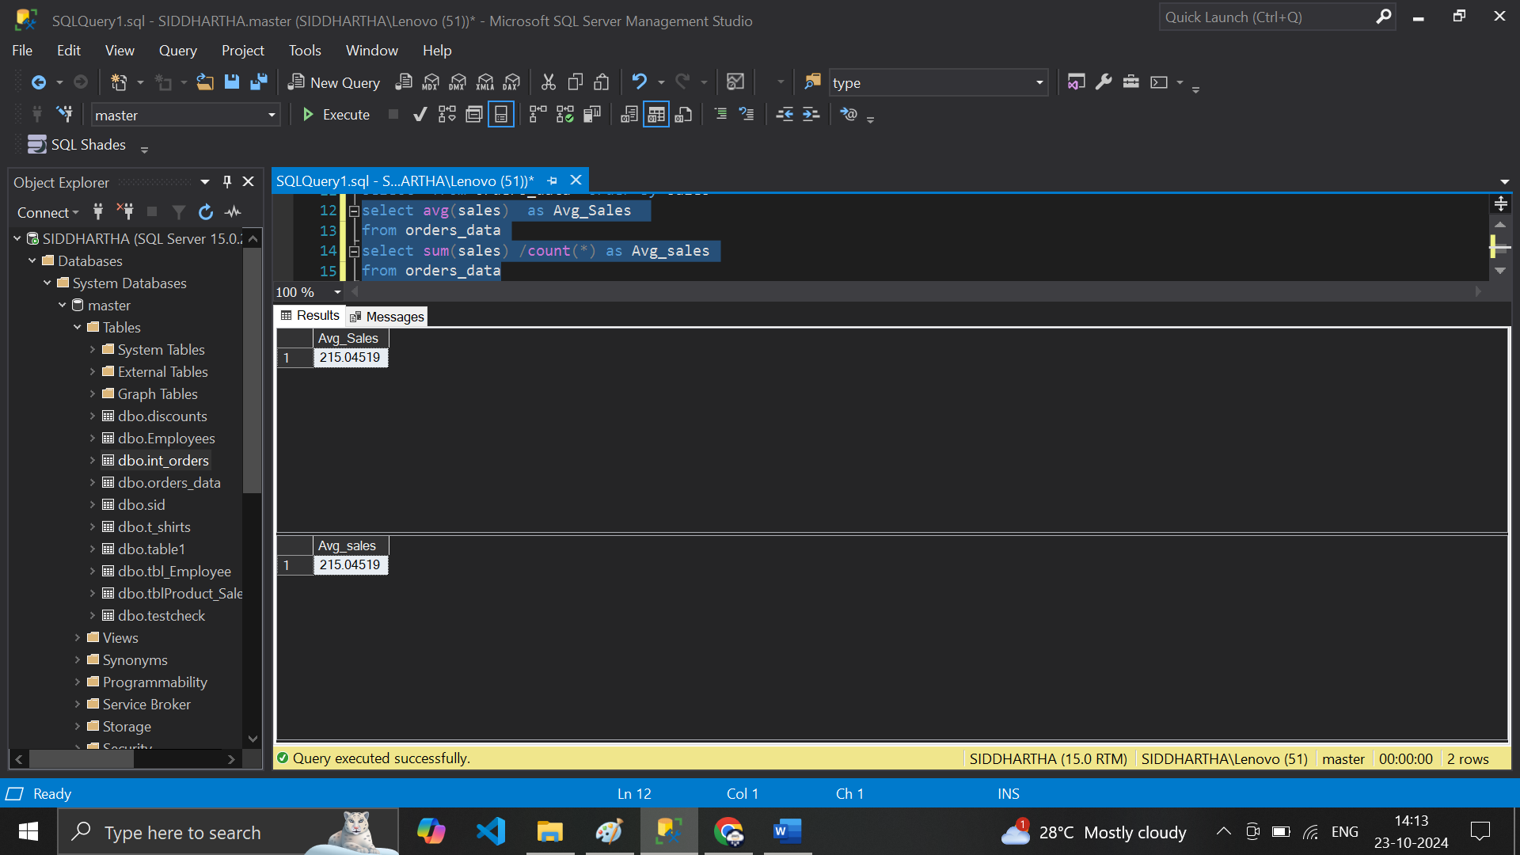

**# update**

**update orders_data set city=null where order_id in ('CA-2020-152156','US-2019-108966')**

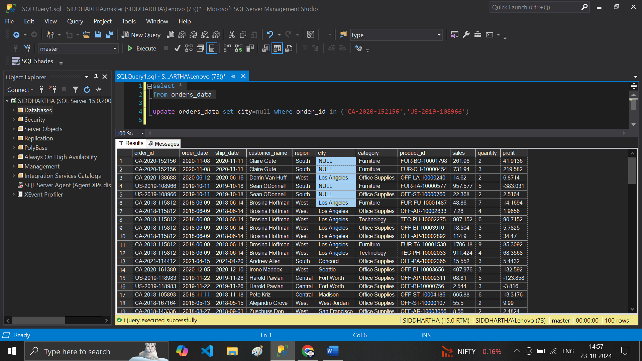

**# City is null**

**select *from orders_datawhere city is null**

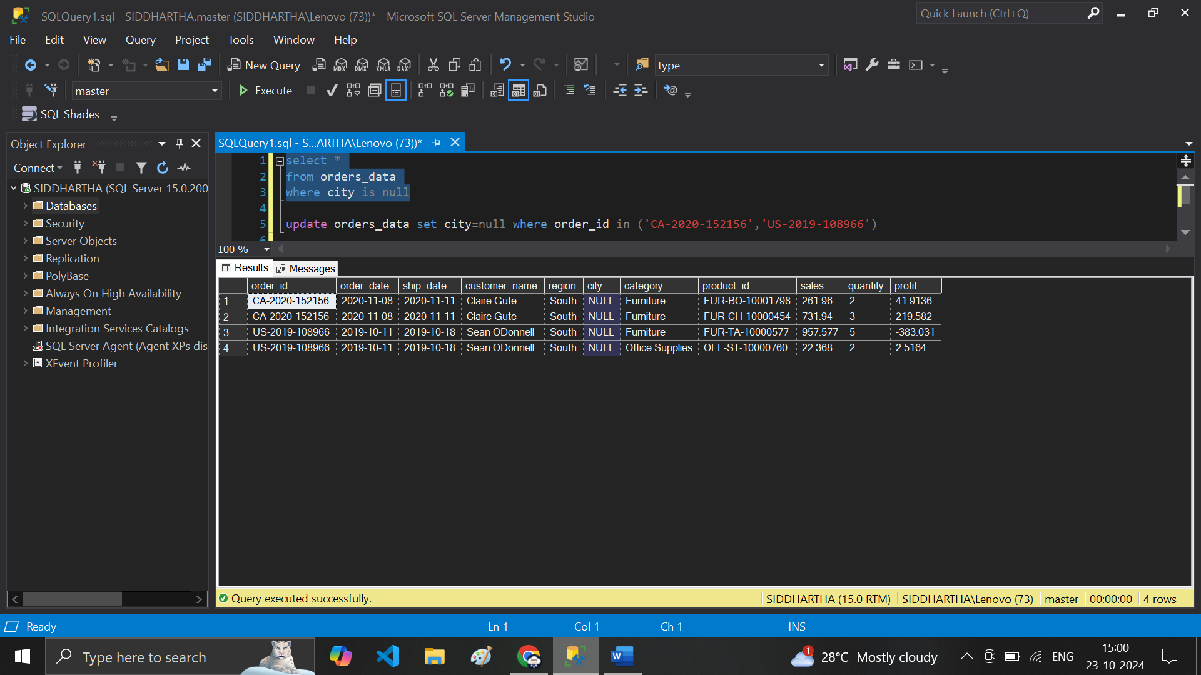

**# not null**

**select *from orders_datawhere city is not null**

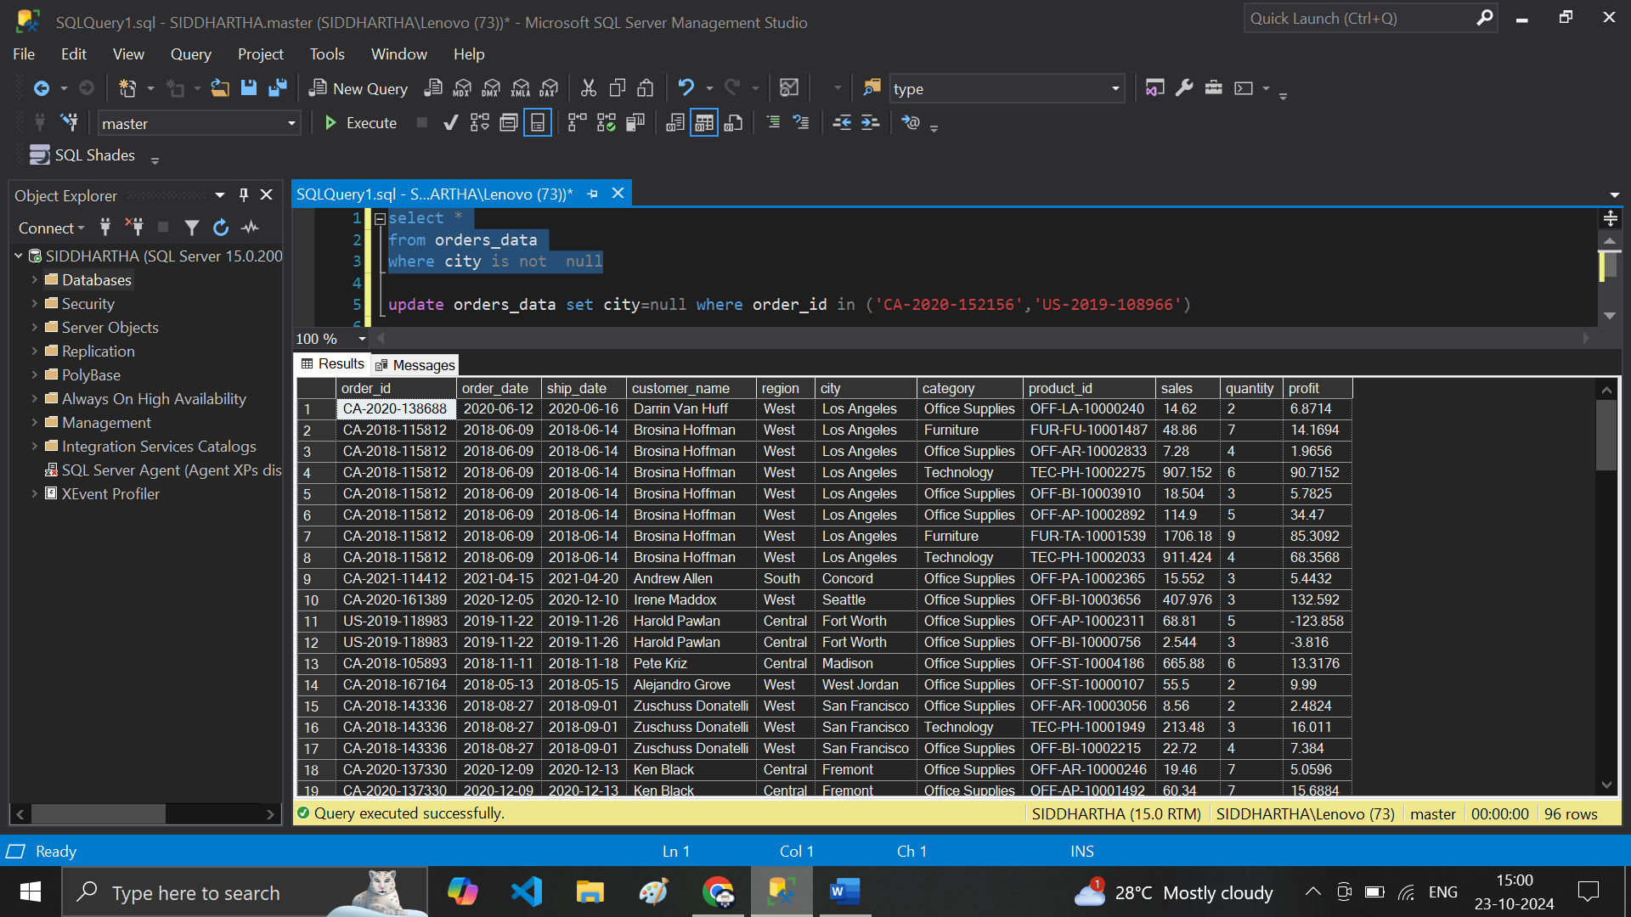

**# Toal records**

**select count(*) ,count(order_id),count(city) as Numb_of_Records from orders_data**

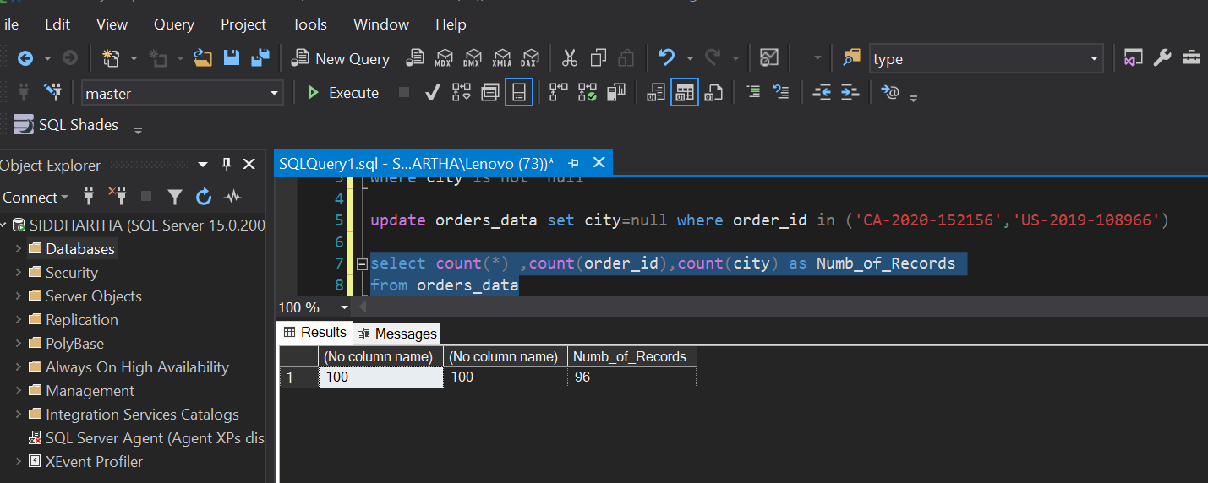

**# next**

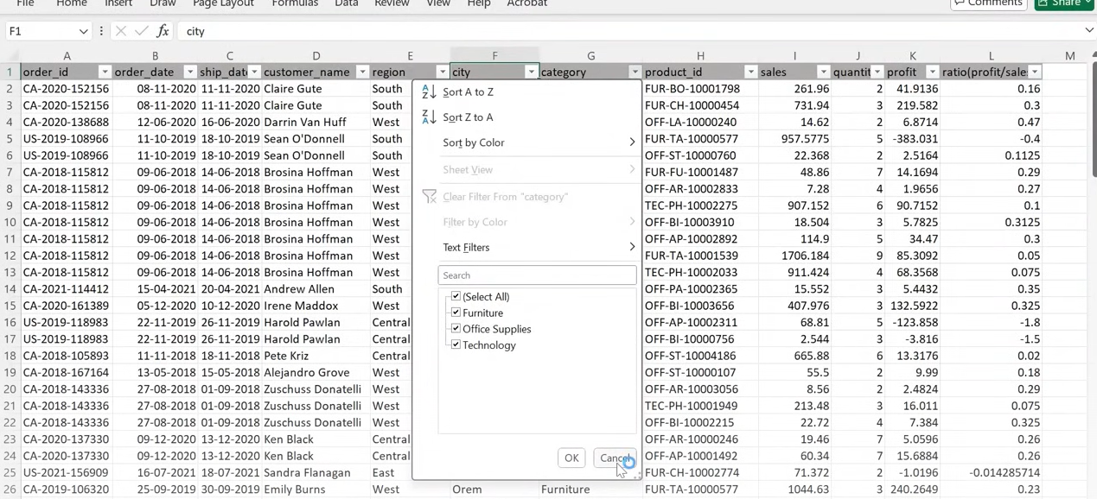

**# We need this list in SQL .. ?? how to Do this use Distinct Keyword**

**select distinct category from orders_data**

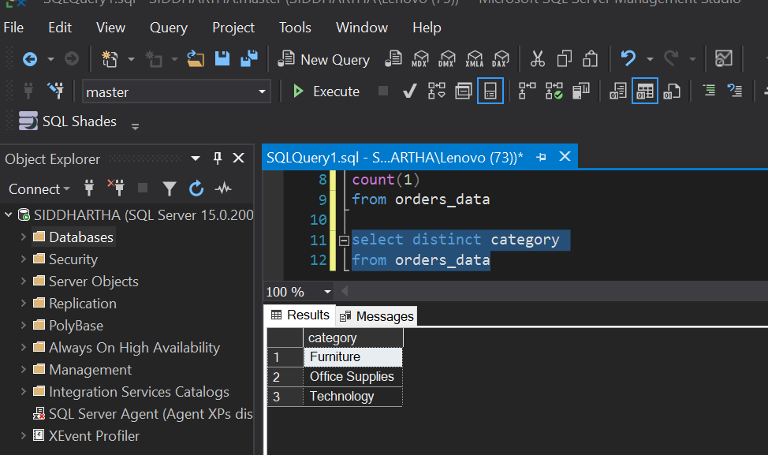

**# Region**

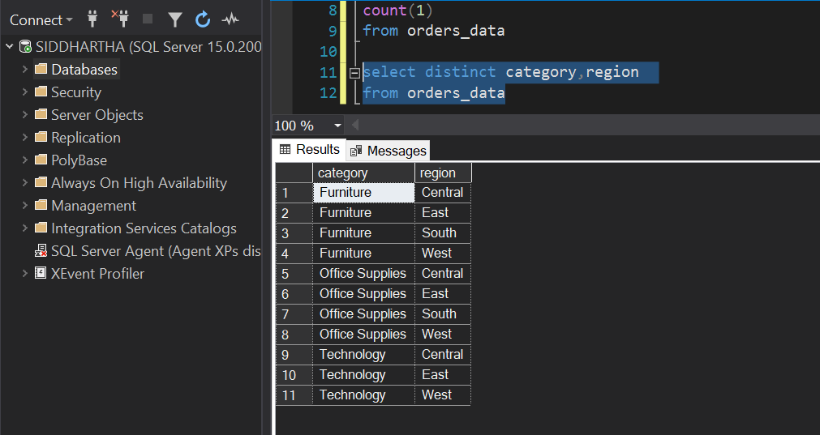

**select count( distinct category) as Category_col,count(distinct region) as region_col**

**from orders_data**

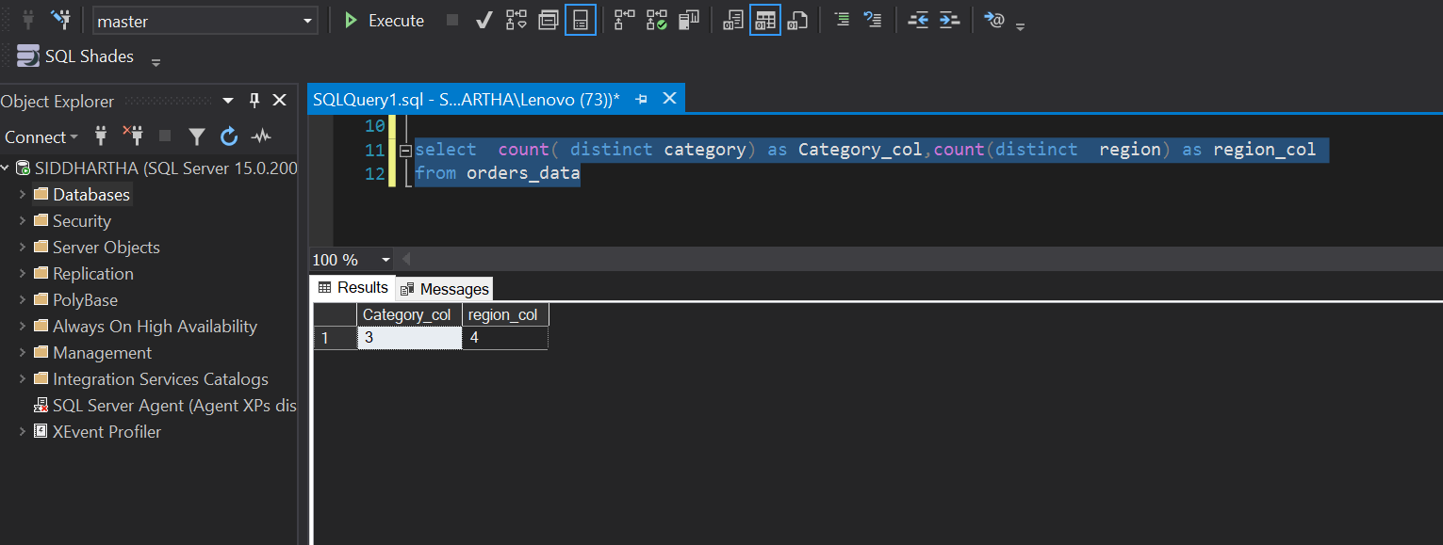

**# Pivot Table**

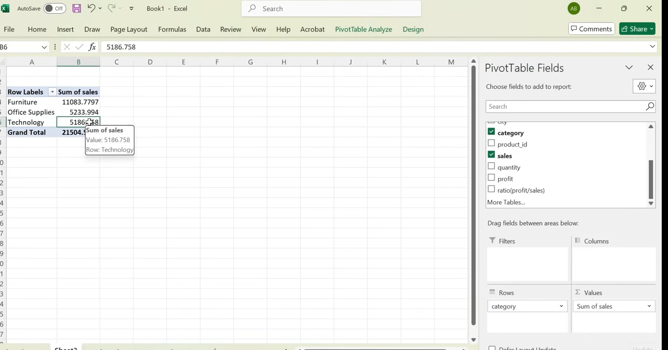

**# SQL – Group By -- Data Matching**

**select category , sum(sales) as Category_salesfrom orders_data group by category**

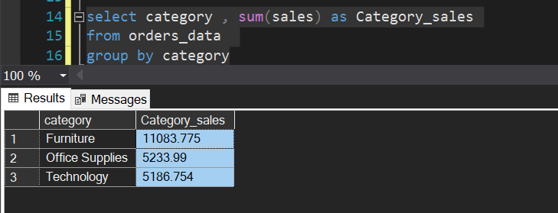

**# For Profit**

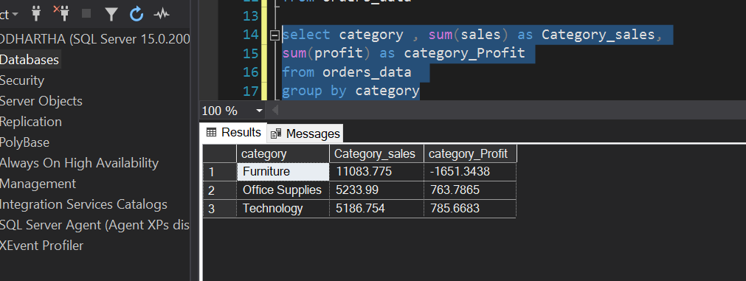

**# By Region**

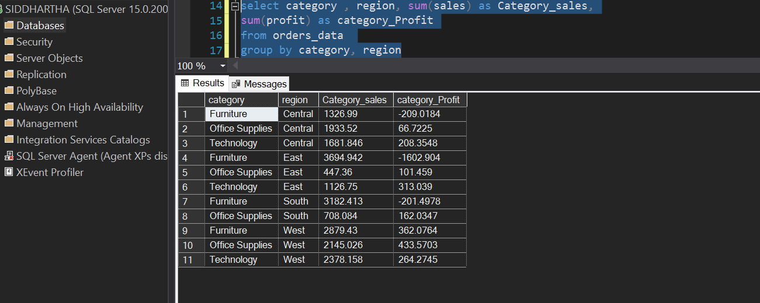

**# check in Pivot – for Data validation**

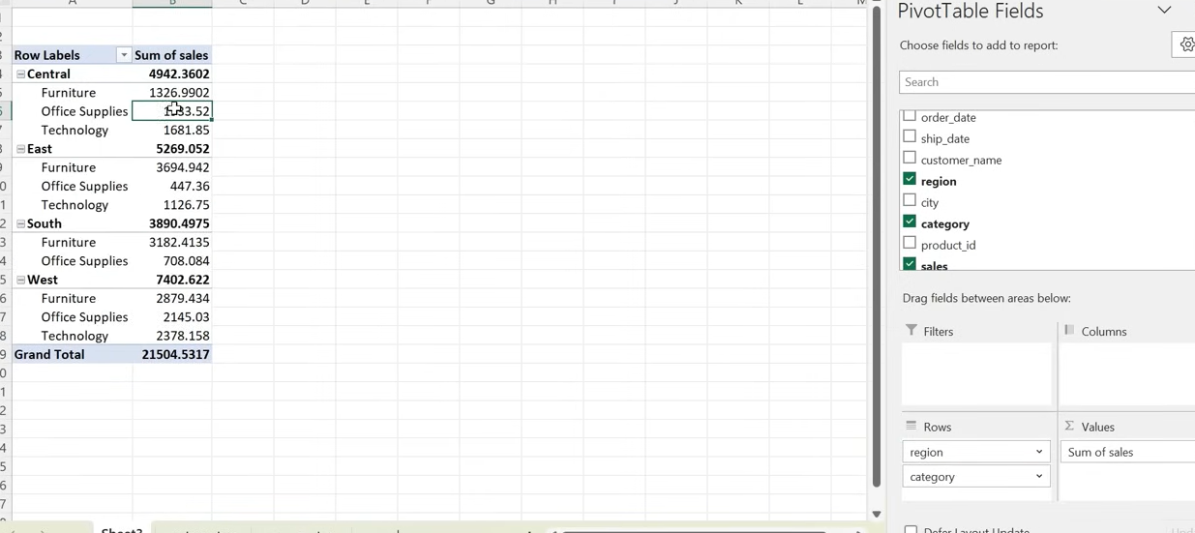

**# now question .. I need sales @ least 100 from any city**

**select city , sum(sales) as sales_city from orders_data group by cityhaving sum(sales) >=1000**

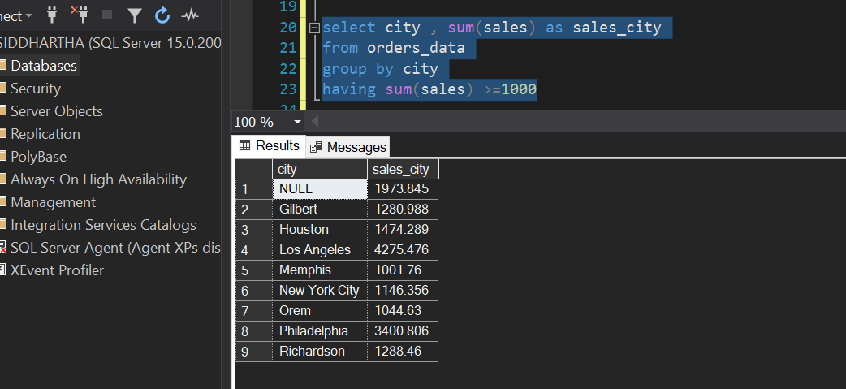

**# Region**

**select city , sum(sales) as city_salesfrom orders_datawhere region='West'group by city**

**having sum(sales) >1000**

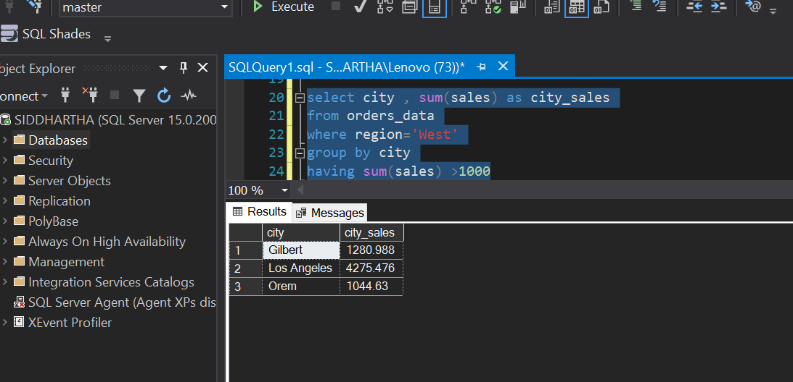



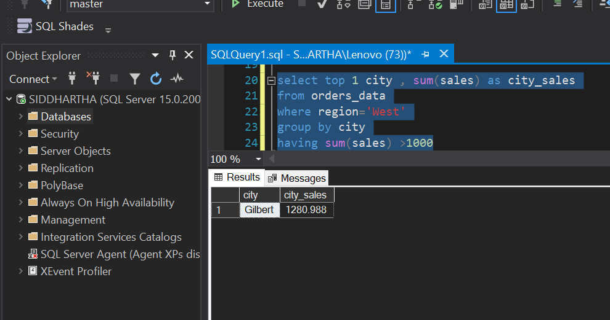

**# Returns Data Details – mentioned in notepad file**

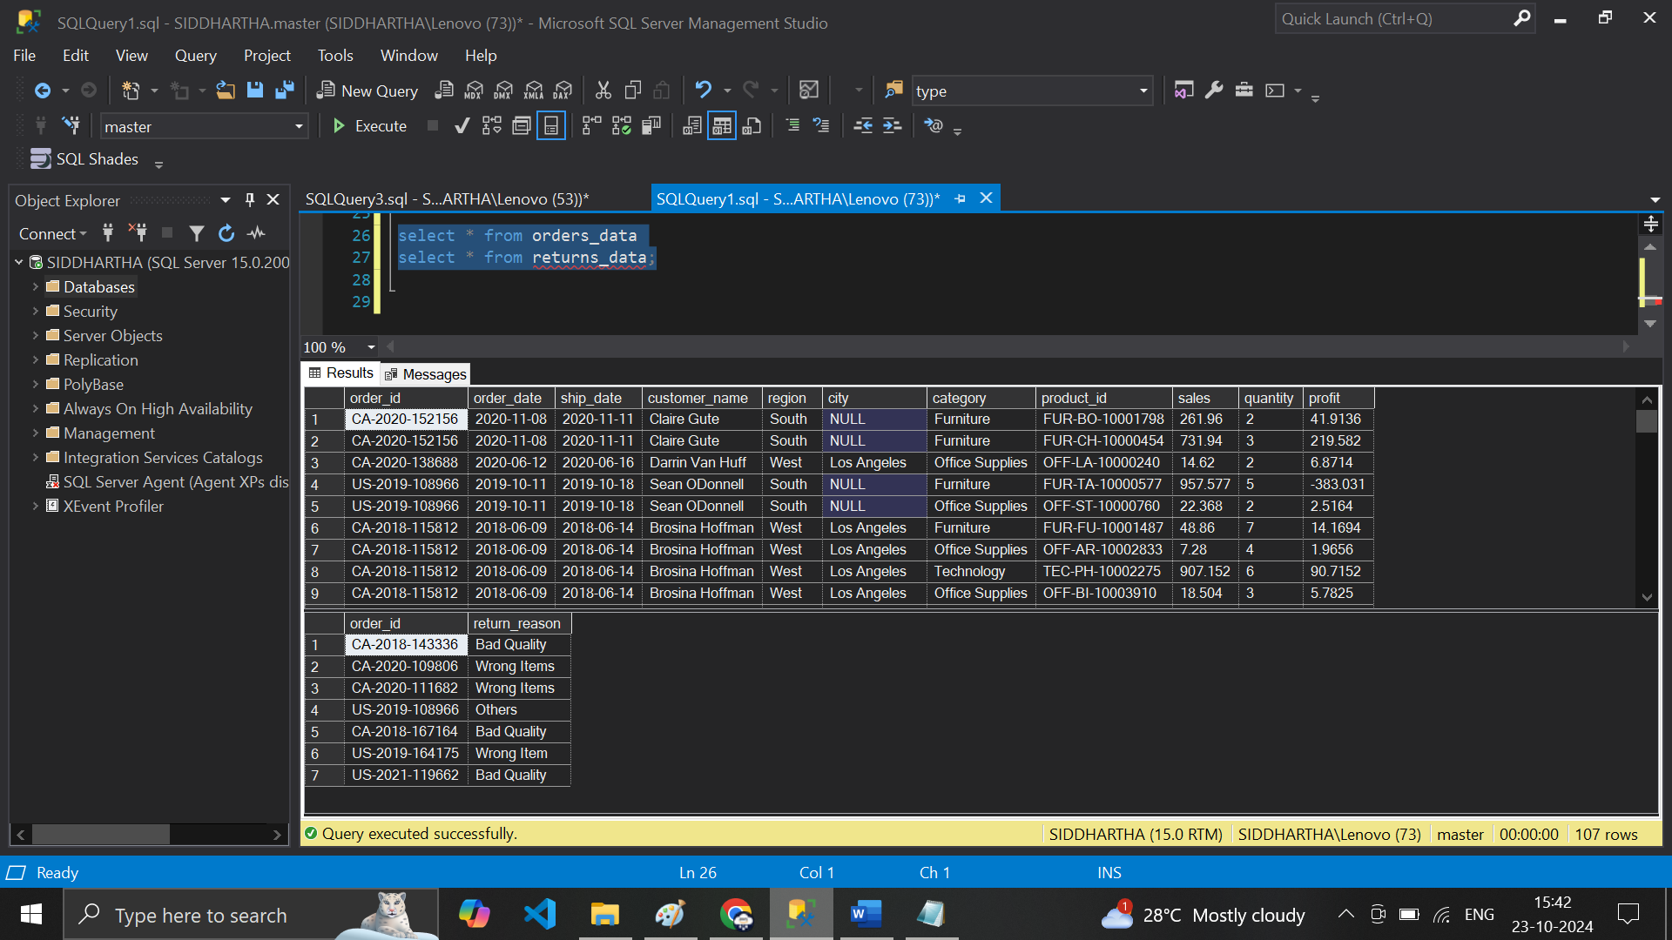

**# analysis Total Sales of Return Order**

**# Go to Excel use V-Lookup .. on order_id**

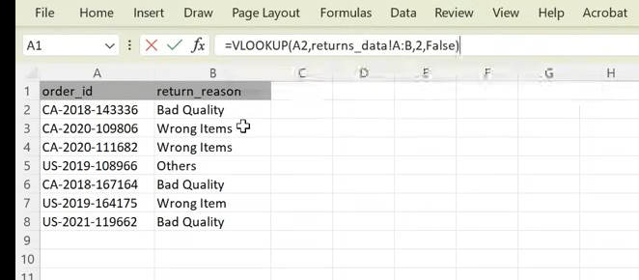

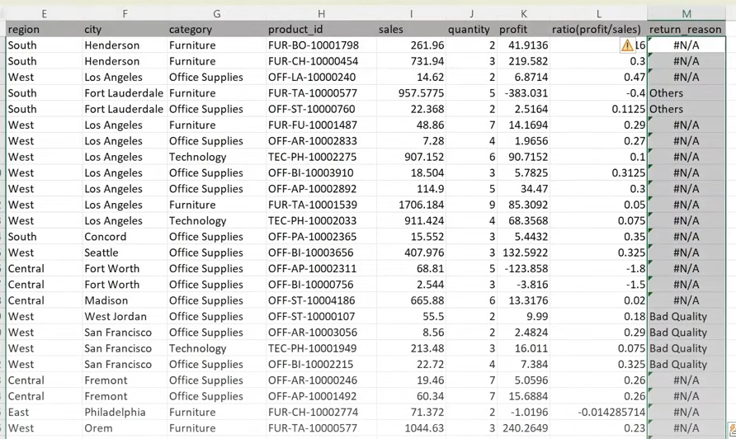

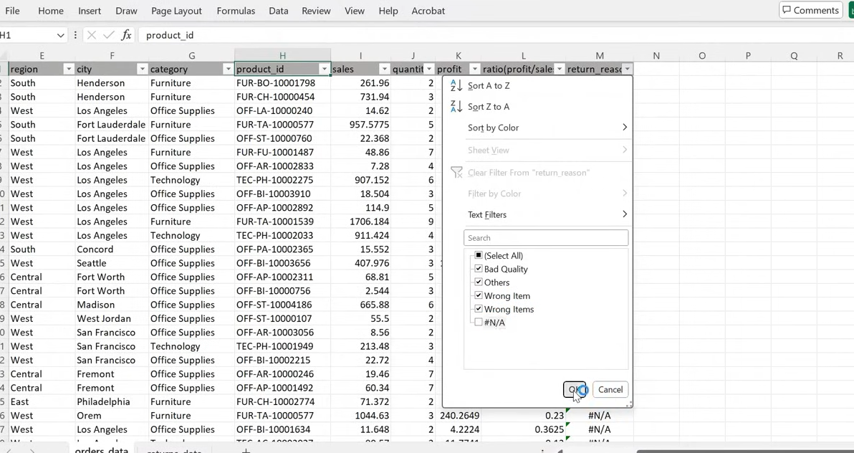

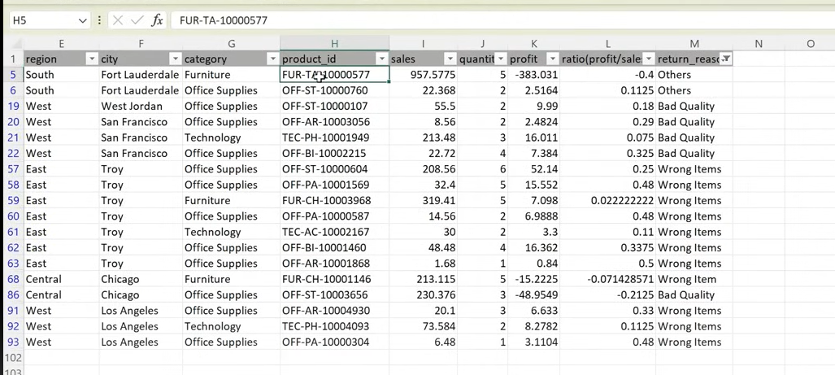

**We must have 7 distinct order_id**

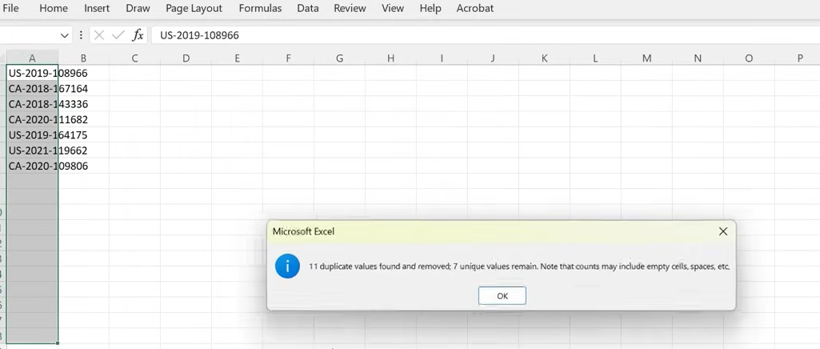

**# 18 Rows**

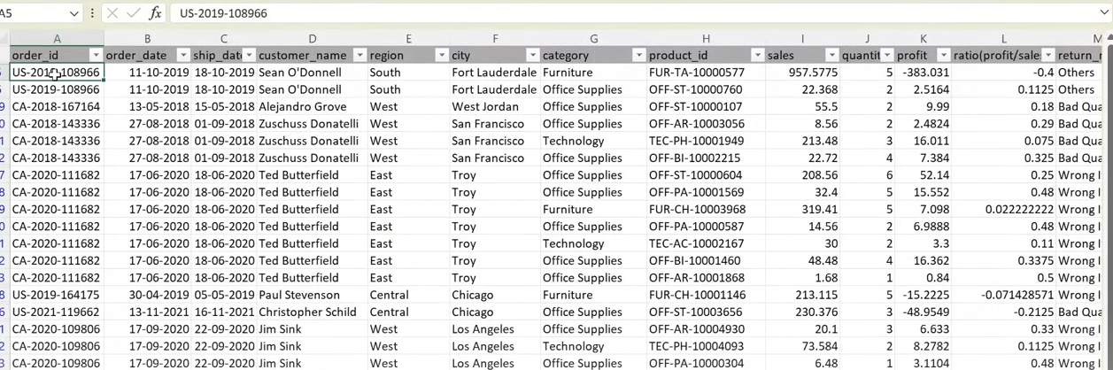

**select * from orders_data inner join returns_data on orders_data.order_id =returns_data.order_id**

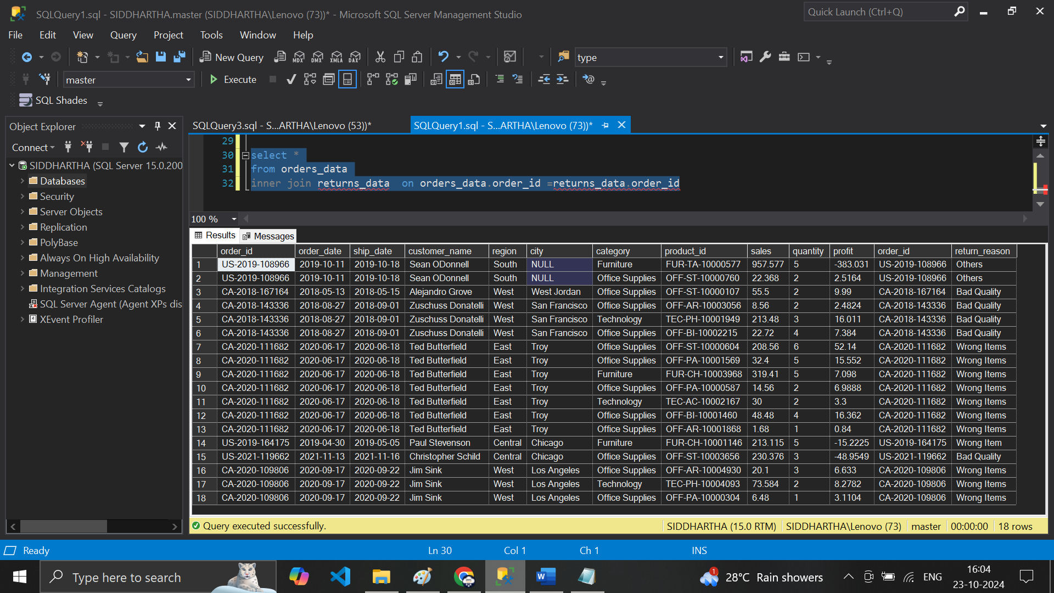

**# now Calculate Total Sales**

**# Joins**

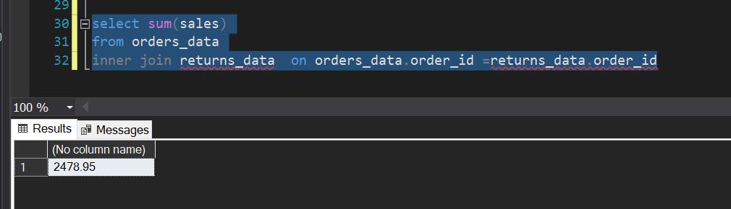

**# Category sales**

**select category, sum(sales) from orders_data**

**inner join returns_data on orders_data.order_id =returns_data.order_id group by category**

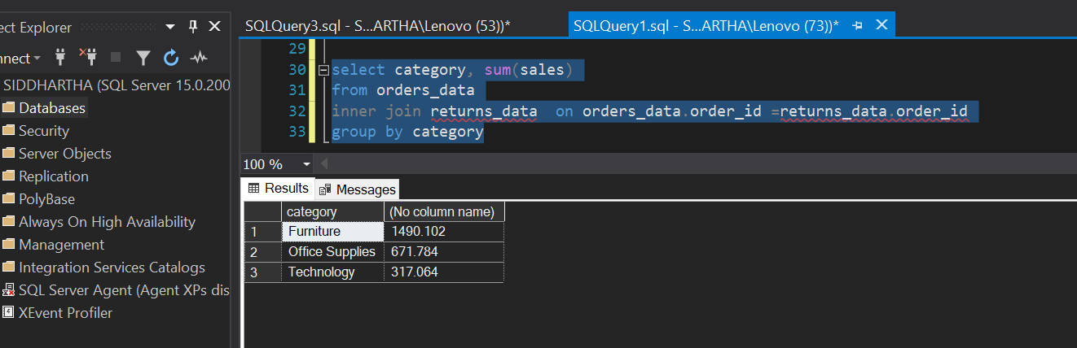

**# Go back two Tables Combined & Check the return_reasons one by one**

**select *from orders_datainner join returns_data on orders_data.order_id =returns_data.order_id**

**where return_reason='Wrong items'**

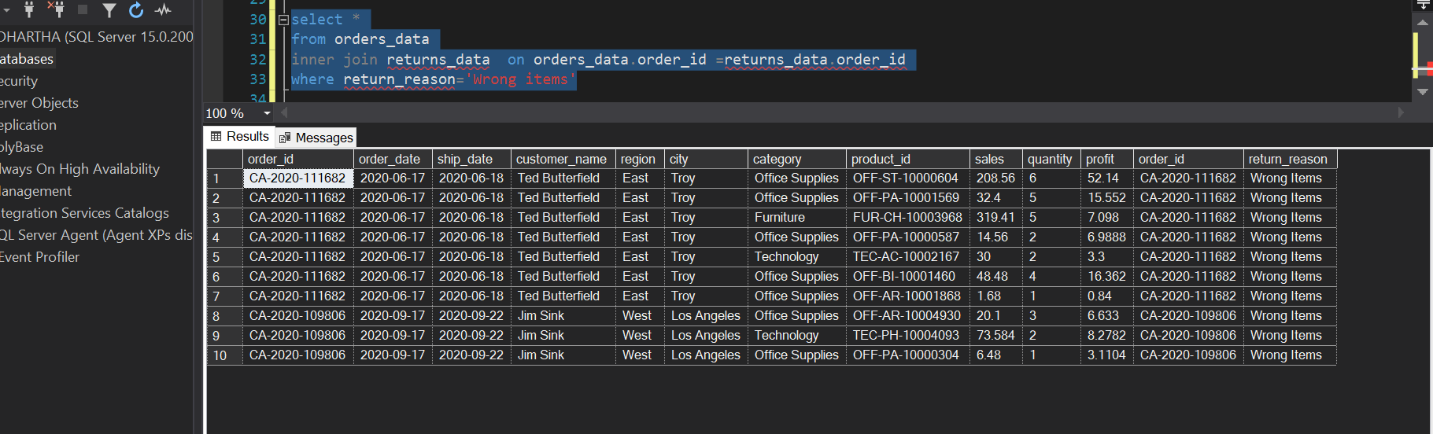

**# Check by City**

**select *from orders_datainner join returns_data on orders_data.order_id =returns_data.order_id**

**where return_reason='Wrong items' and city='Los Angeles'**

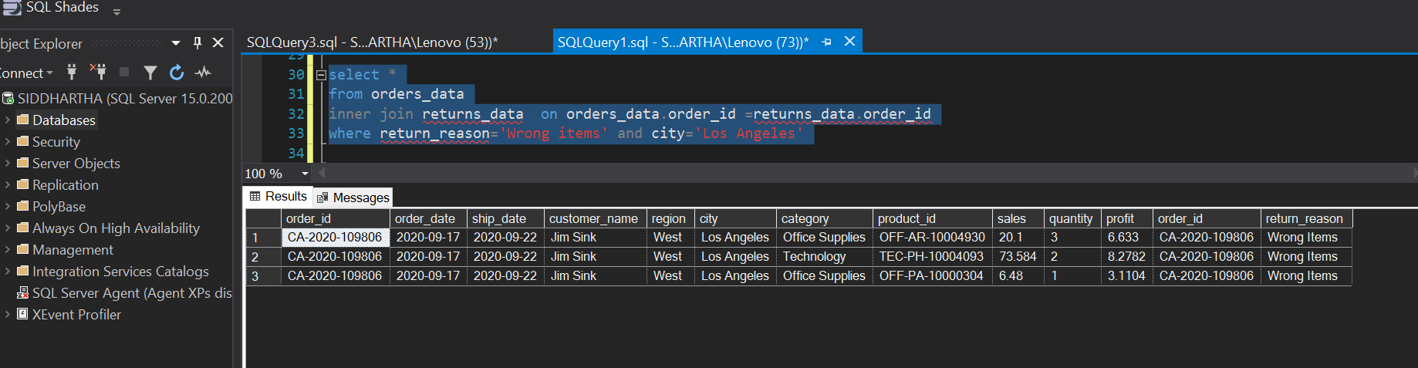

**# particular order_id from any 1 of the table**

**select *from orders_data inner join returns_data on orders_data.order_id =returns_data.order_id where orders_data.order_id='US-2019-108966'**

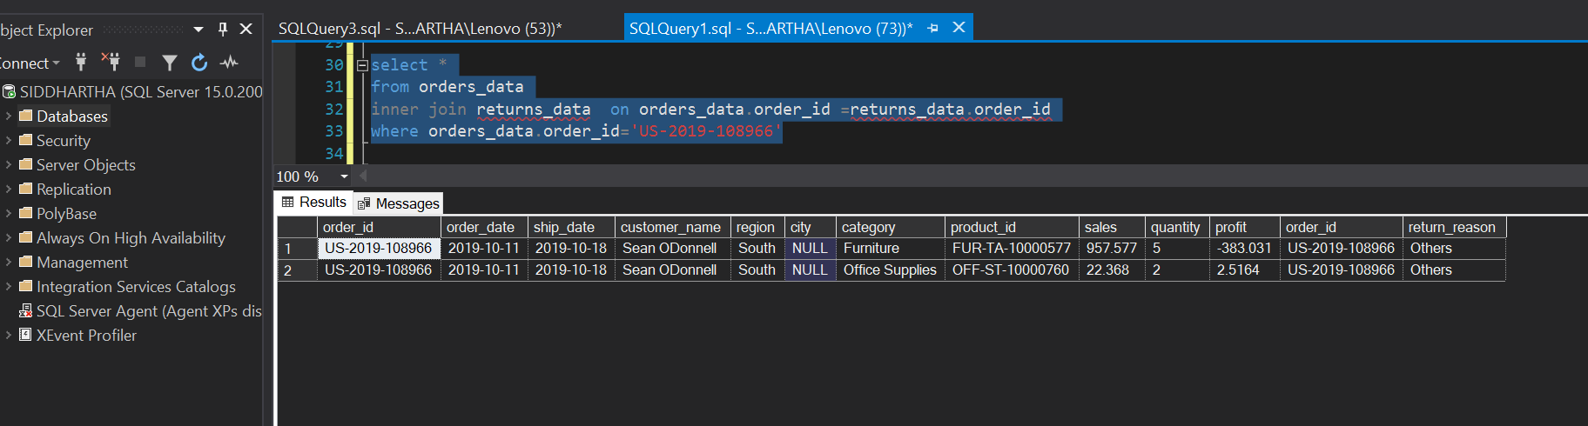

**# use alias in the table to look Simple & elegant**

**select *from orders_data o inner join returns_data r on o.order_id =r.order_id**

**where o.order_id='US-2019-108966'**

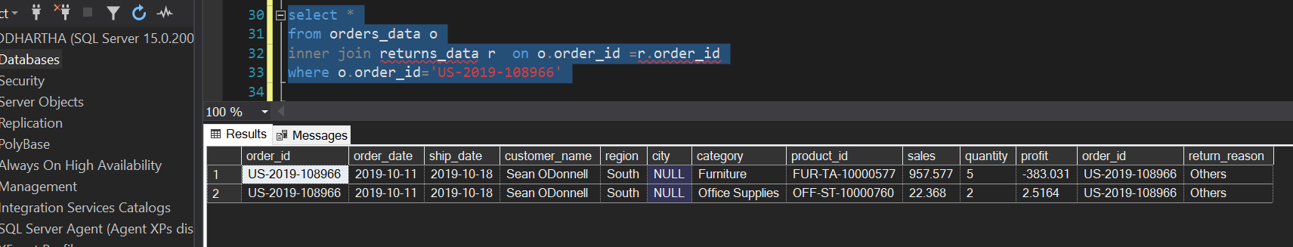

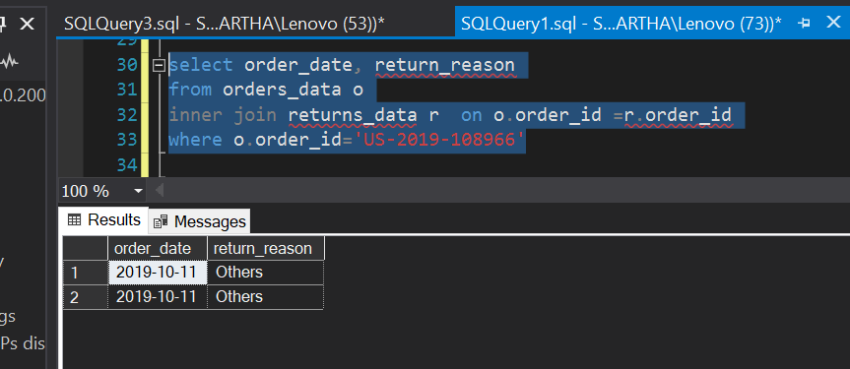

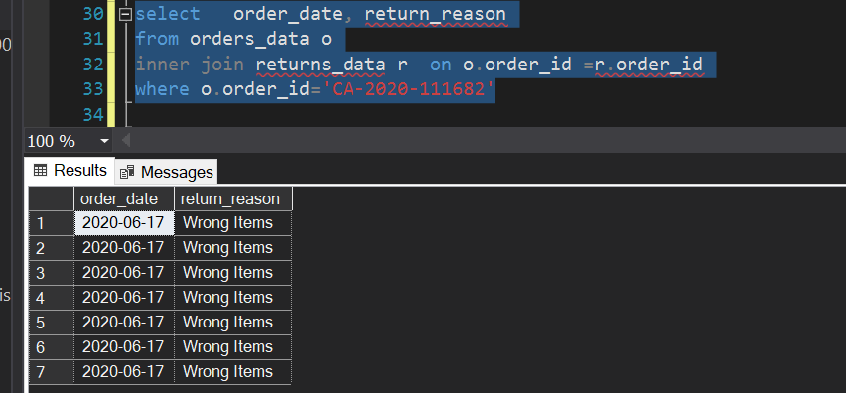

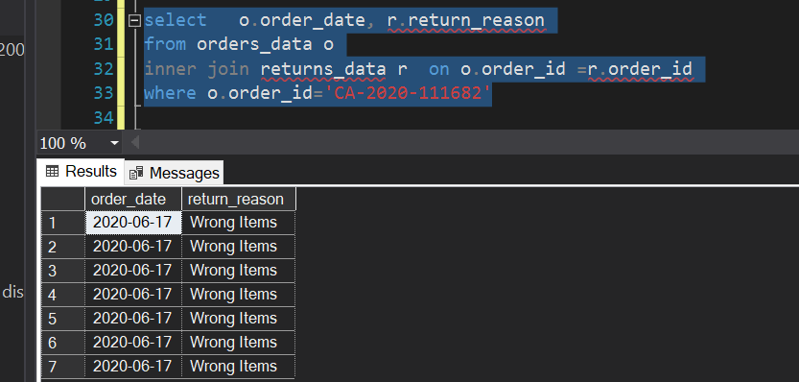



**# now Return the Data where Return_reason als include N/A**

**select *from orders_data o left join returns_data r on o.order_id =r.order_id**

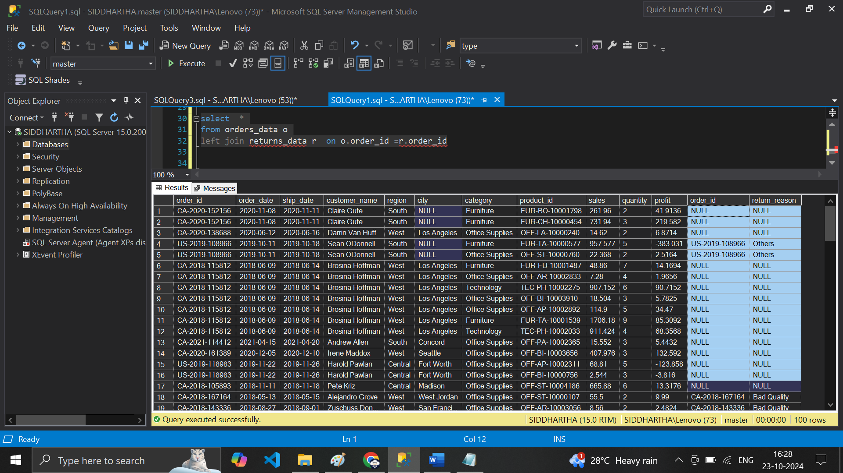**------- Return_reason is null**

**select * from orders_data o left join returns_data r on o.order_id =r.order_id**

**where r.return_reason is null**

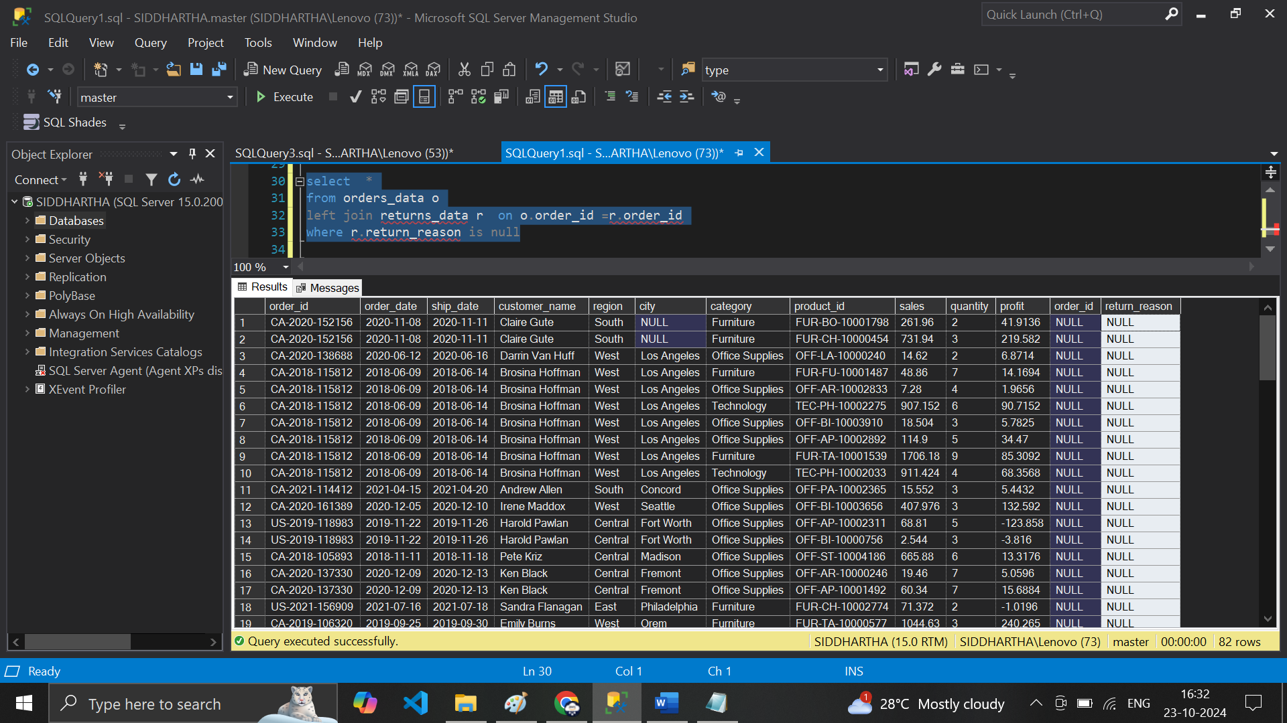

**# all the data in two table using * clause**

**# 1st with first Table o.\***

**select o.*from orders_data o inner join returns_data r on o.order_id =r.order_id**

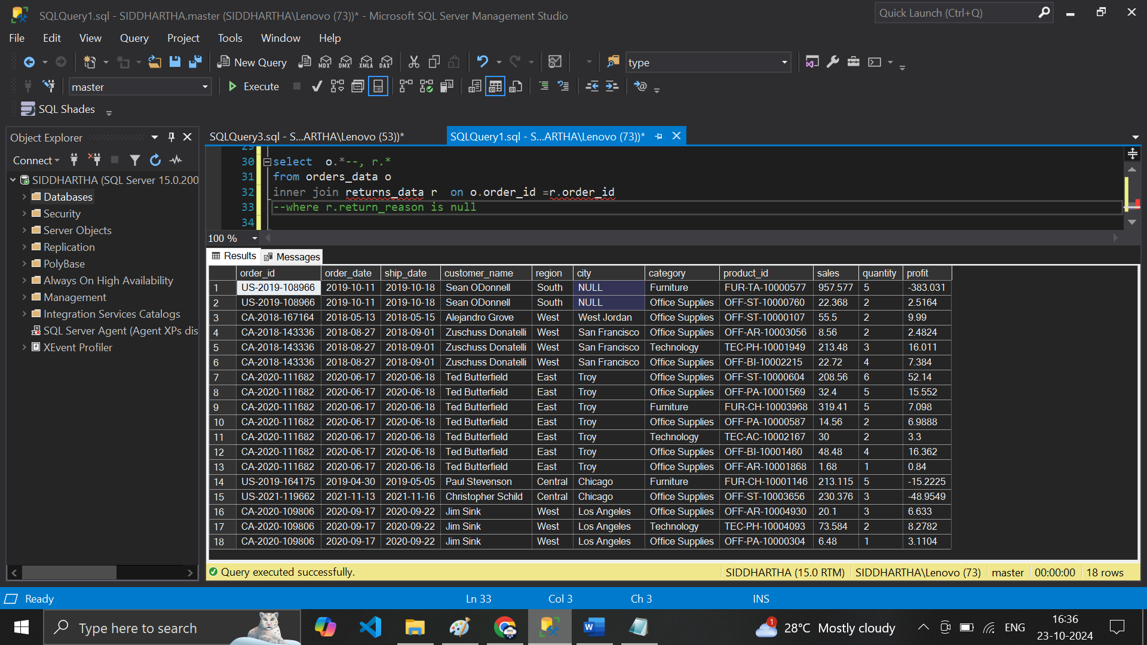

**# 2nd Table**

**select r.* --o.* from orders_data o inner join returns_data r on o.order_id =r.order_id**

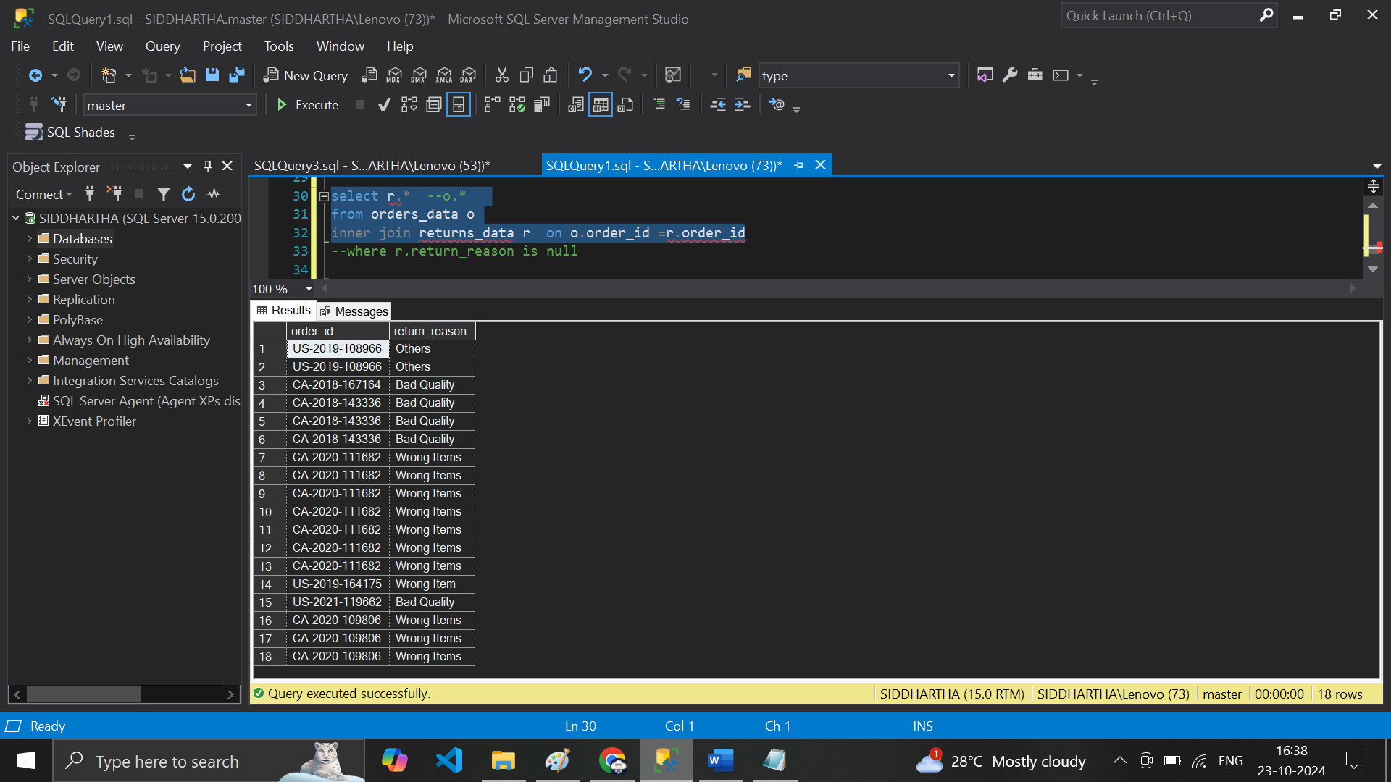

**# final -- both combined table --- o.* + r.\***

**select r.* , o.* from orders_data o inner join returns_data r on o.order_id =r.order_id**

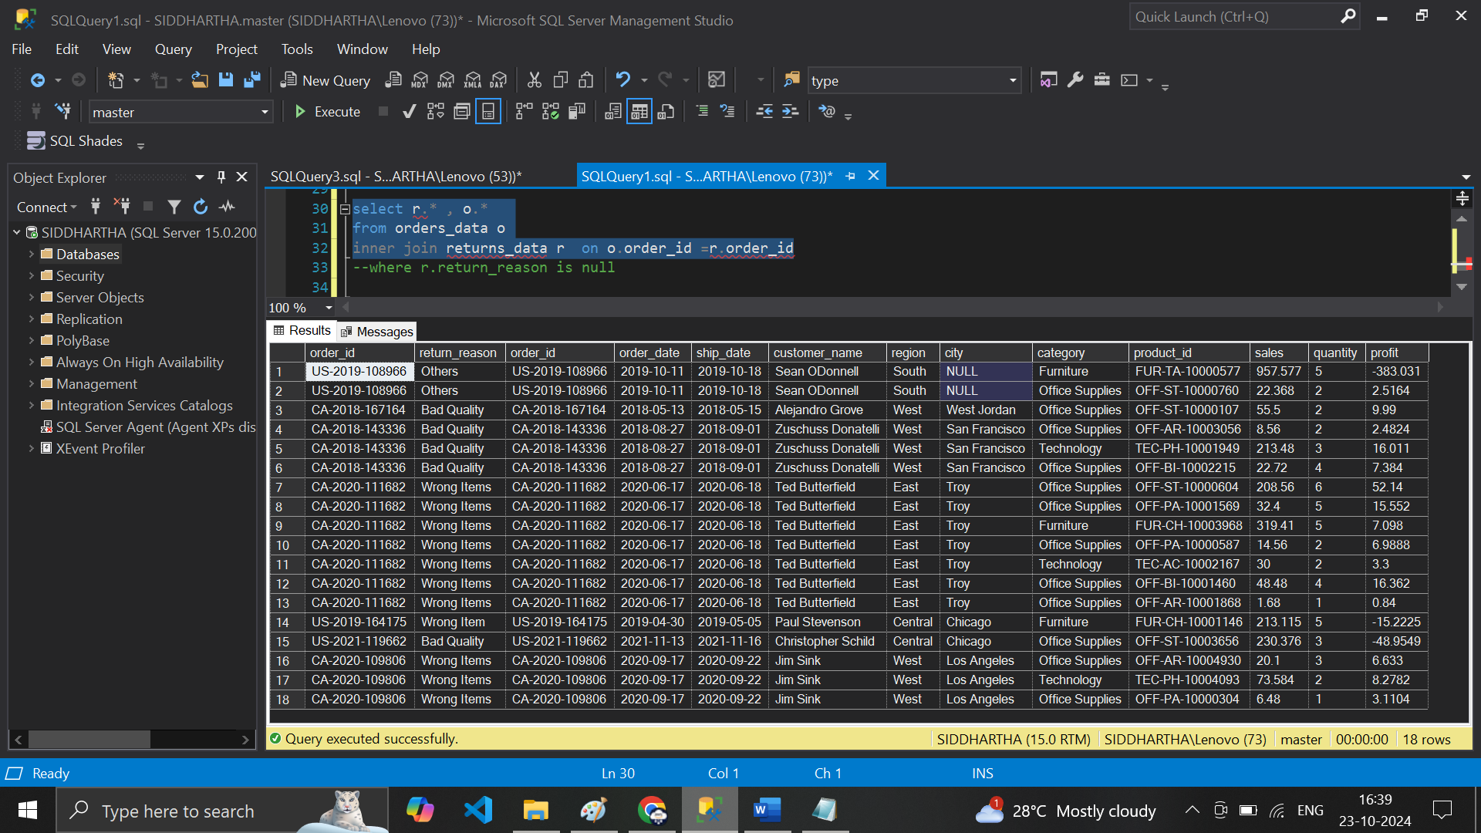

**# I need one columns from Table 2 .. return_reason only & all table from Table 1 – orders_Data**

**select o.*, r.return_reason from orders_data oinner join returns_data r on o.order_id =r.order_id**

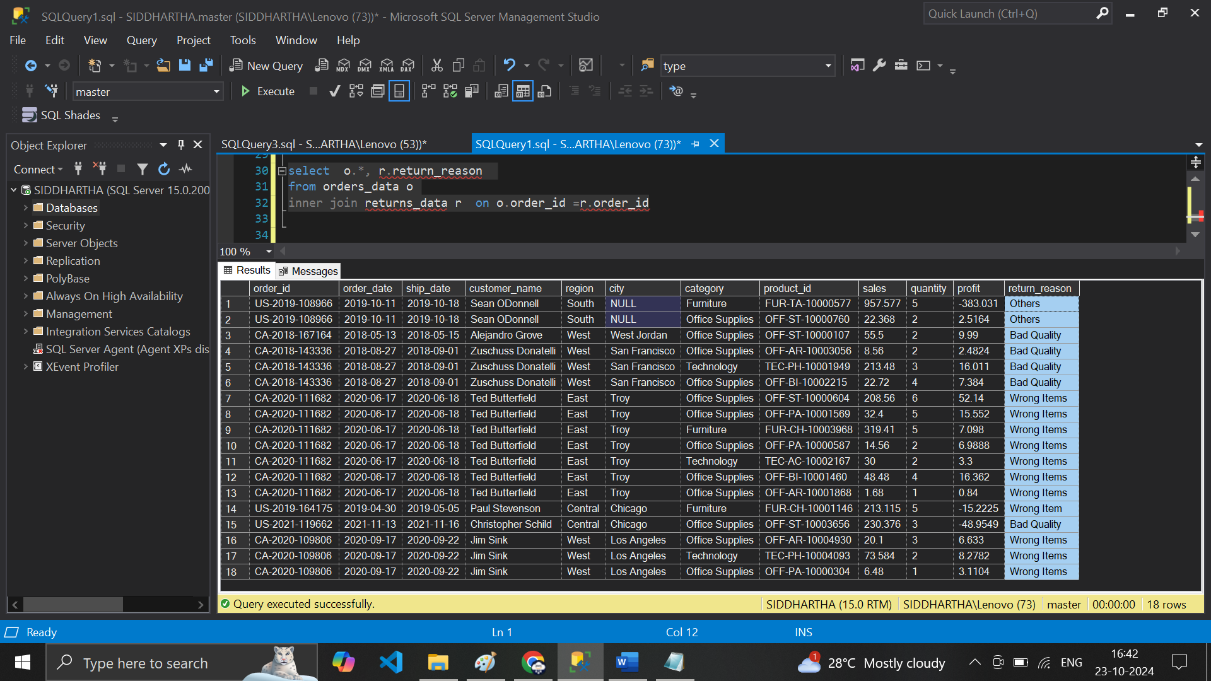

**# same thing I need only 1 col order_id from table 1 * return_reason from Table 2 Col**

**select o.order_id, r.return_reason from orders_data o inner join returns_data r on o.order_id =r.order_id**

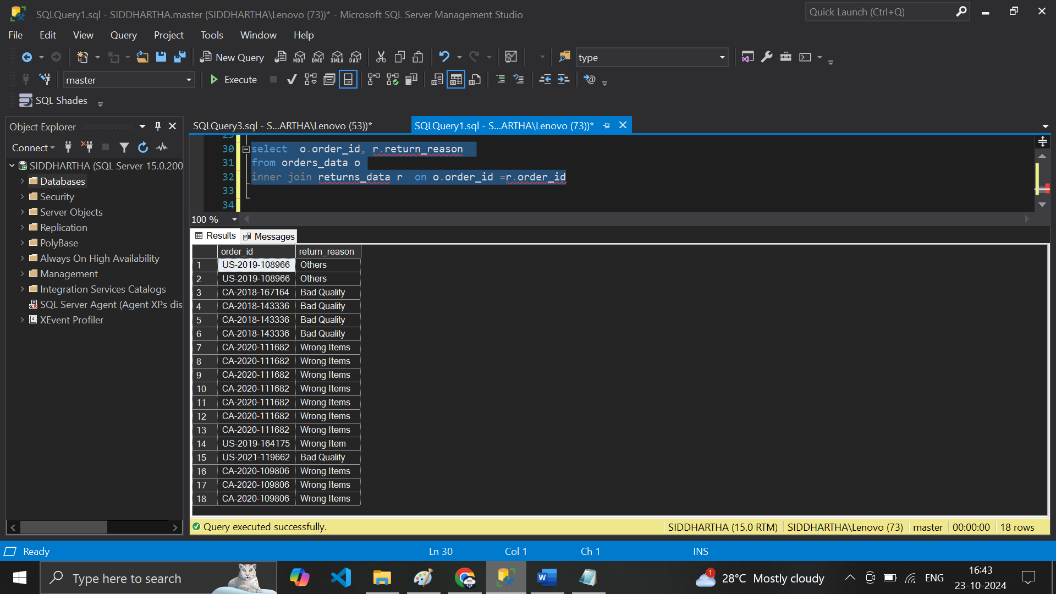

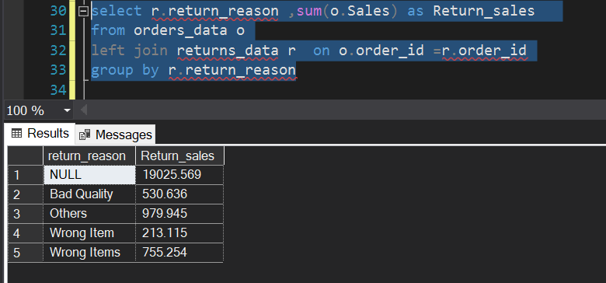

**# case Statement -- wrong items/item—need to change this**

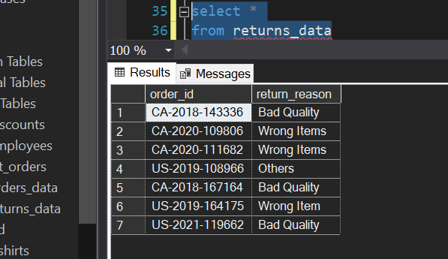

**select * ,case when return_reason='Wrong Item'then 'Wrong Items' else return_reason end as new_Return_Reason from returns_data**

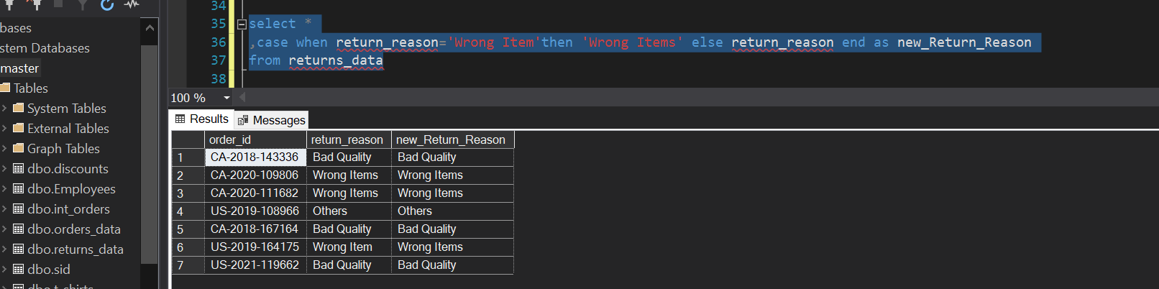

**# now do a analysis for order_data w.r.t profit / loss using case statement**



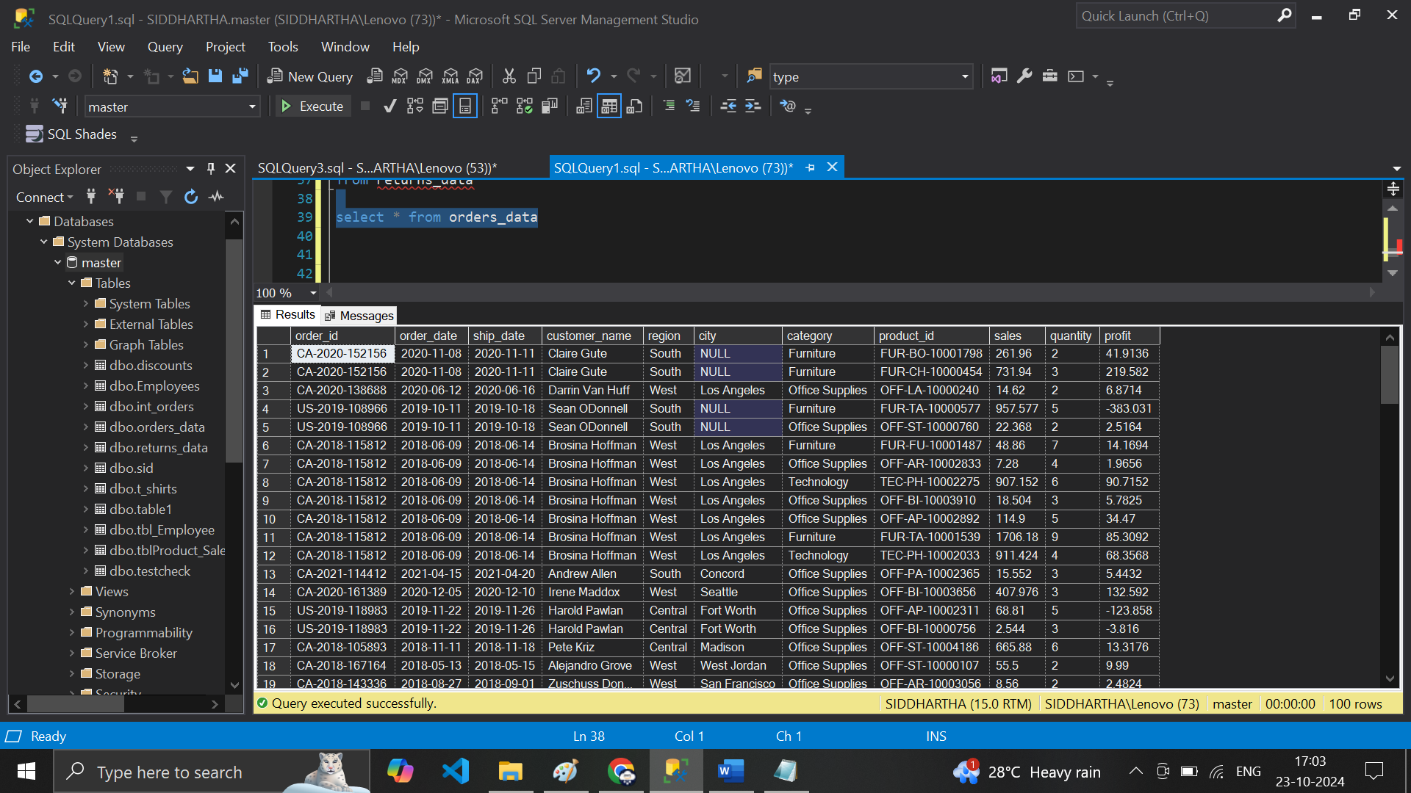



**select * ,case when profit<0 then 'loss'when profit<500 then 'Low Profit'when profit>1000 then 'Huge**

**Profit' else 'Huge Profit'end as Profit_Bucket from orders_data**

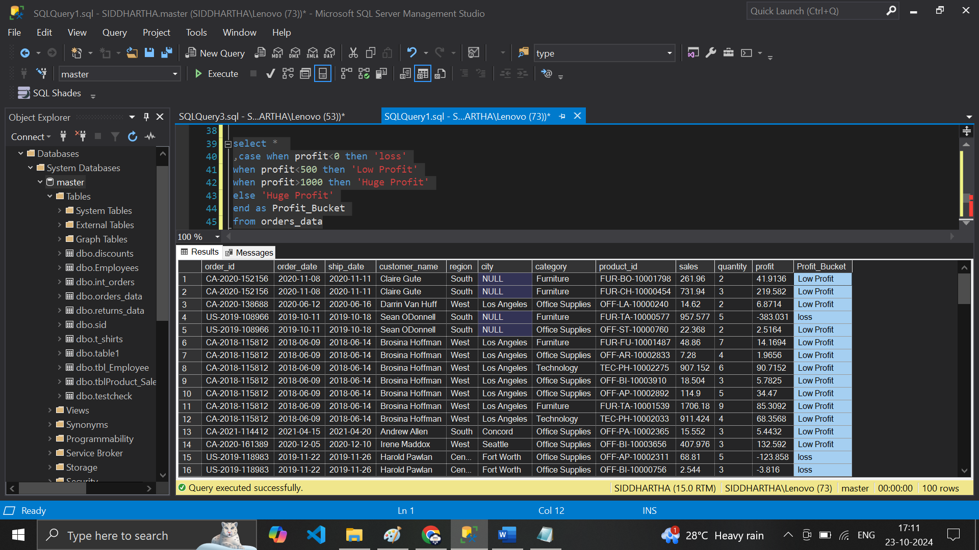

**# Case statement – order of execution is from Top to Bottom**

**# now use Case & B/W Clause**

**select * ,case when profit<0 then 'loss' when profit between 50 and 99 then 'high Profit'**

**when profit between 0 and 99 then 'Low Profit'else 'Huge Profit'end as Profit_Bucket**

**from orders_data**

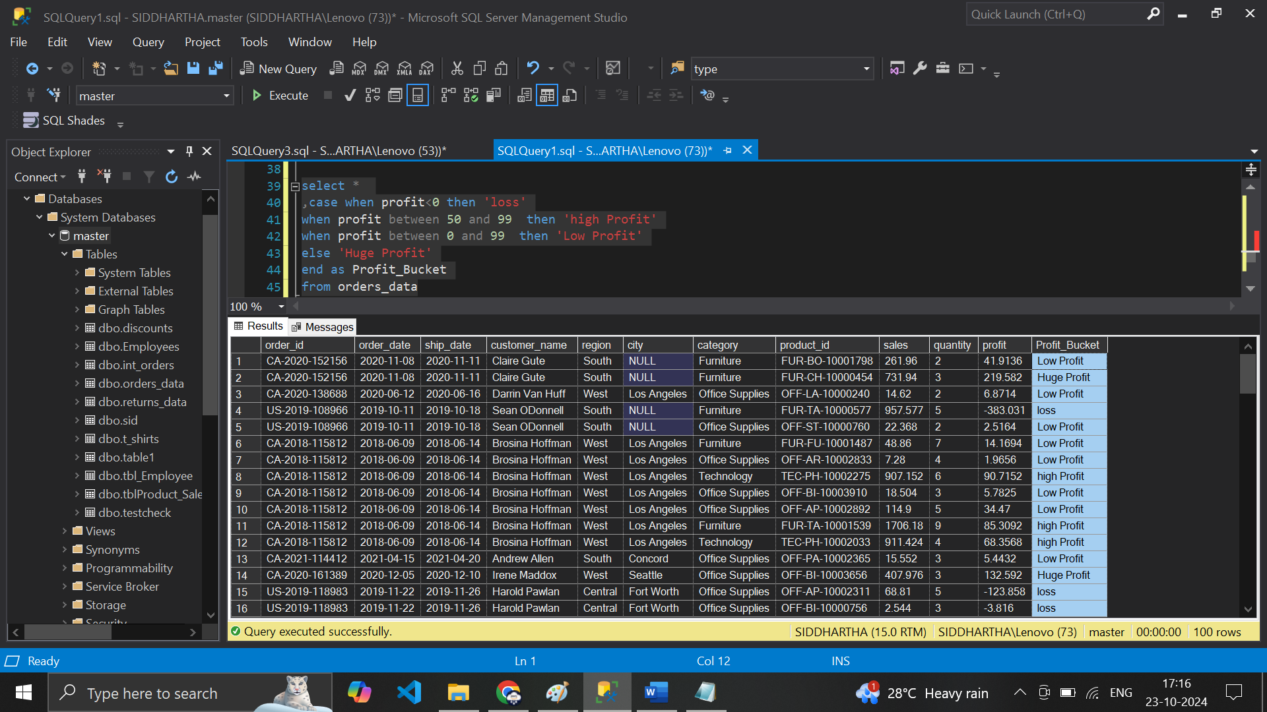**----- Date + String functions**

**select * , len(customer_name) as cust_Len**

**from orders_data**

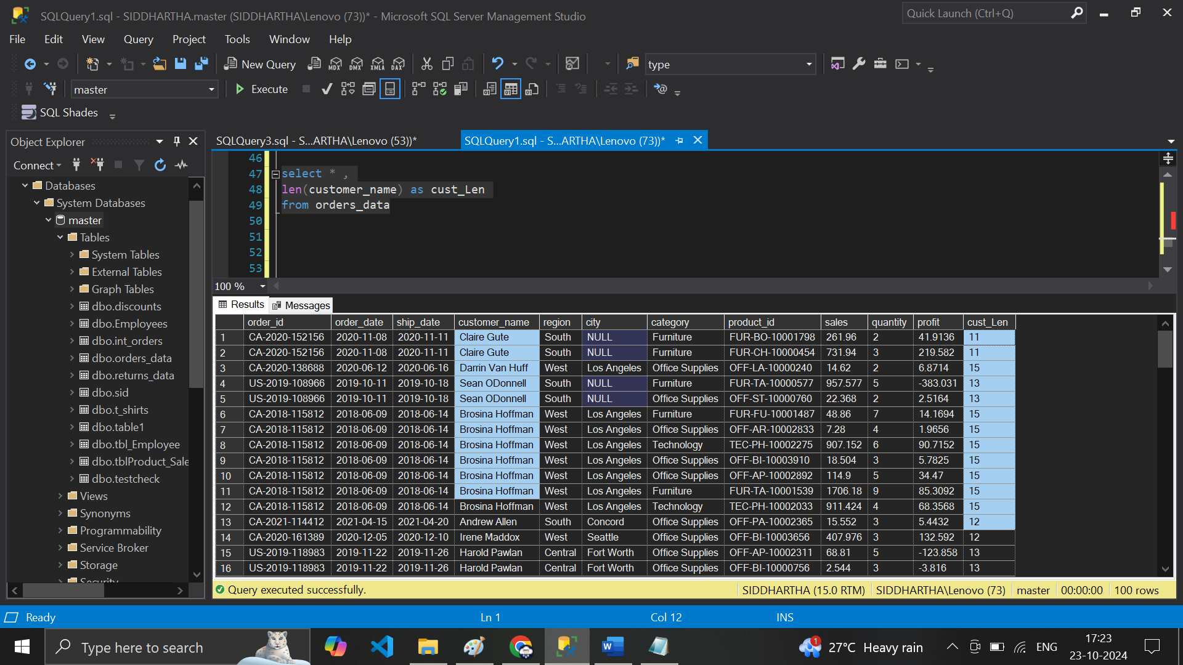

**select * ,len(customer_name) as cust_Len,left(order_id,2) as cust_order_id**

**from orders_data**

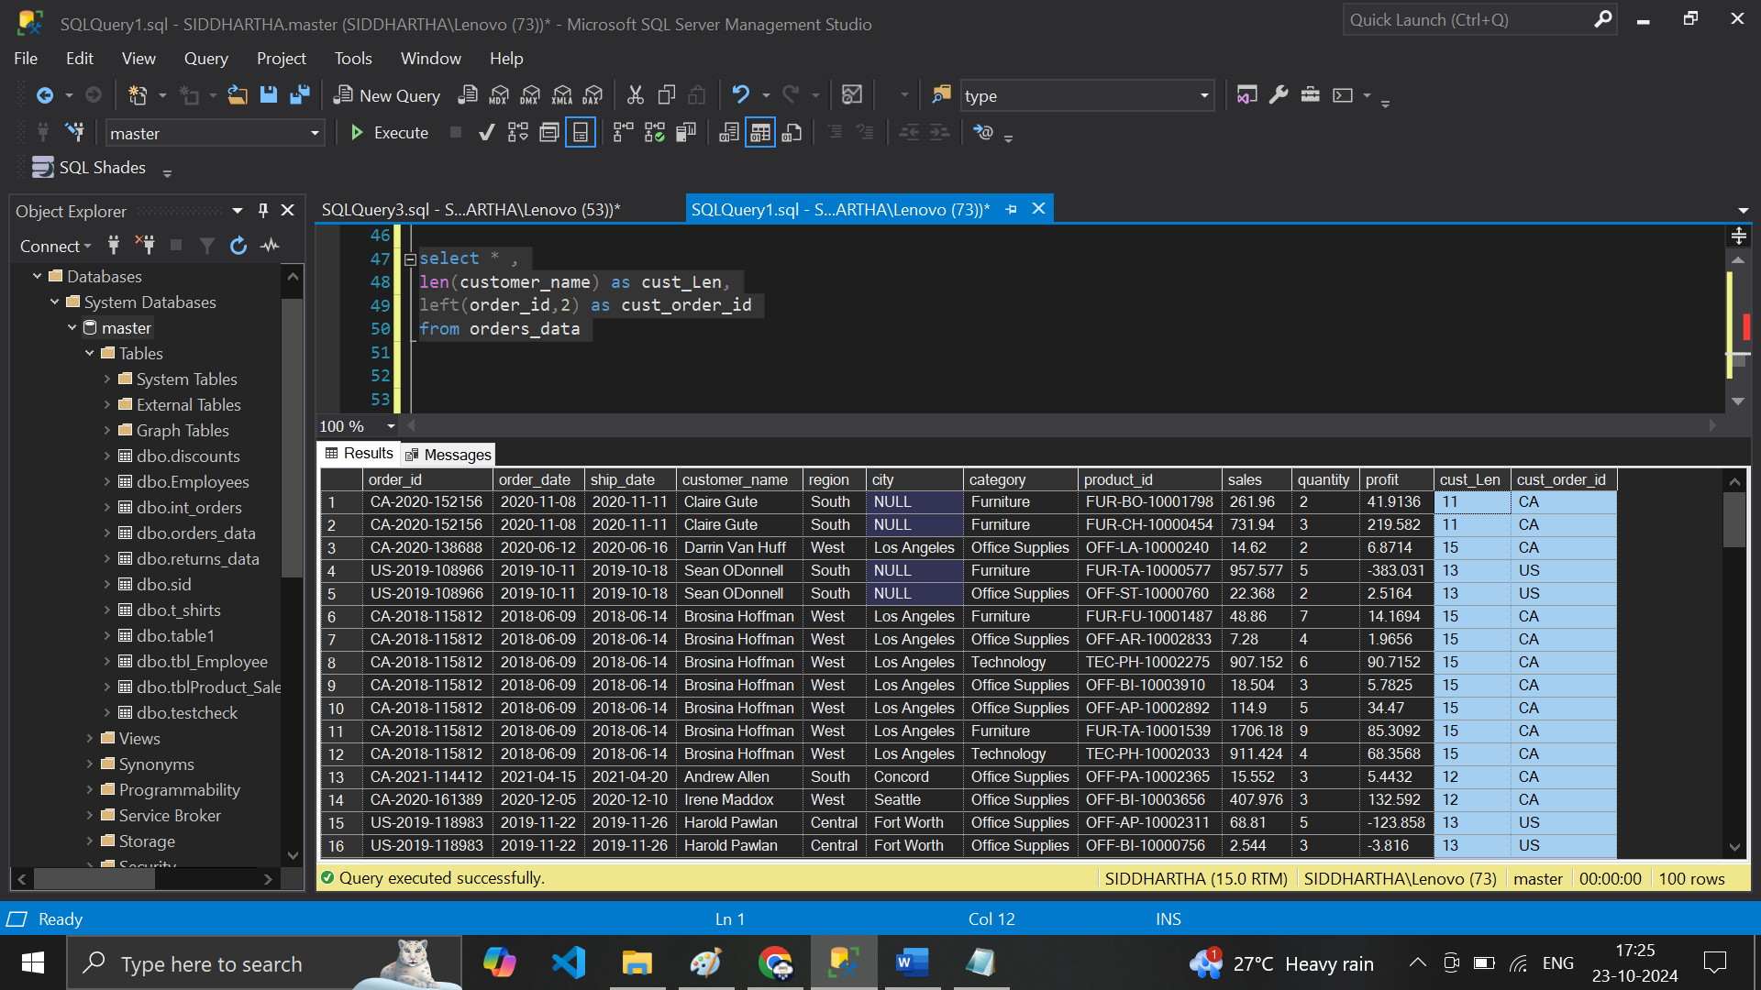

**select * ,len(customer_name) as cust_Len,right(order_id,6) as Right_order_idfrom orders_data**

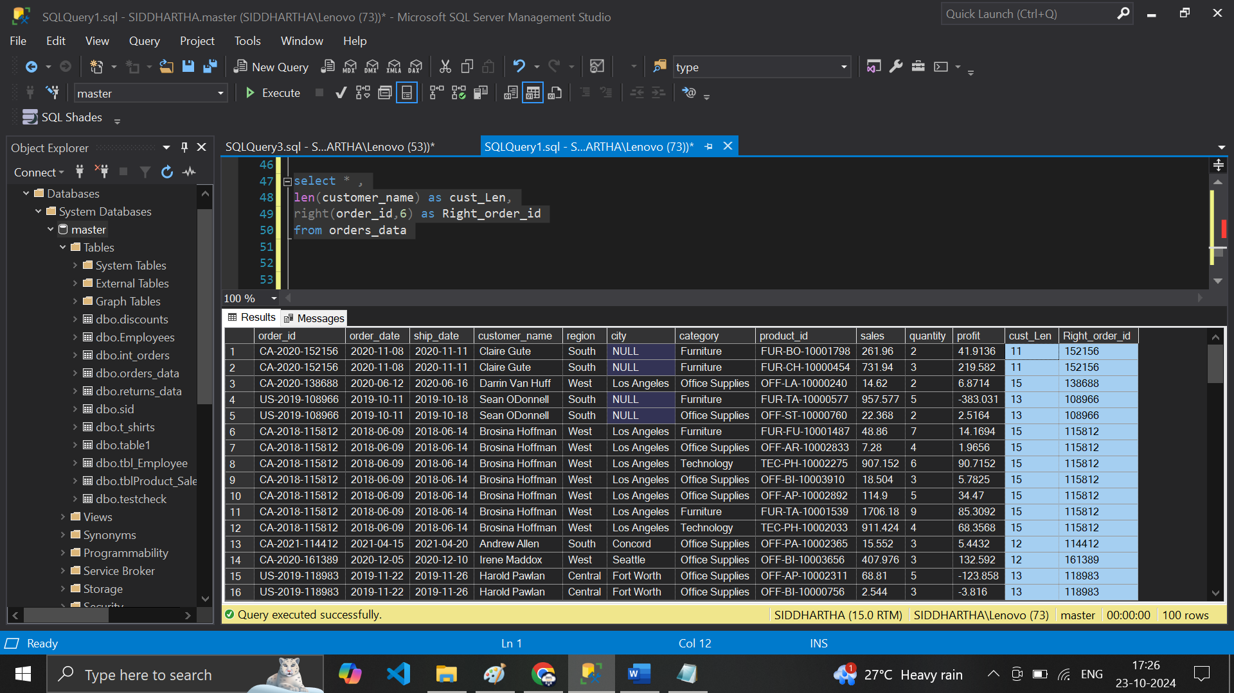**---- Substring**

**select * ,len(customer_name) as cust_Len,right(order_id,6) as Right_oder_id,substring(order_id,4,4) as year_order from orders_data**

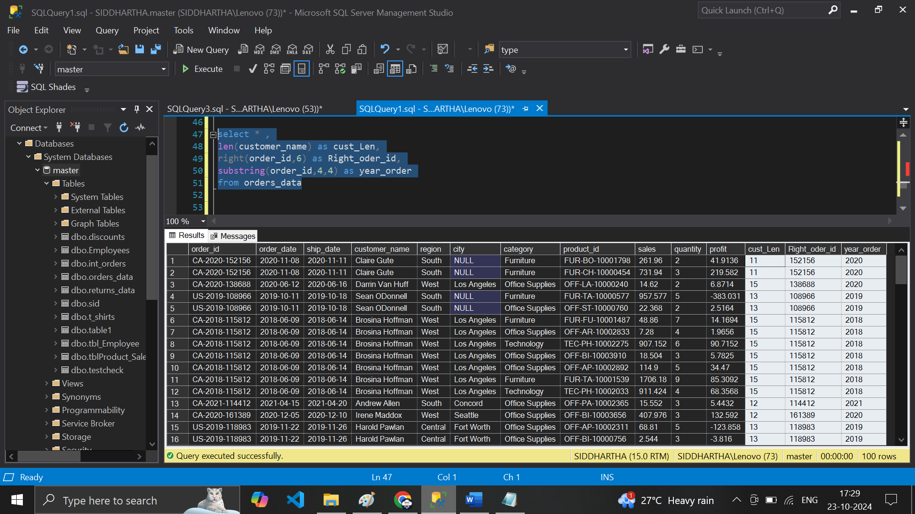

**---- only 2 characters in Subtring**

**select * ,len(customer_name) as cust_Len,right(order_id,6) as Right_oder_id,substring(order_id,4,2) as year_orderfrom orders_data**

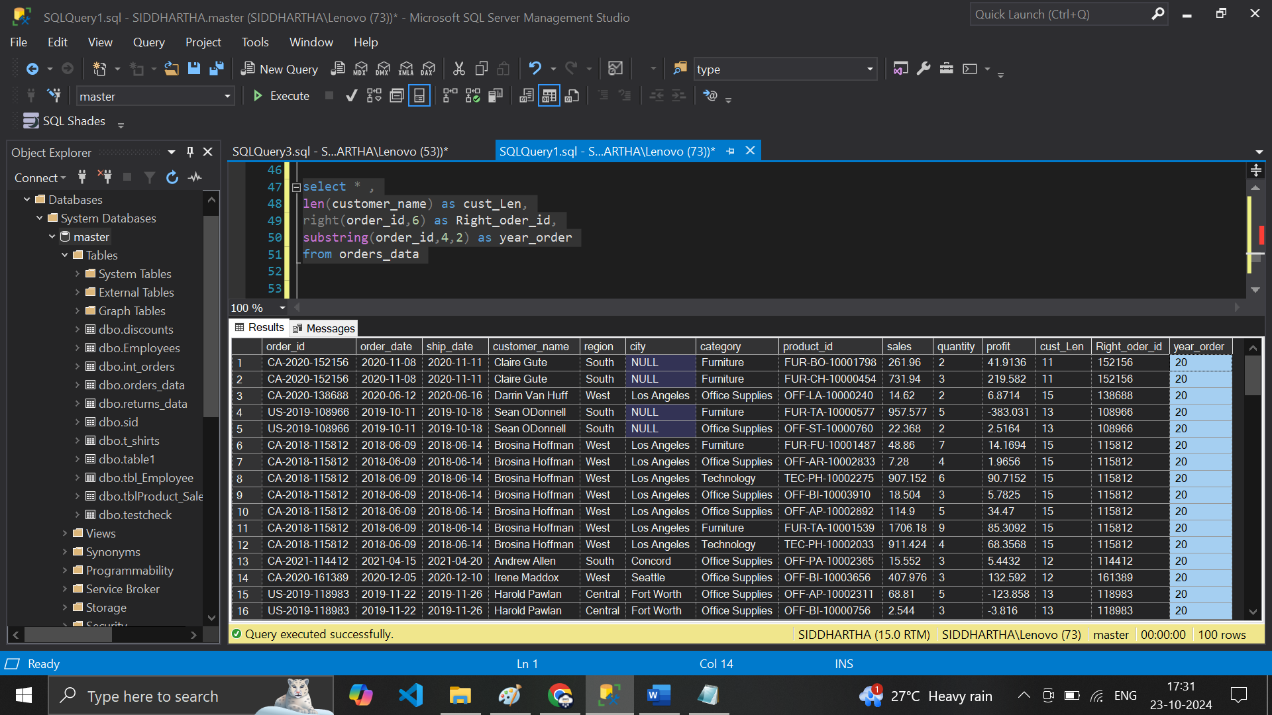

**---- Replace Value**

**select * ,len(customer_name) as cust_Len,right(order_id,6) as Right_oder_id,substring(order_id,4,2) as year_order,REPLACE(customer_name, 'C','P') as new_Cust_namefrom orders_data**

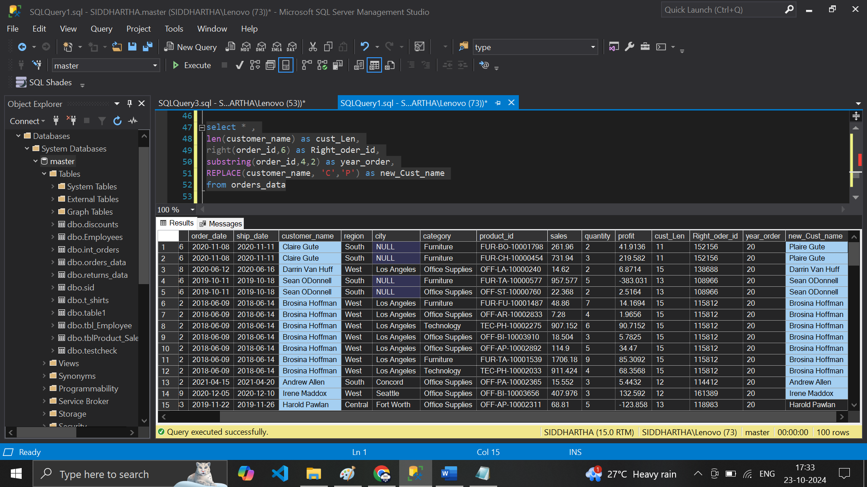

**------ Date Functions**

**---- year wise sales**

**select left(order_date,4), sum(sales)from orders_datagroup by left(order_date,4)**

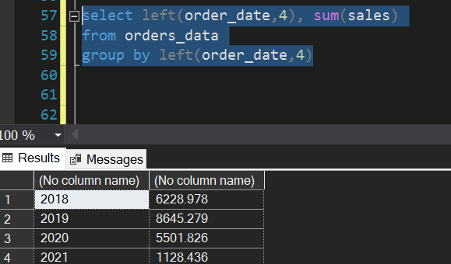

**----- Datepart functions**

**select order_id,order_date,datepart(year,order_date) as Order_year**

**from orders_data**

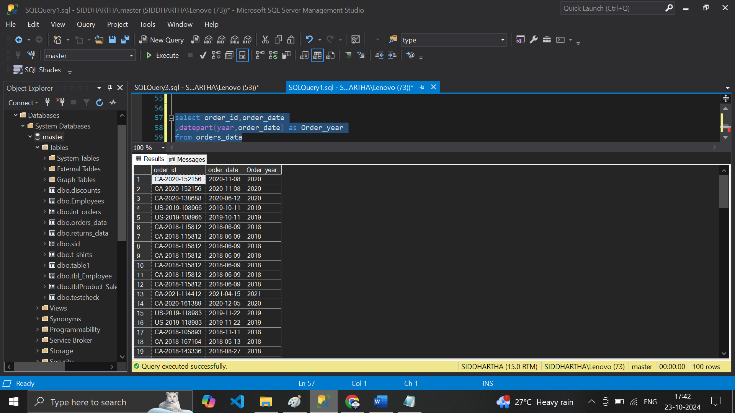

**--- month wise**

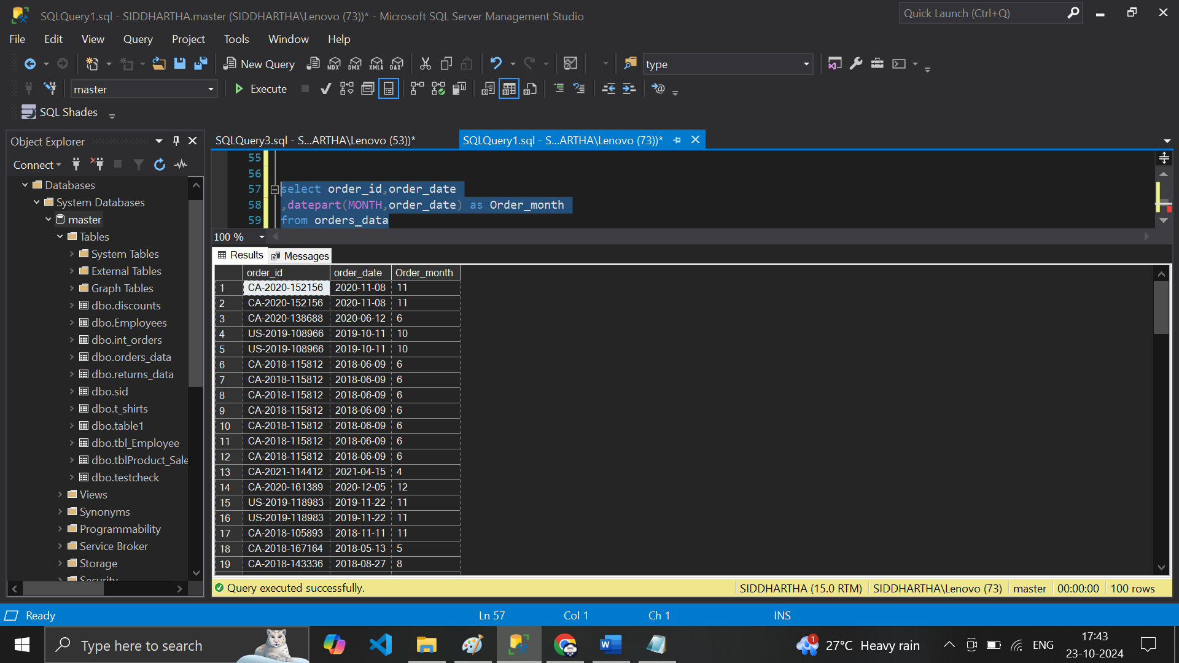

**--- Order- day**

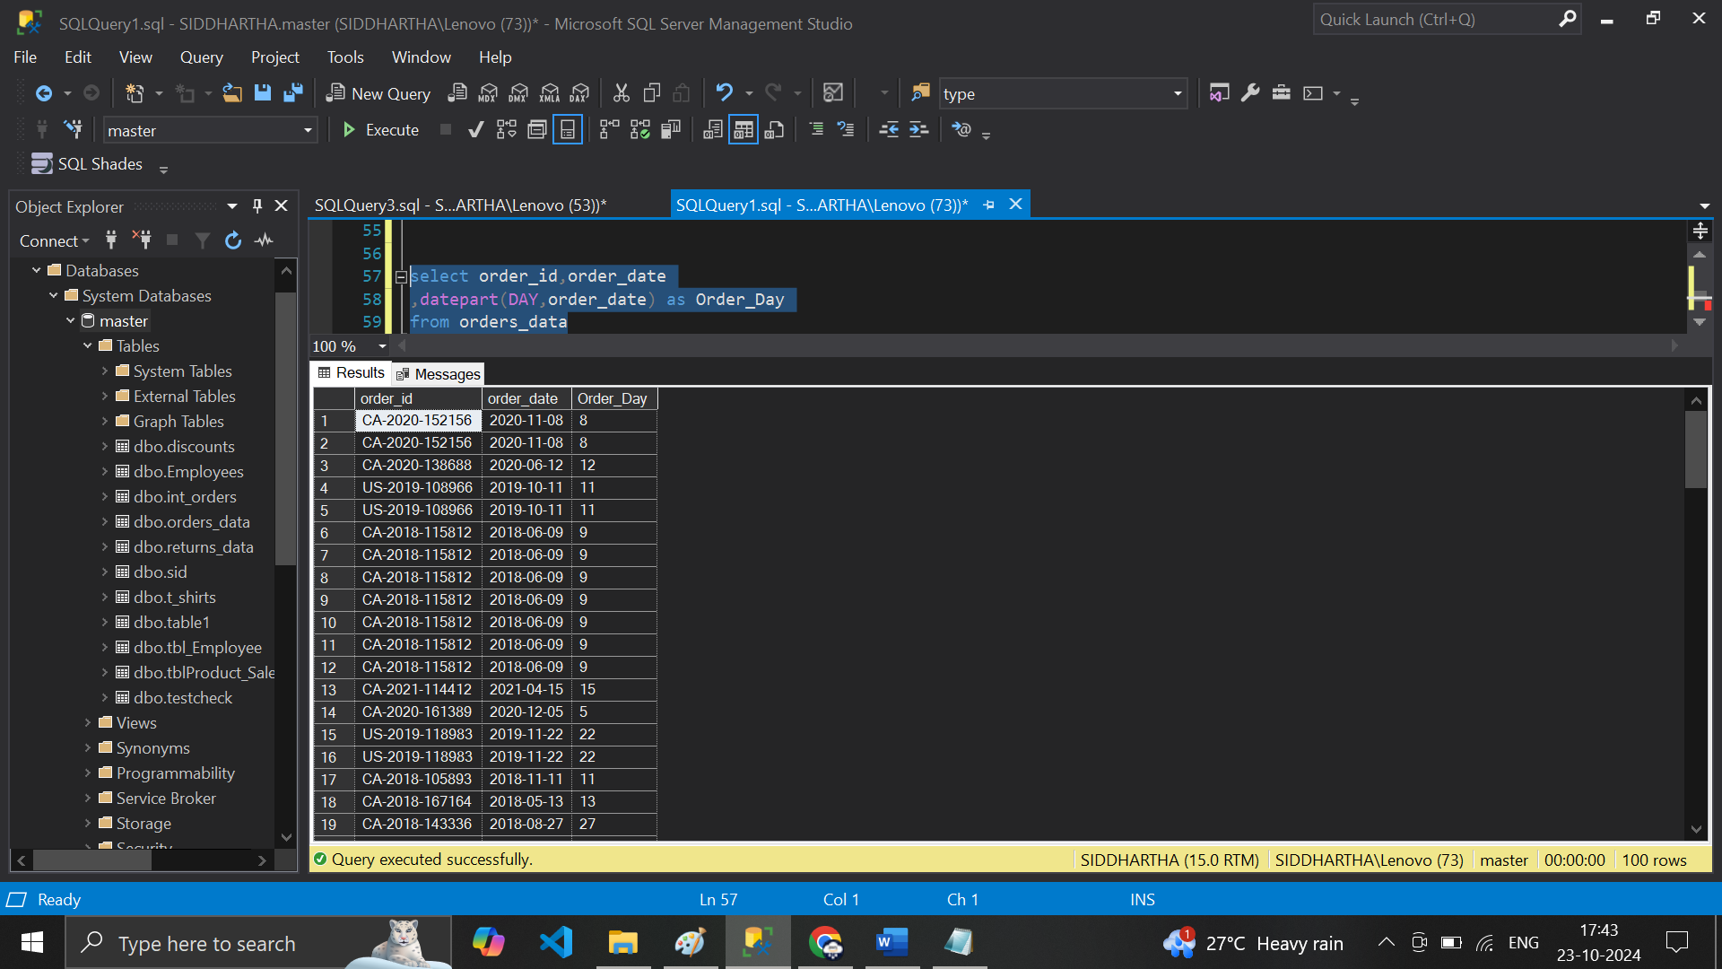**----- Sales on year**

**select datepart(year,order_date) as Order_Year ,sum(sales) as Sales_Total_year from orders_datagroup by datepart(year,order_date)**

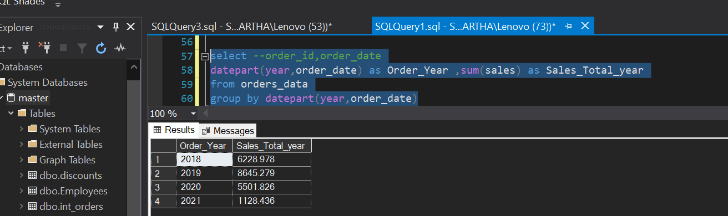

**---- now Check from Ordered Date of any item to ShipemtnDate …**

**( DateDiff – functions)**

**select order_id ,order_date, ship_date,datediff(Day,order_date,ship_date) as Lead_Days**

**from orders_data**

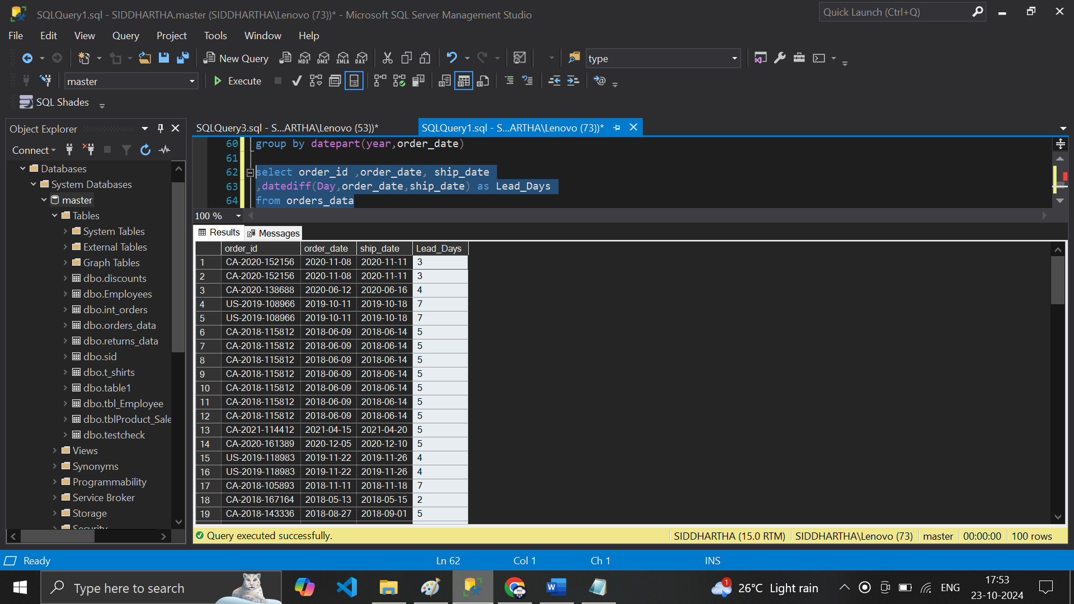

**# month Diff in Dates -- 1 Diff B/w Months or 0 --- no Diff in dates**

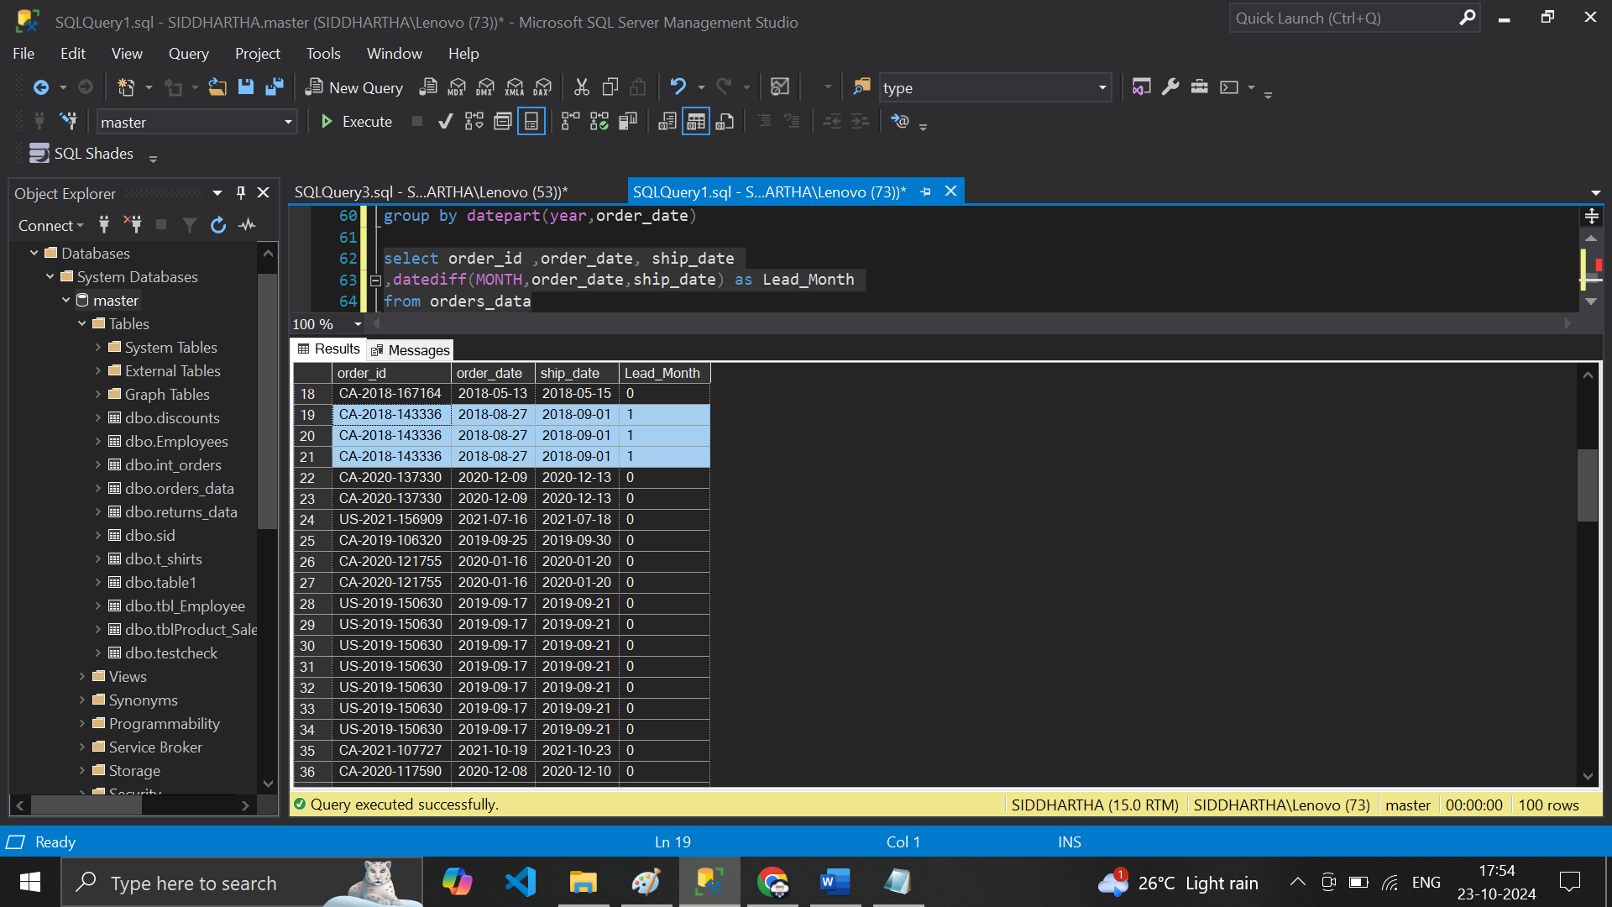

**---- Date Add functions**

**select order_id ,order_date, ship_date,datediff(day,order_date,ship_date) as Lead_Month,dateadd(day,5,order_date) as Add_Order_day_5from orders_data**

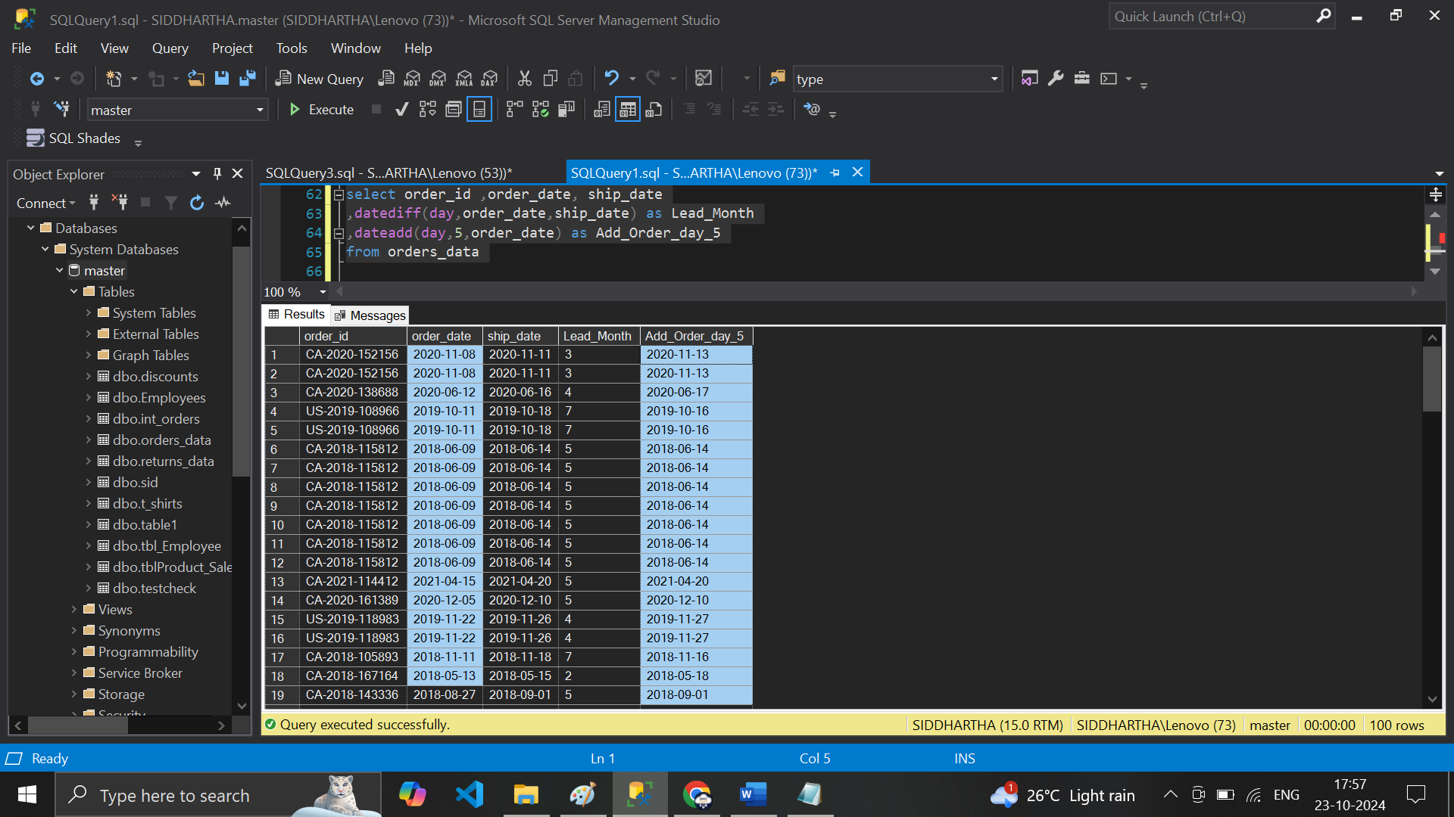

**----Add Quantity added to order date to Shipment Date**

**select order_id ,order_date, ship_date,quantity,datediff(day,order_date,ship_date) as Lead_day**

**,dateadd(day,quantity,ship_date) as Delivery_Datefrom orders_data**

